Load Test Report

### Live assets

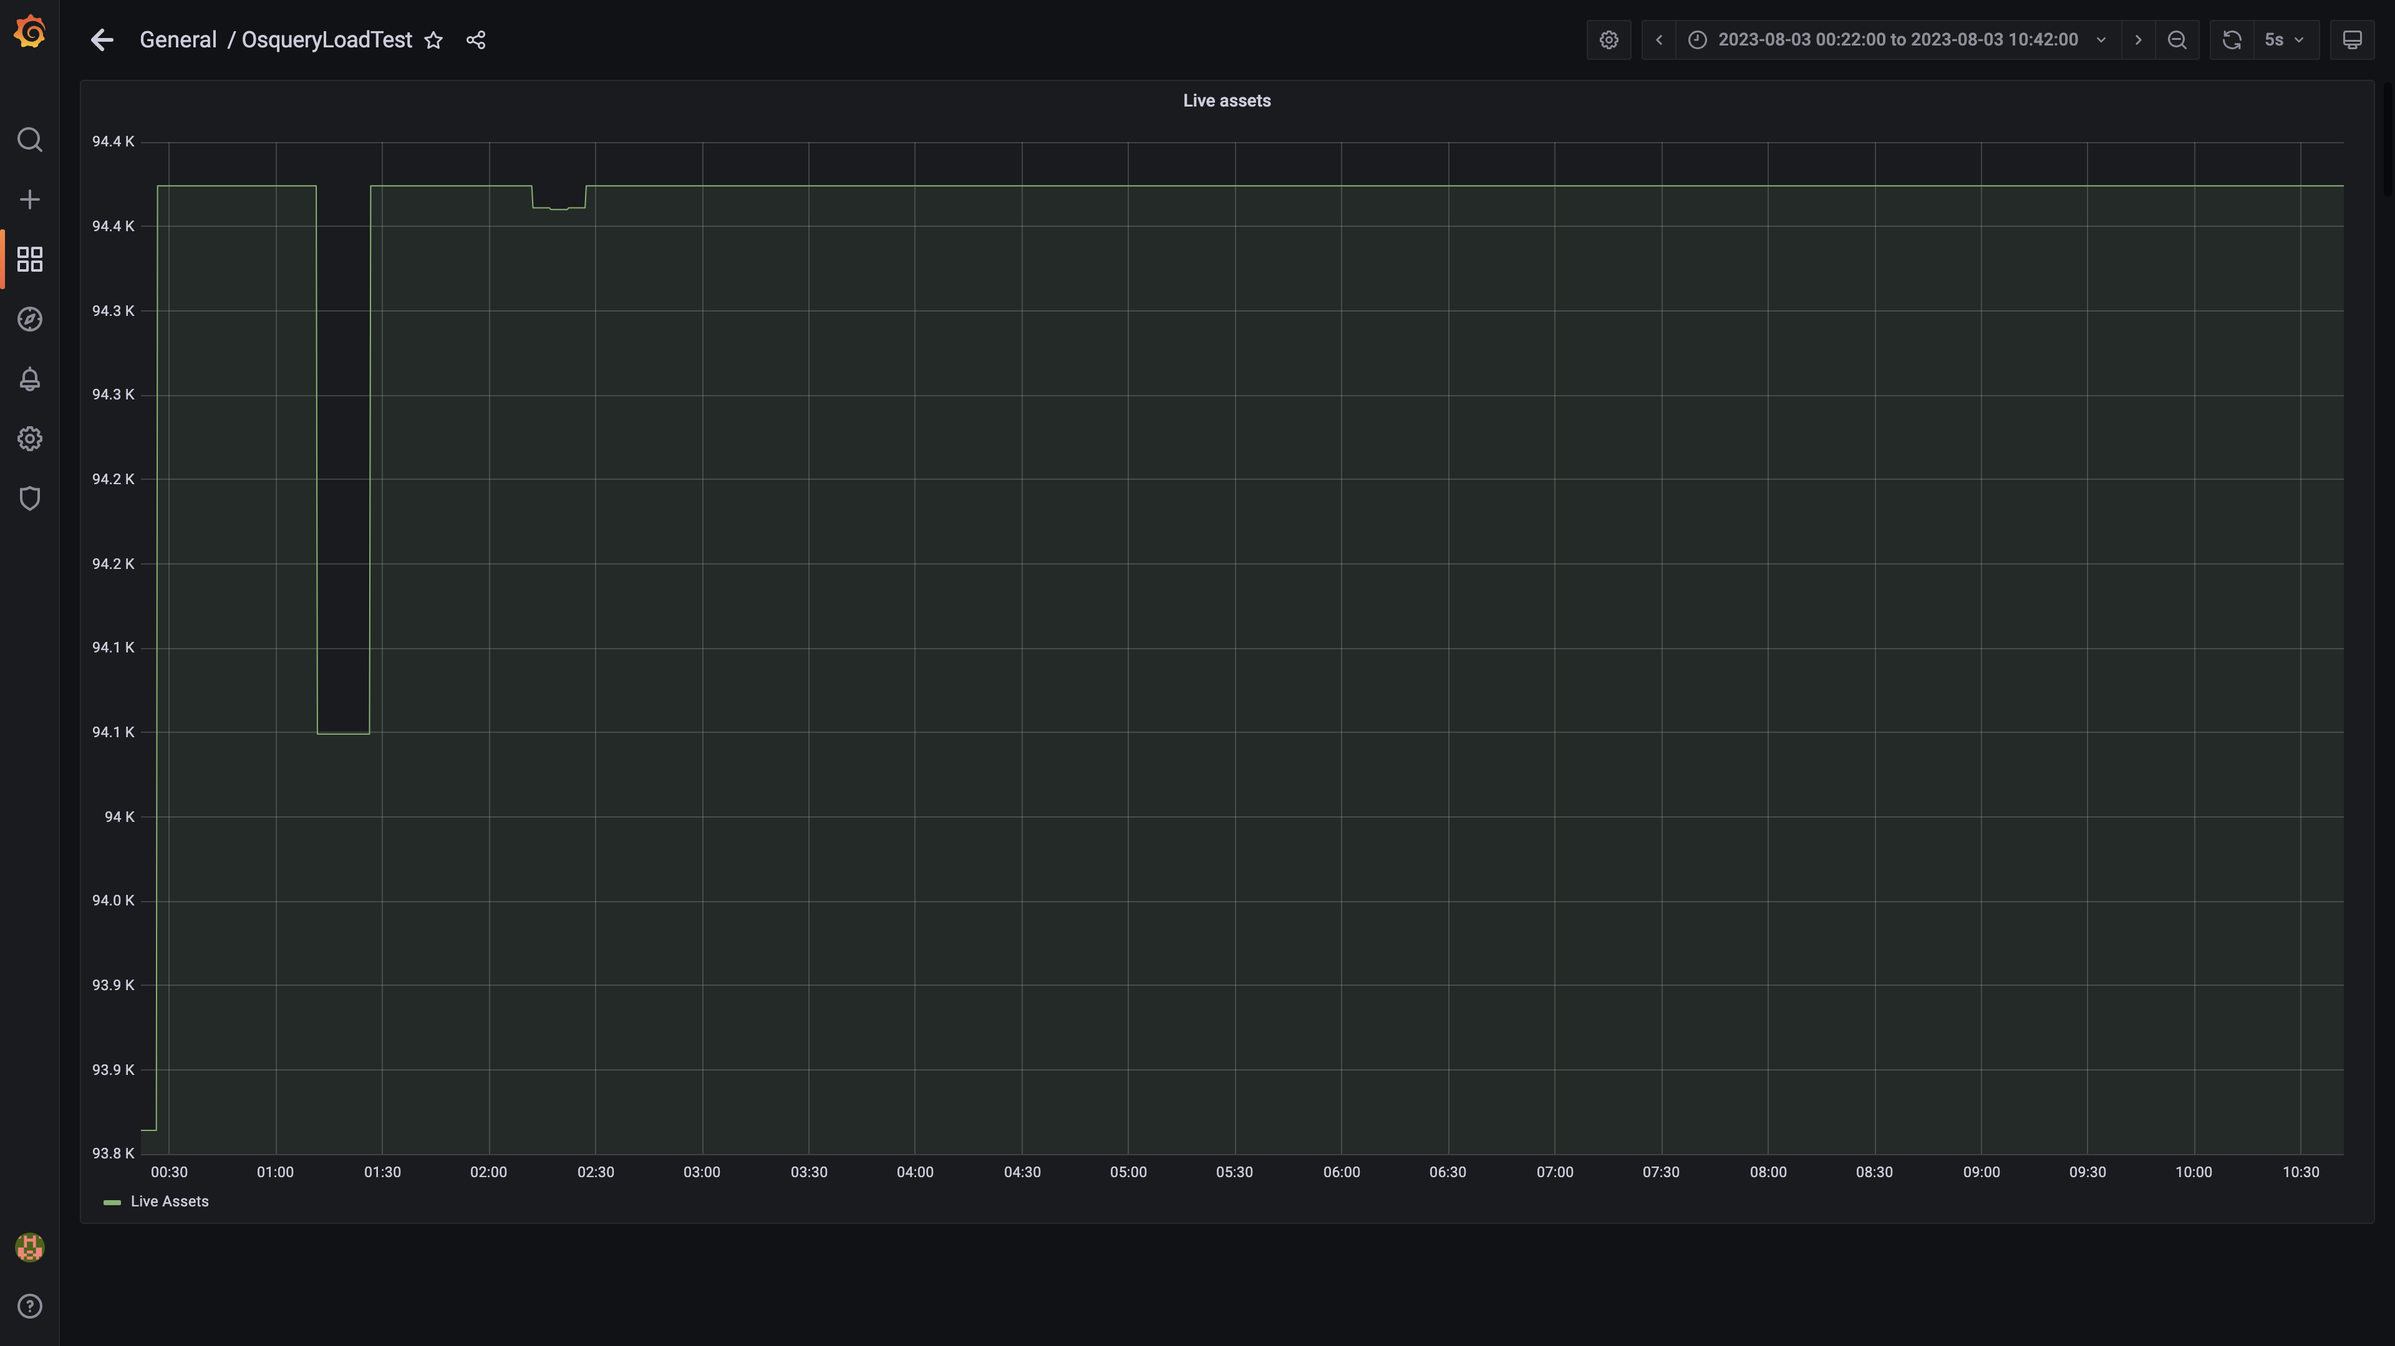

### Kafka lag for all groups

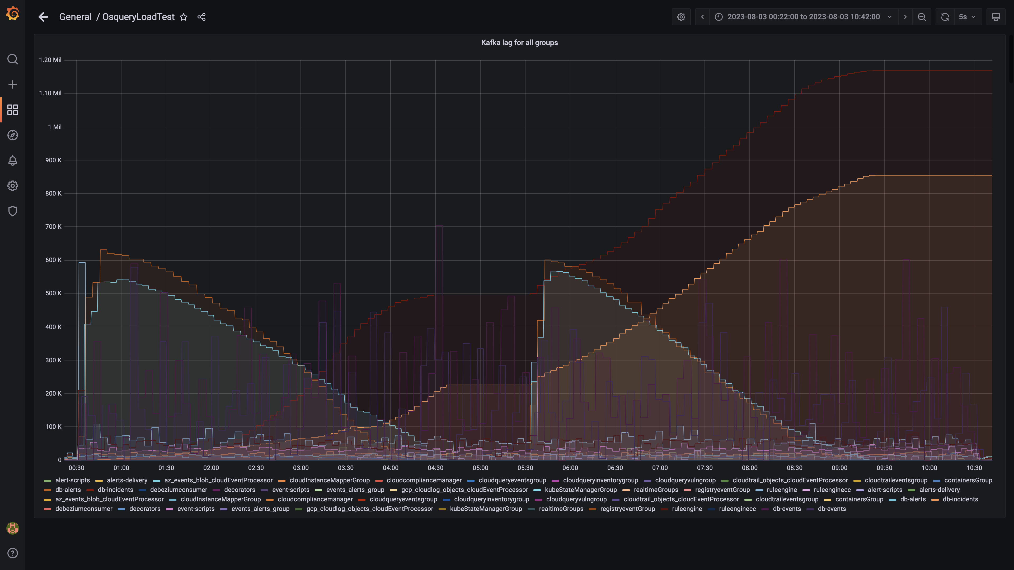

### Process node ram used percent

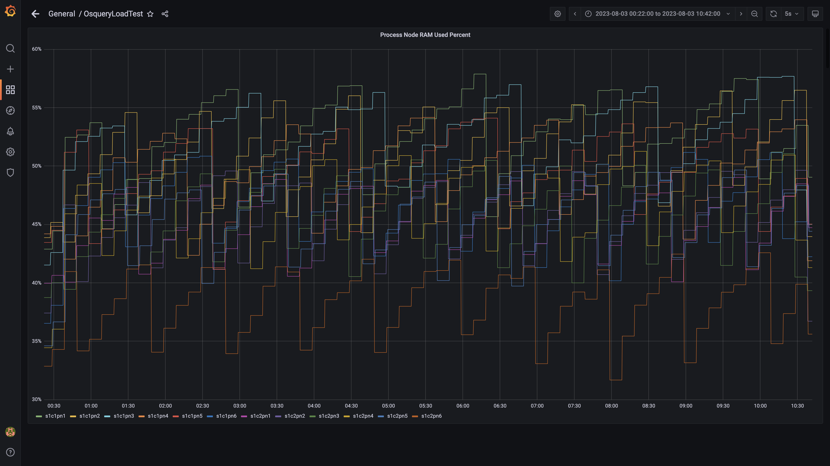

### Data node ram used percent

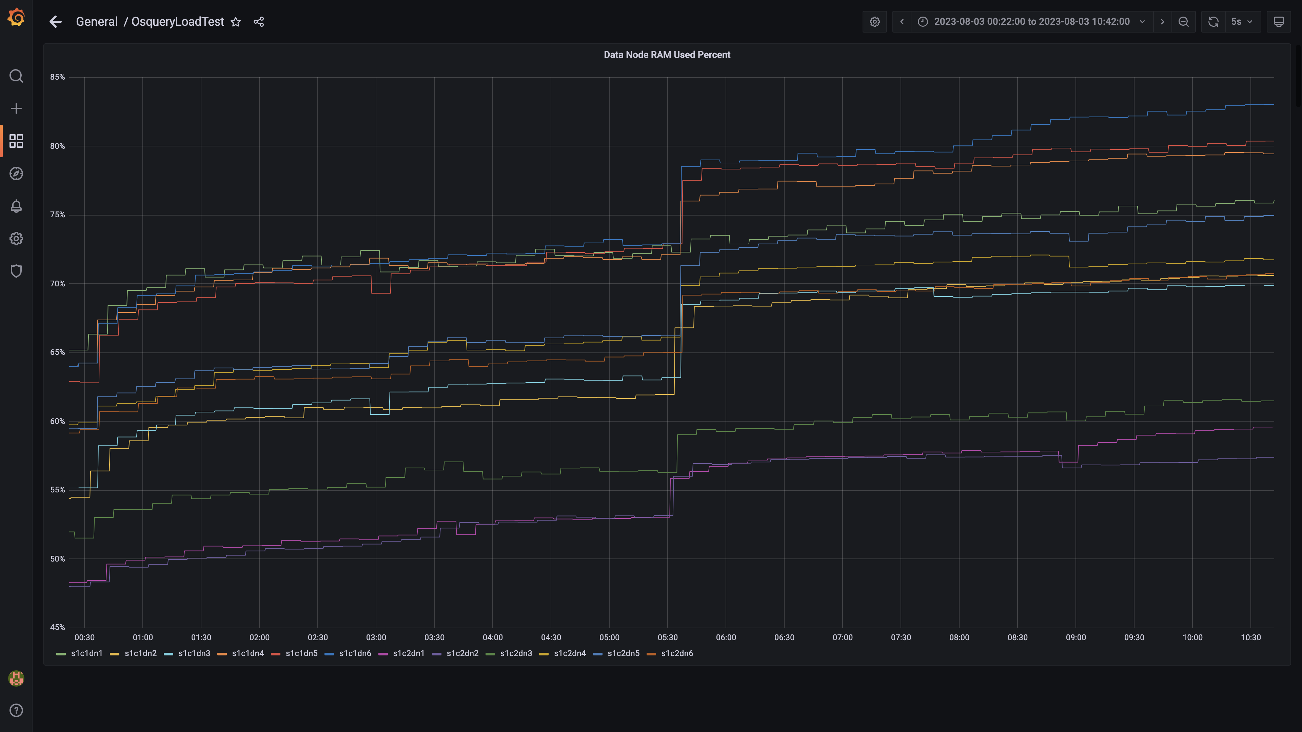

### Postgres node ram used percentage

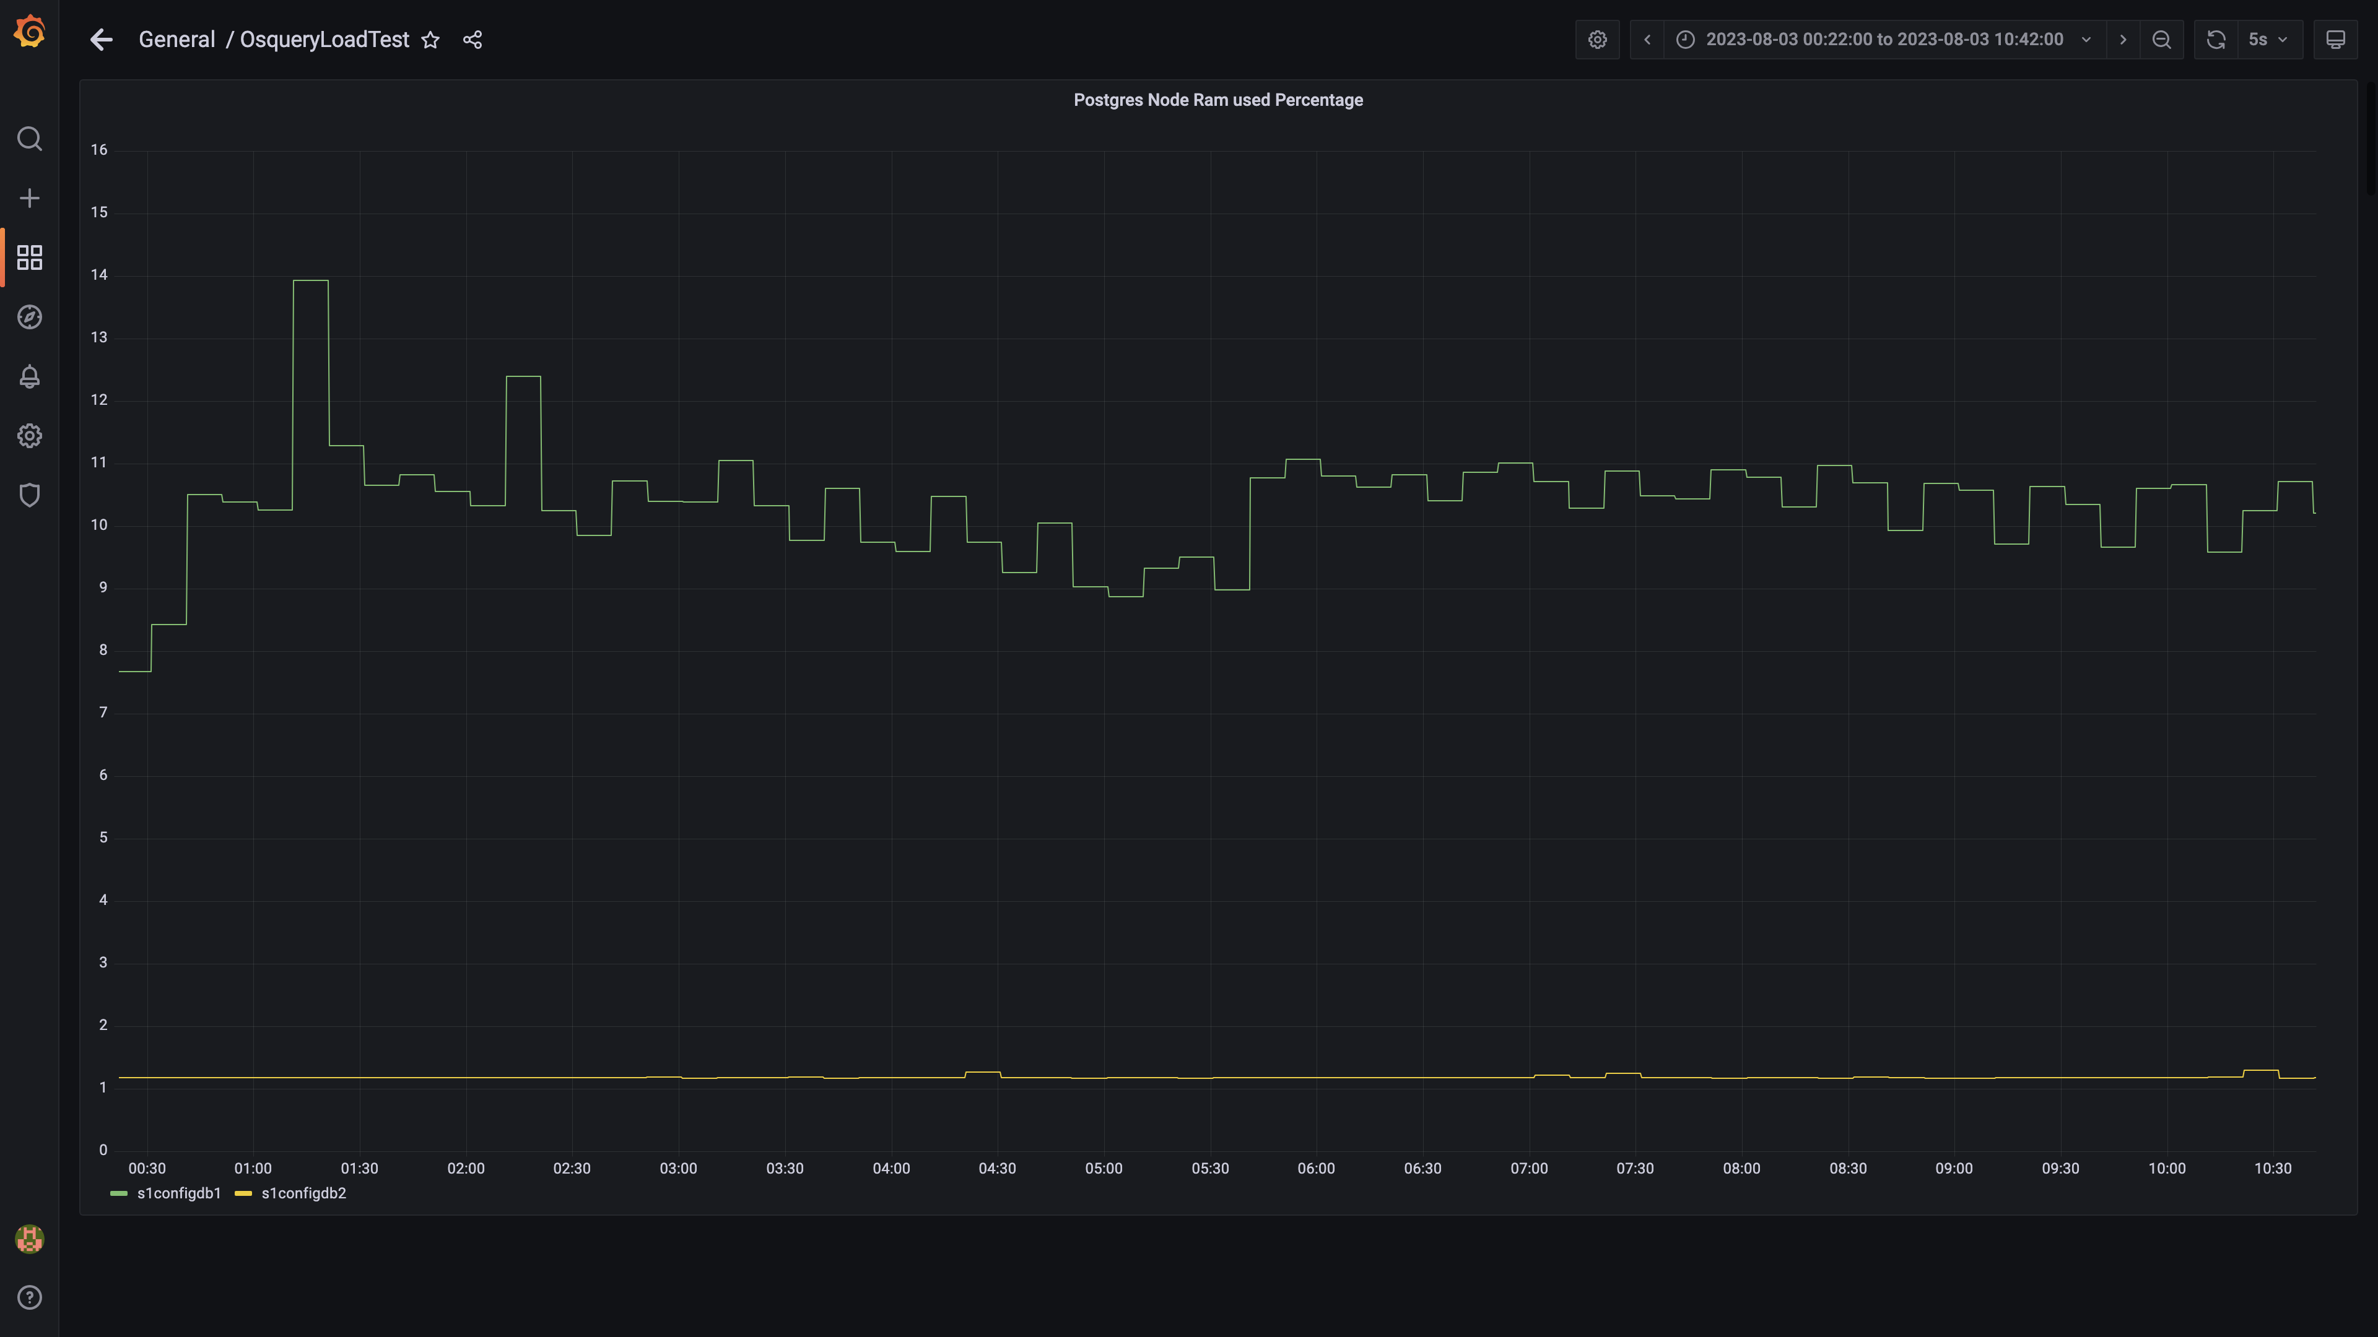

### Memory consumed by eventsdbingestion

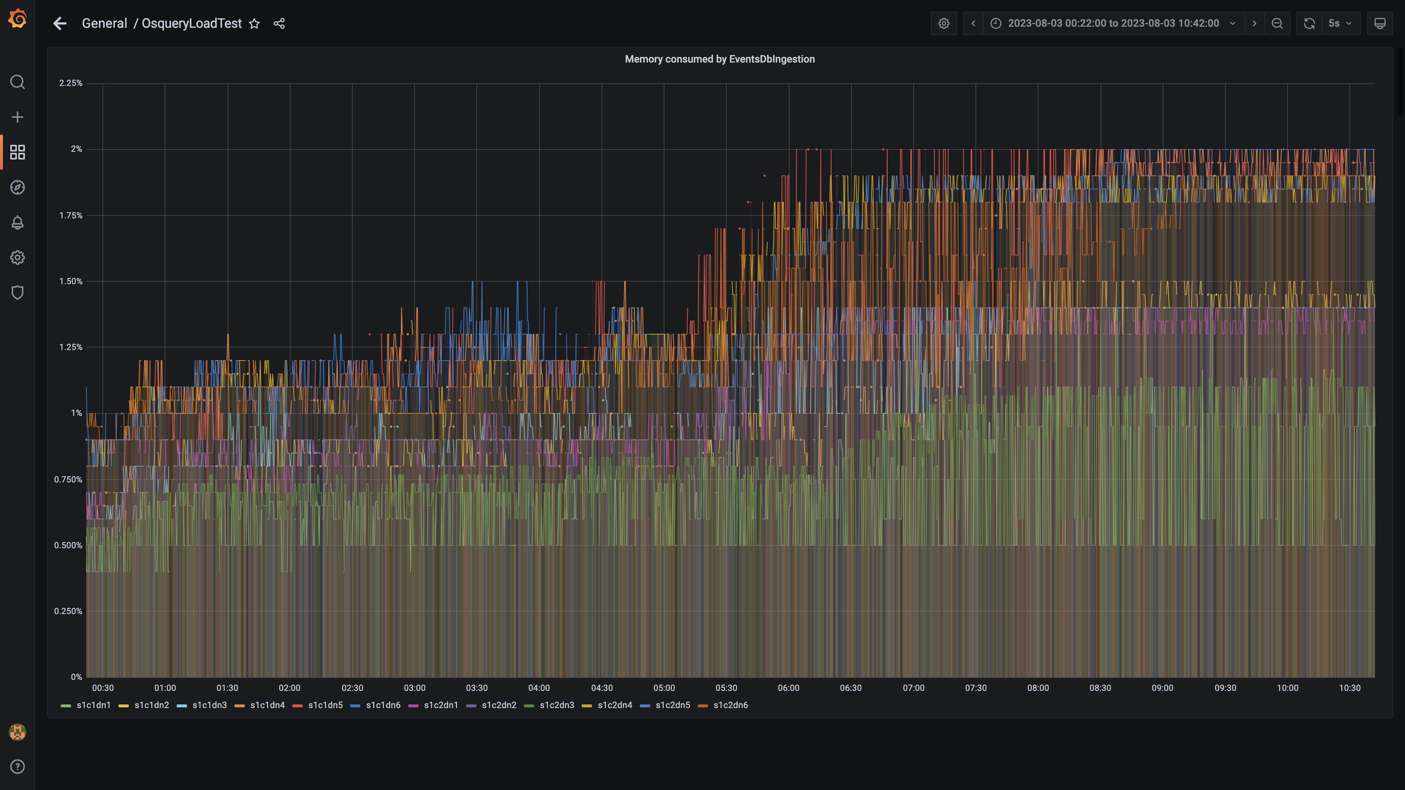

### Kafka disk used percentage

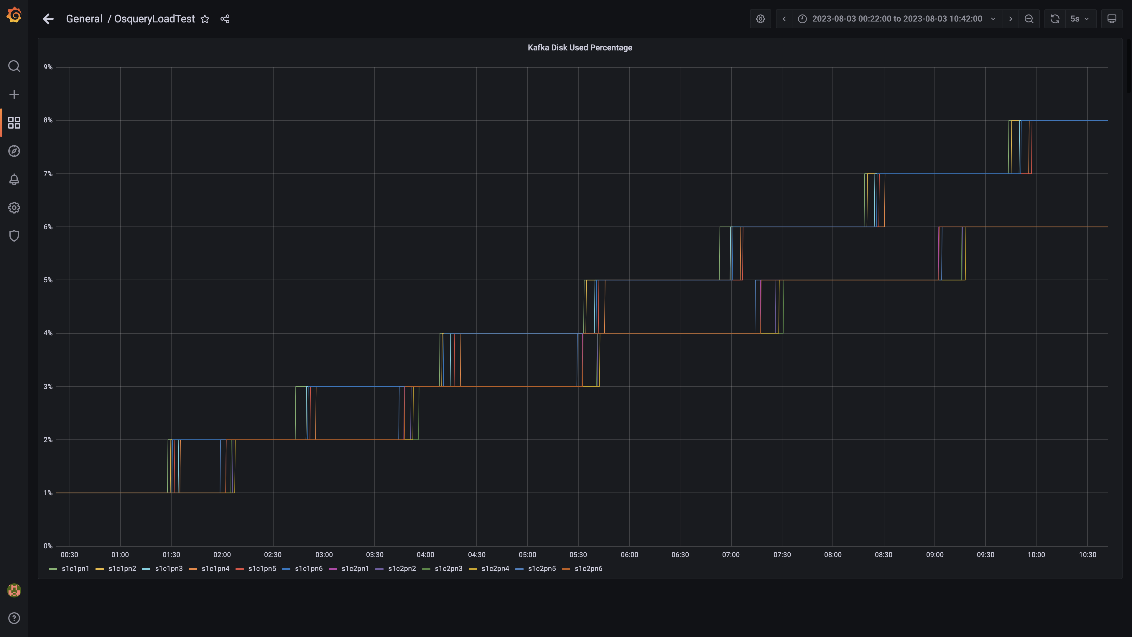

### Memory consumed by orc-compaction

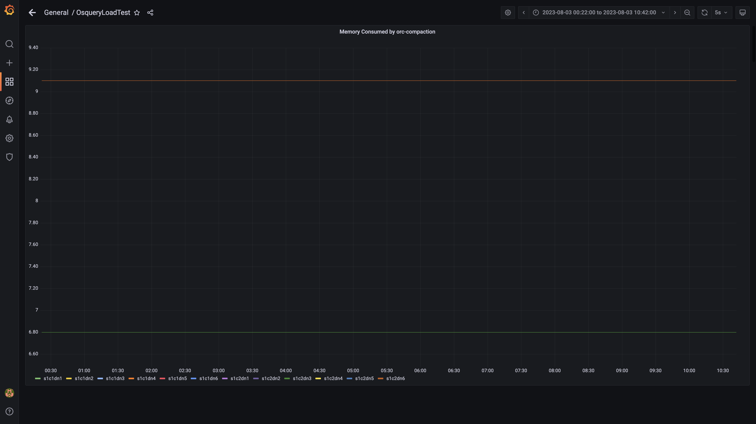

### Compliance summary consumer memory consumption

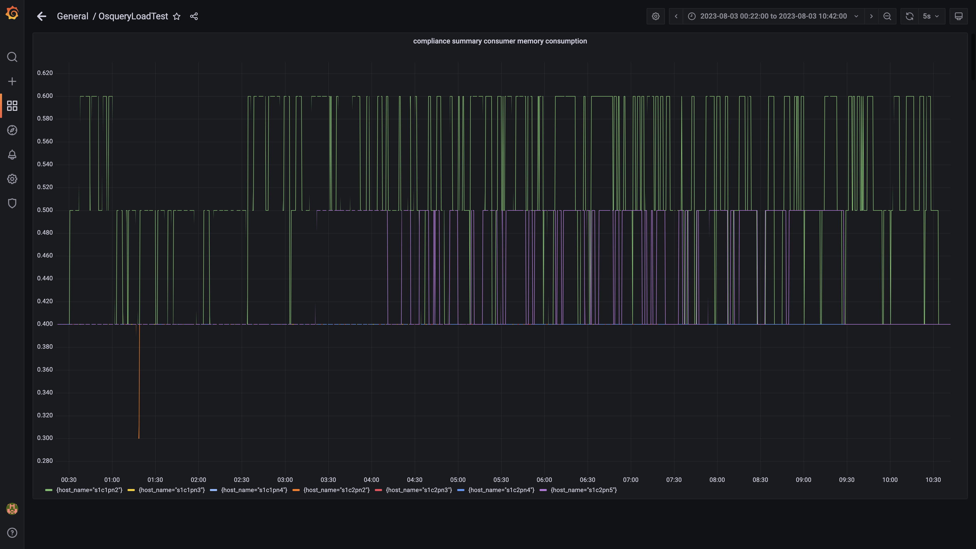

### Memory consumed by logger

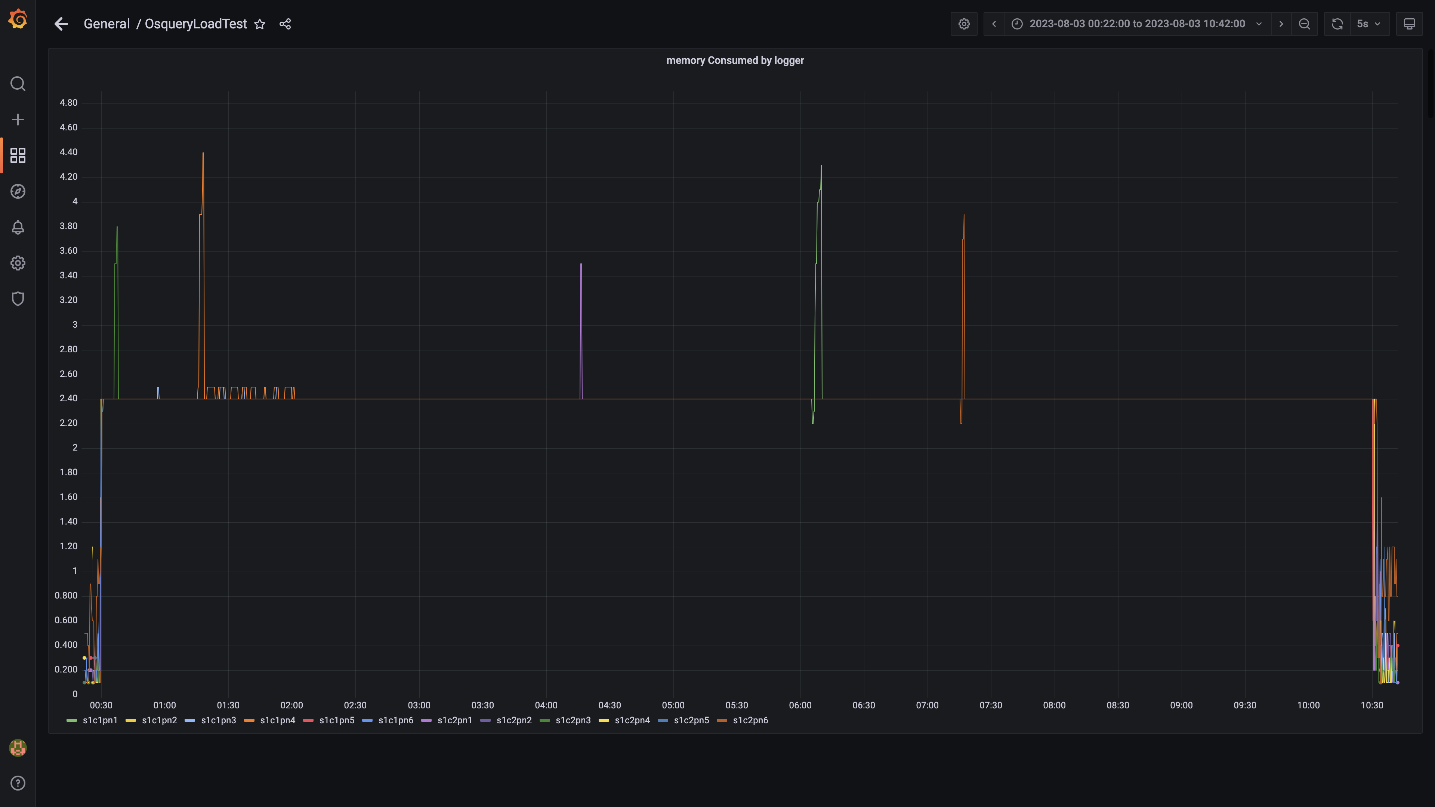

### Kafka memory used percentage

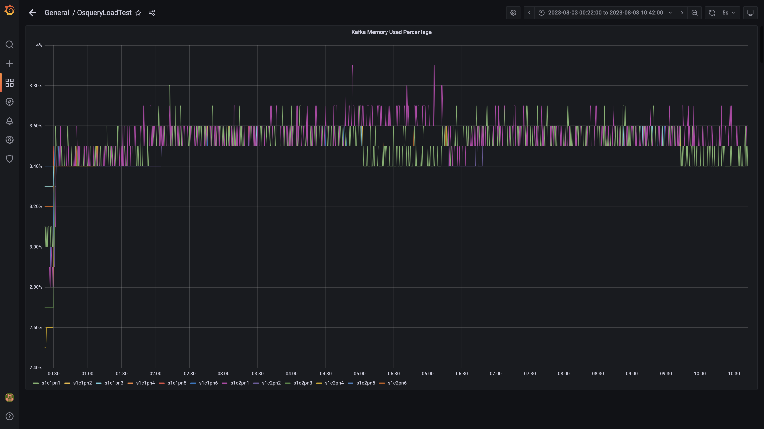

### Memory consumed by trino

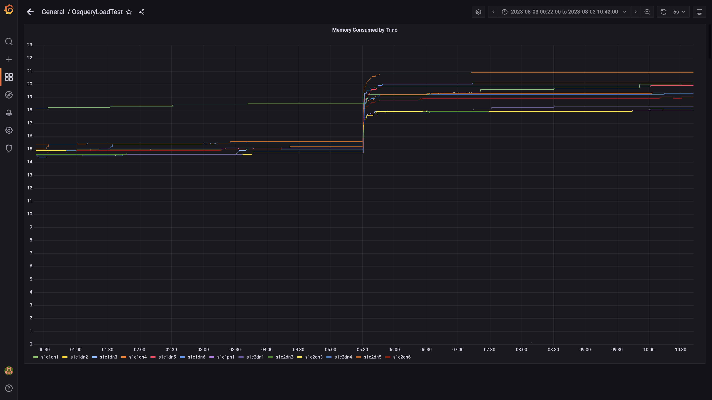

### Memory consumed by osqueryingestion

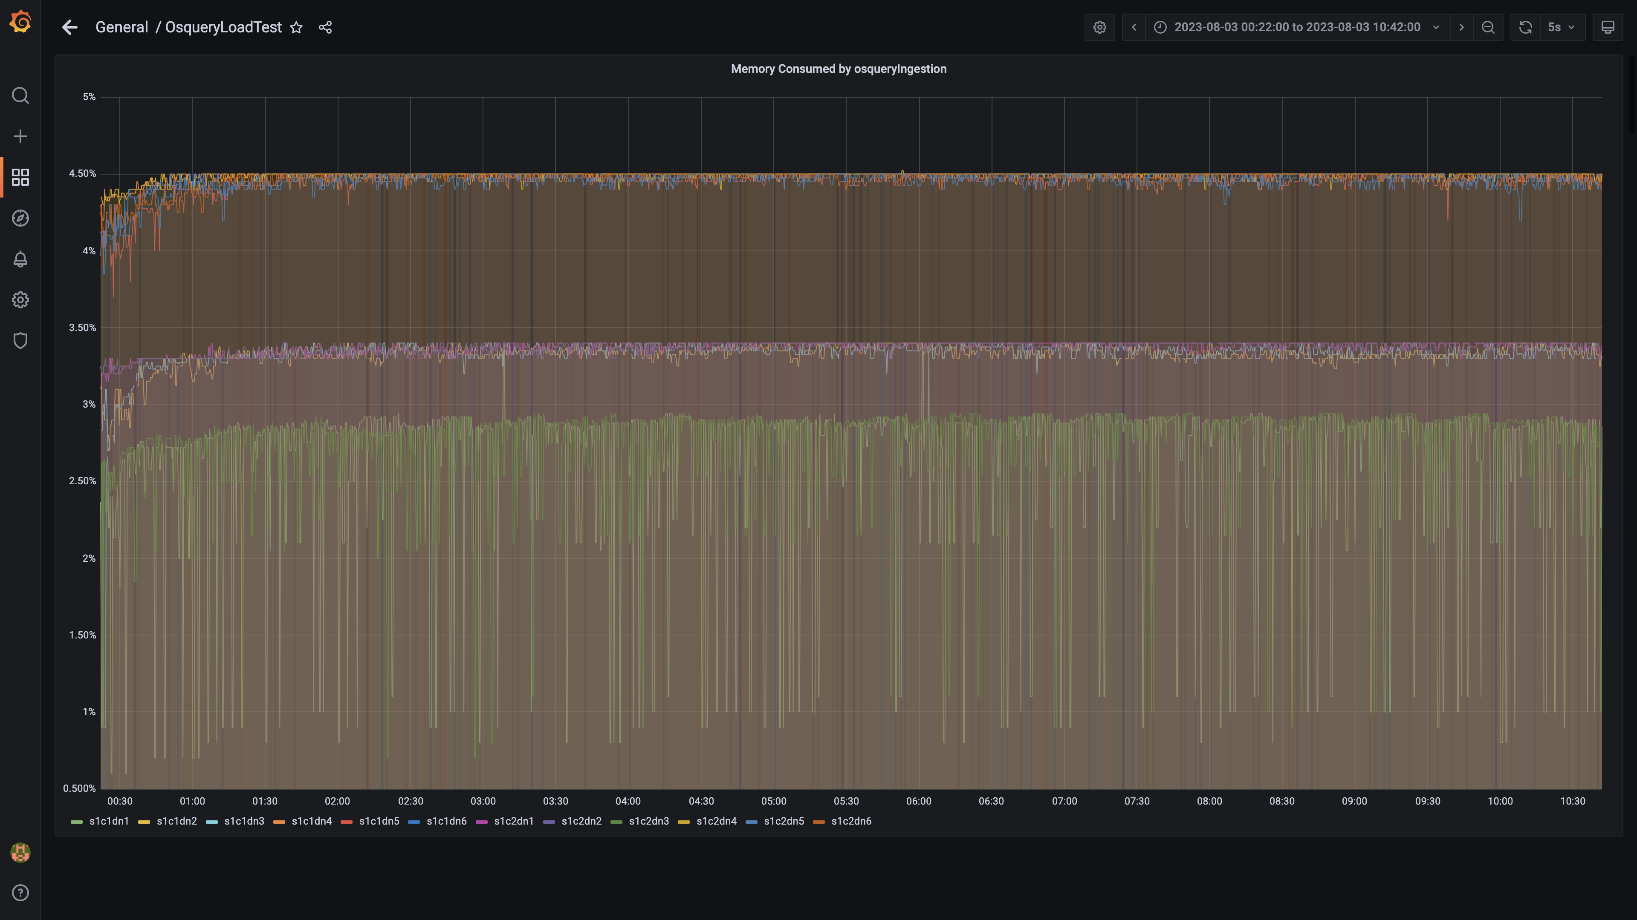

### Memory consumed by spark-worker

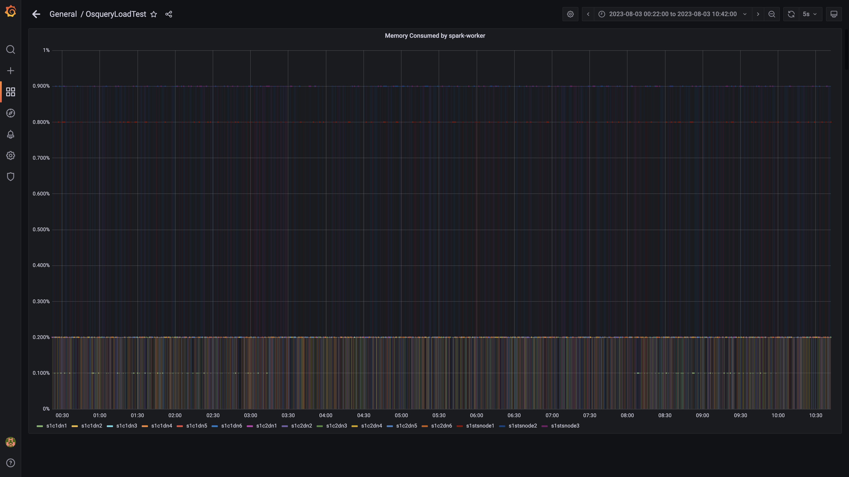

### Memory consumed by ruleengine

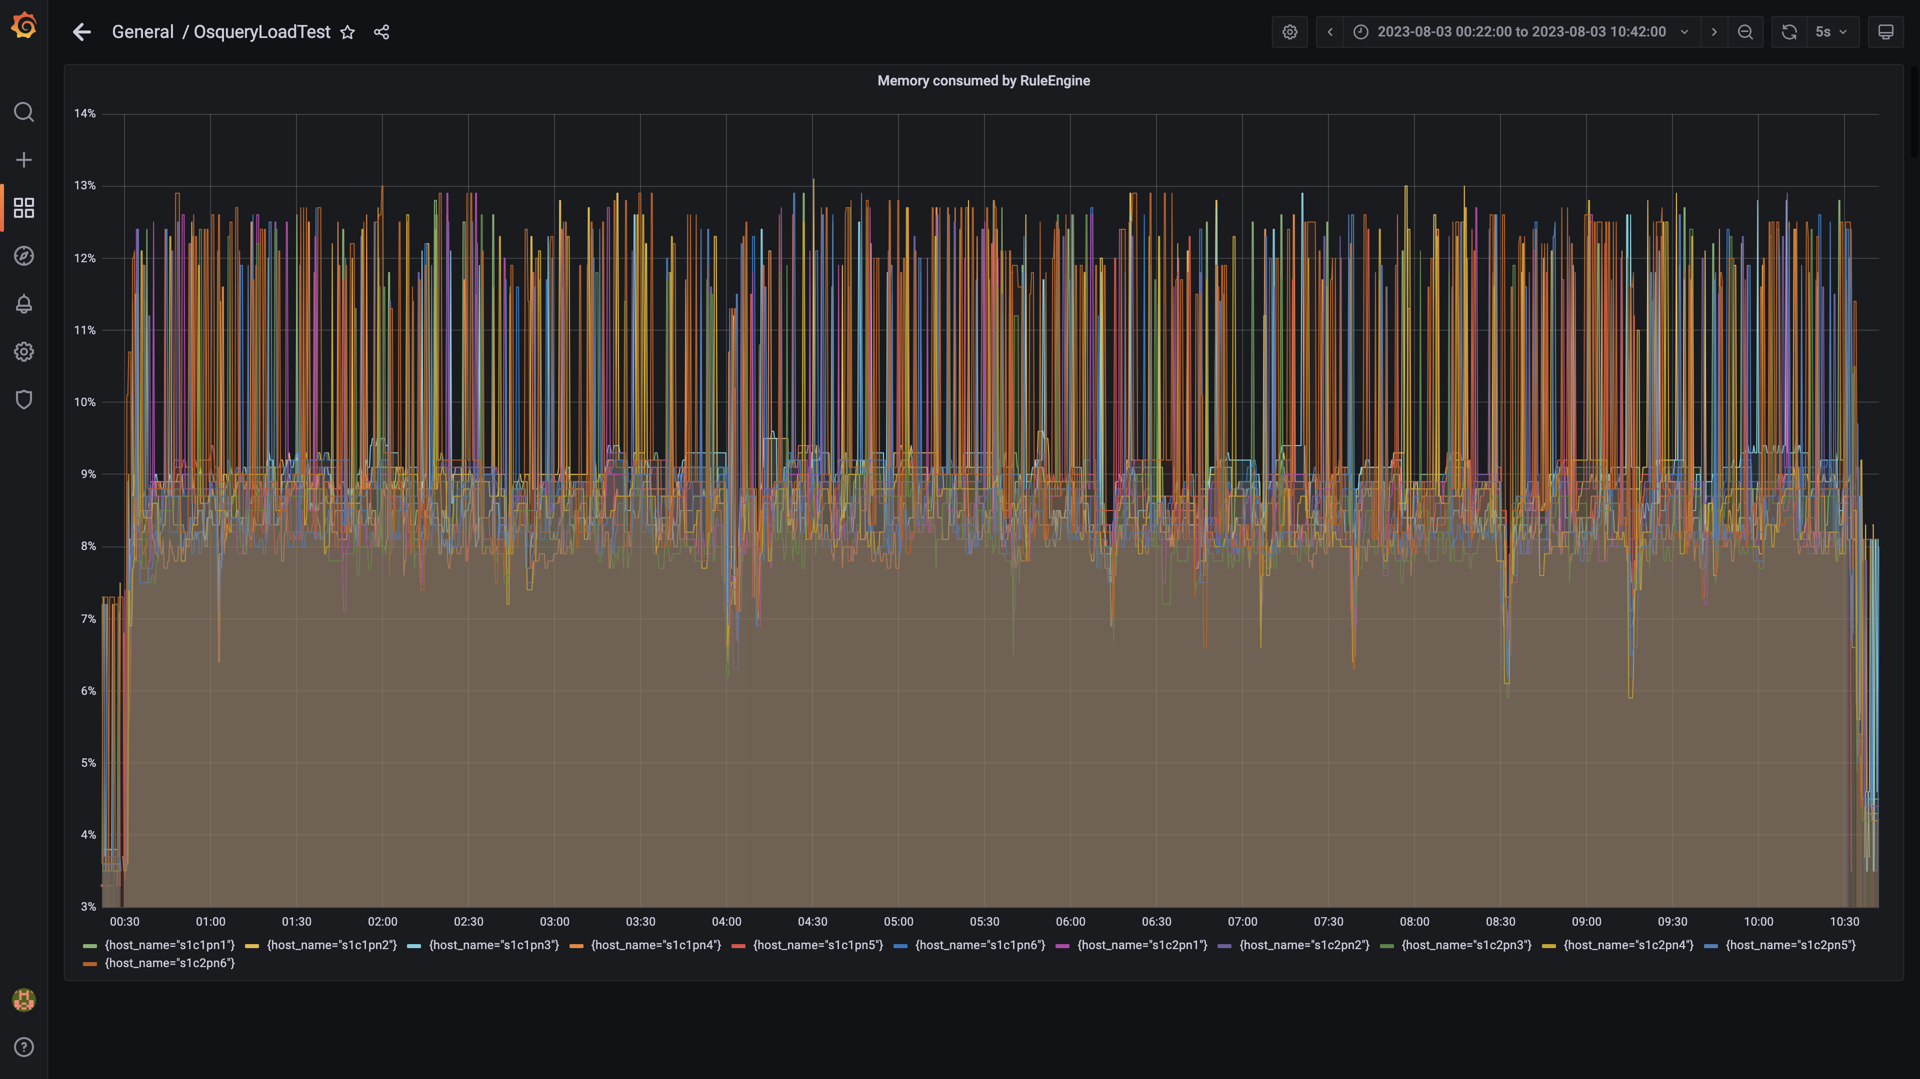

### Memory consumed by configdb

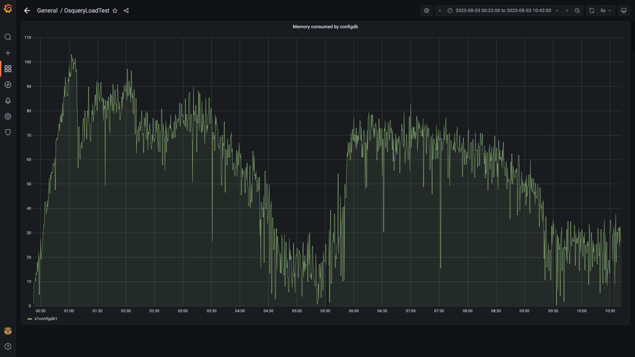

### Memory consumed by data archival

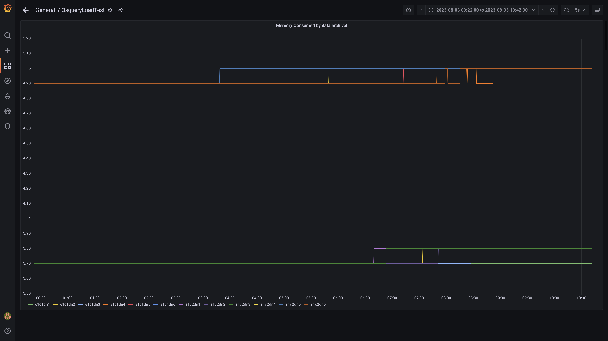

### Debezium memory usage

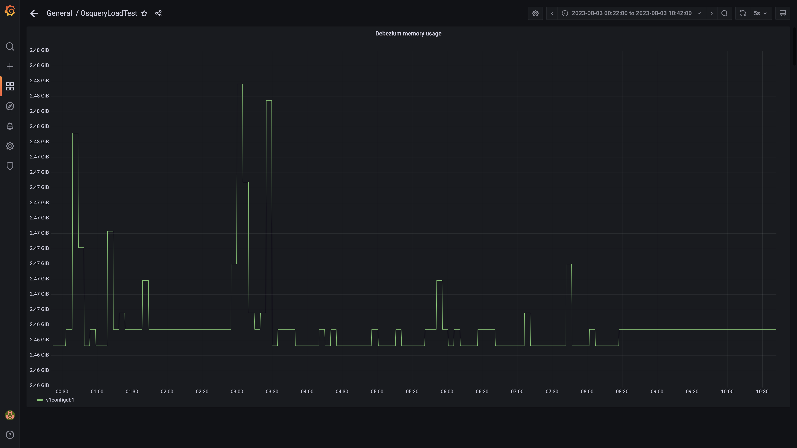

### Memory consumed by redis server

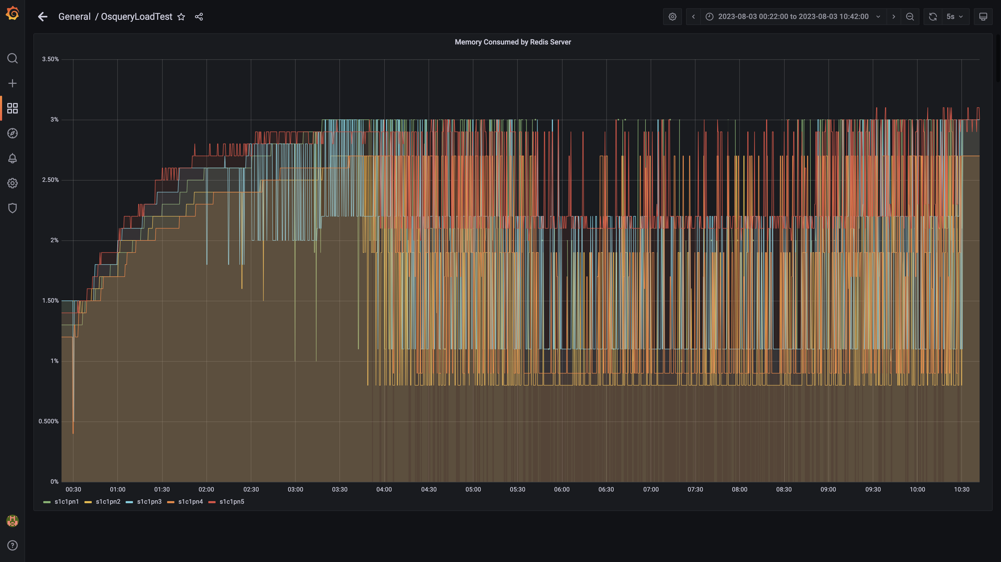

### Memory consumed by tls

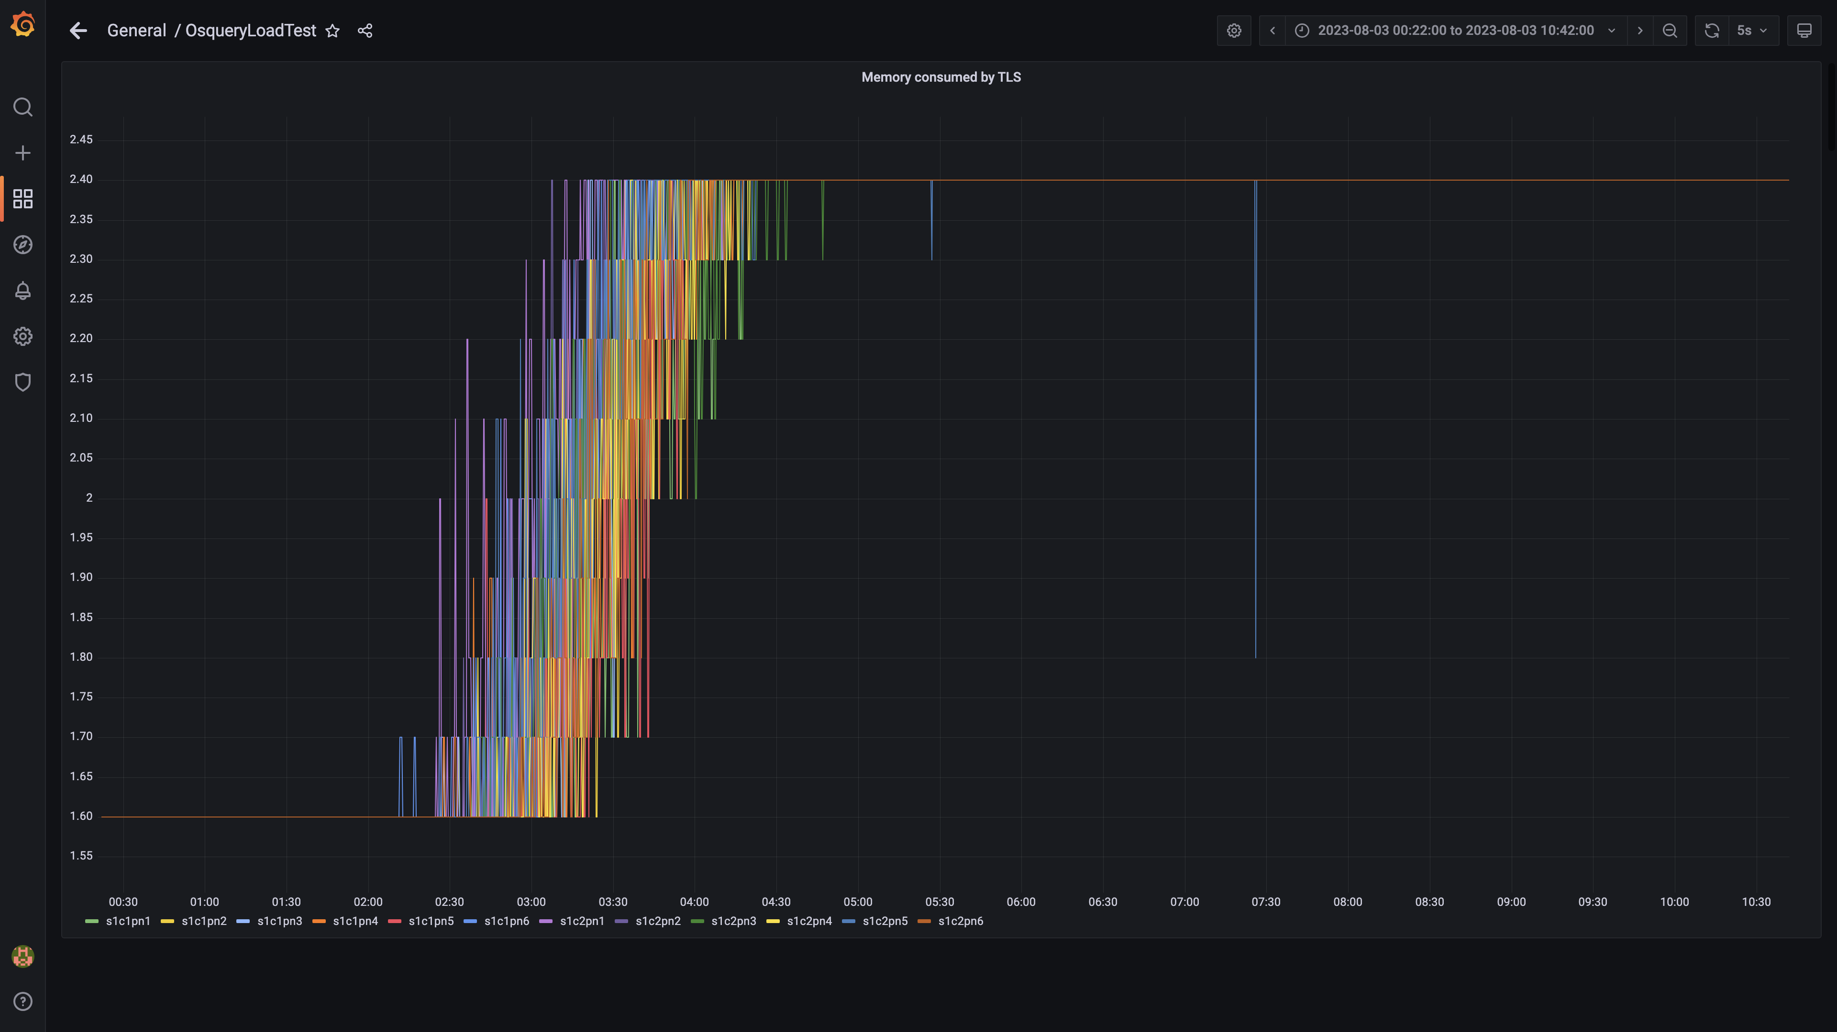

### Airflow memory usage

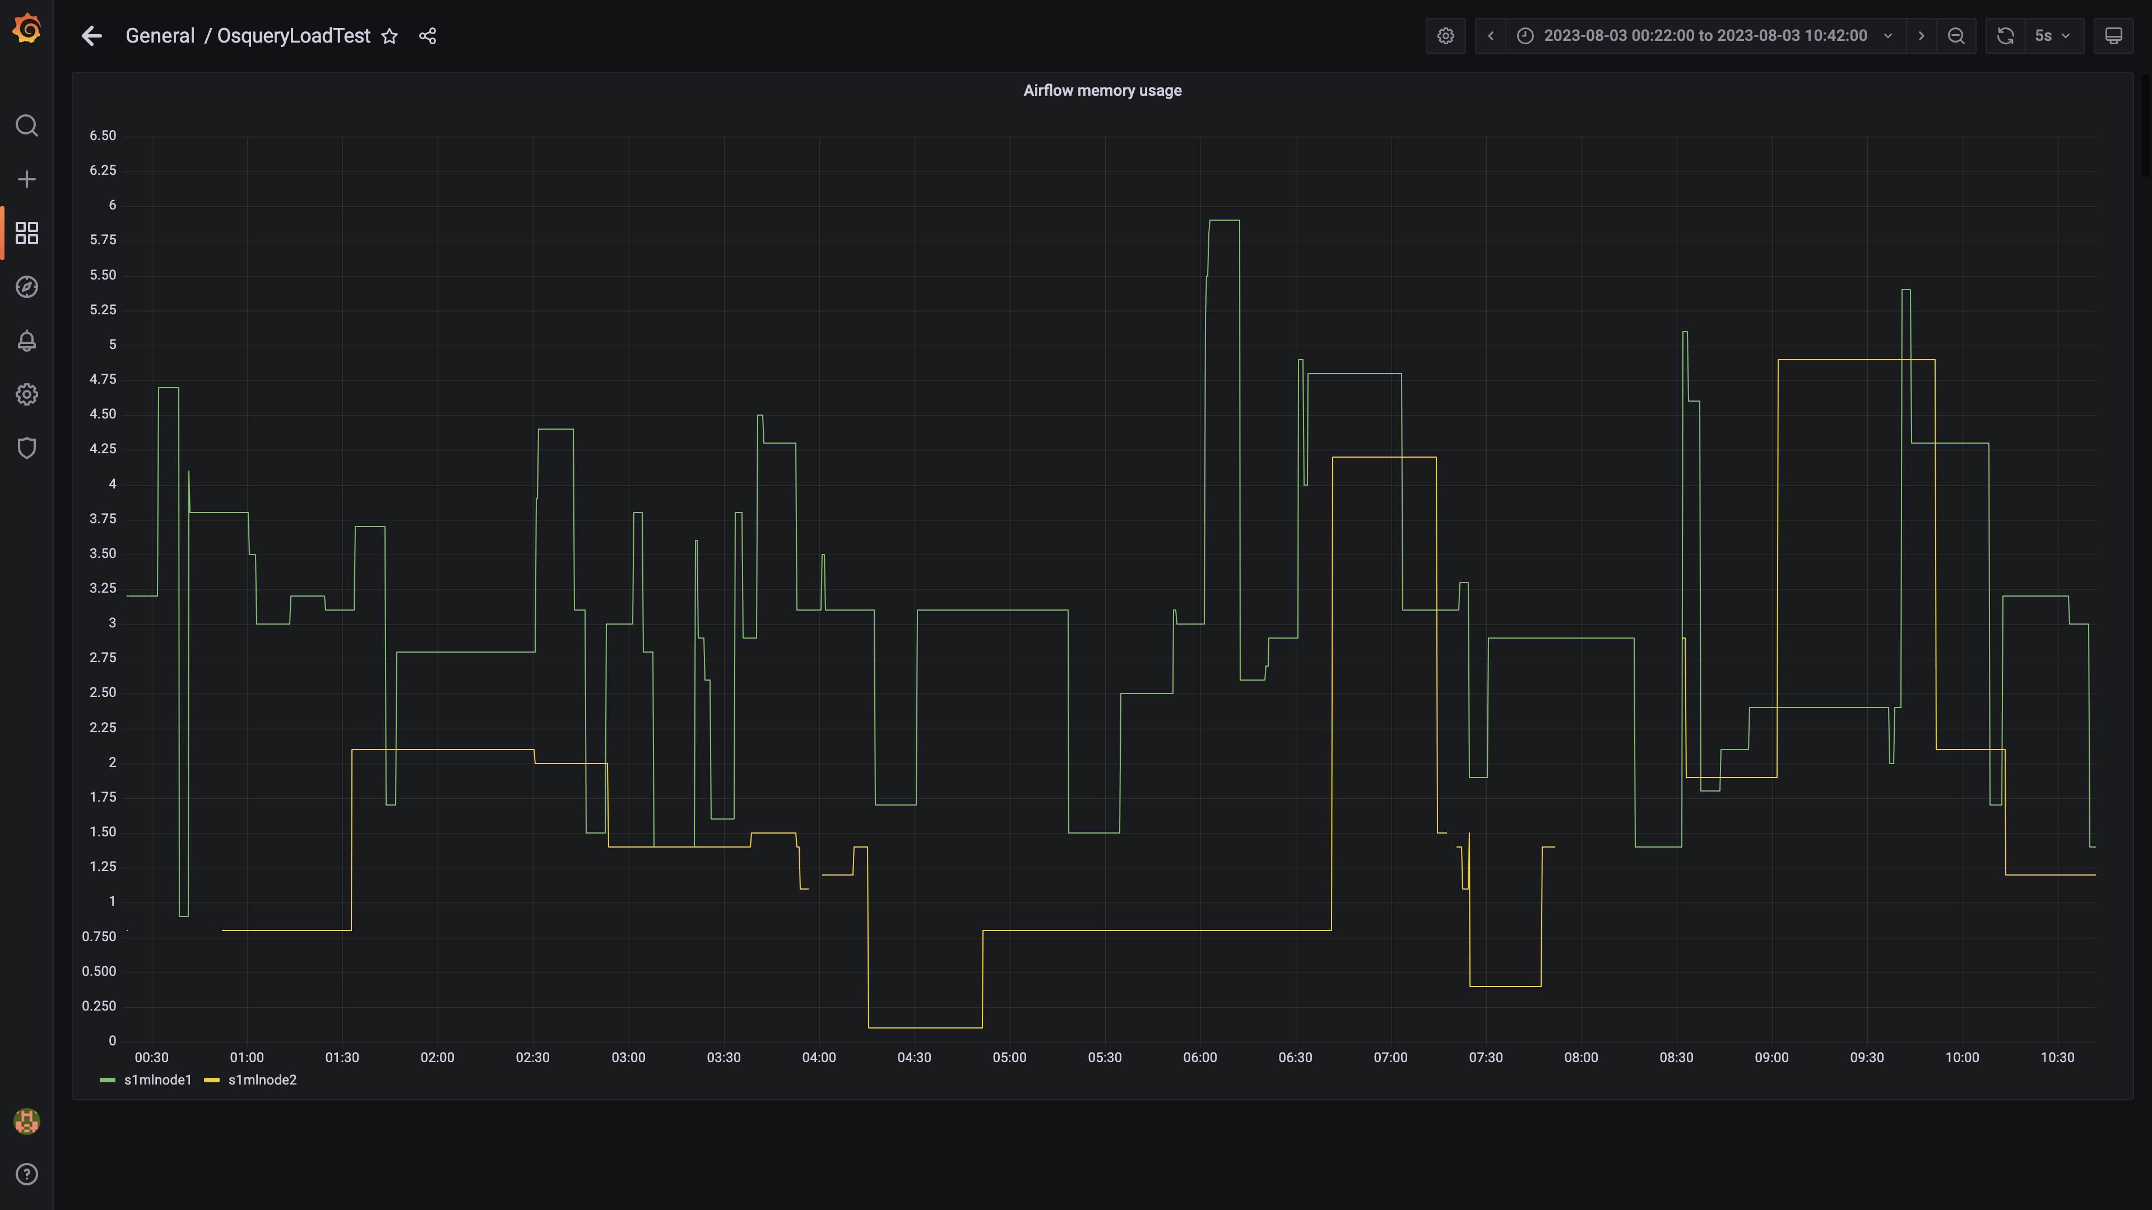

### Postgres node cpu busy percent

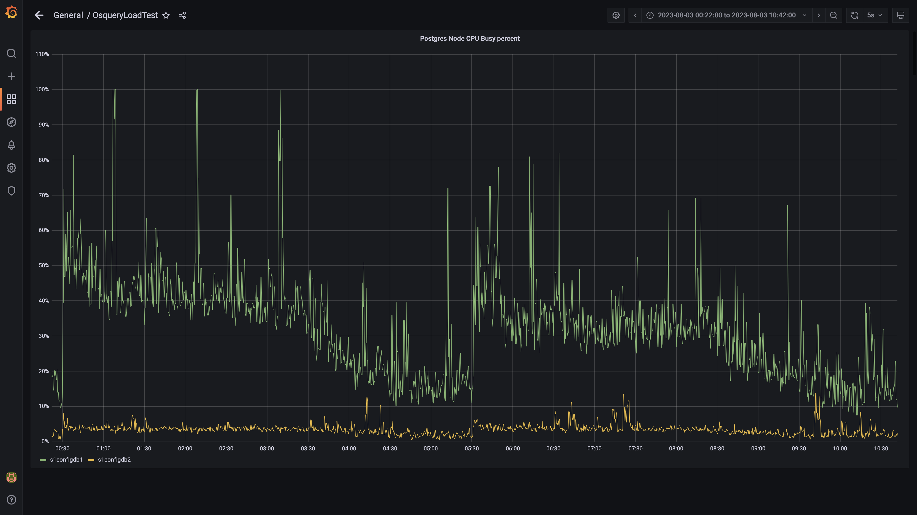

### Process node cpu busy percent

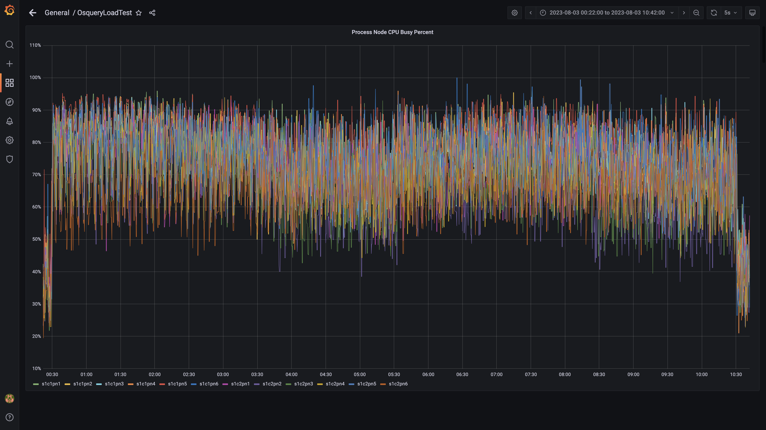

### Data node cpu busy percent

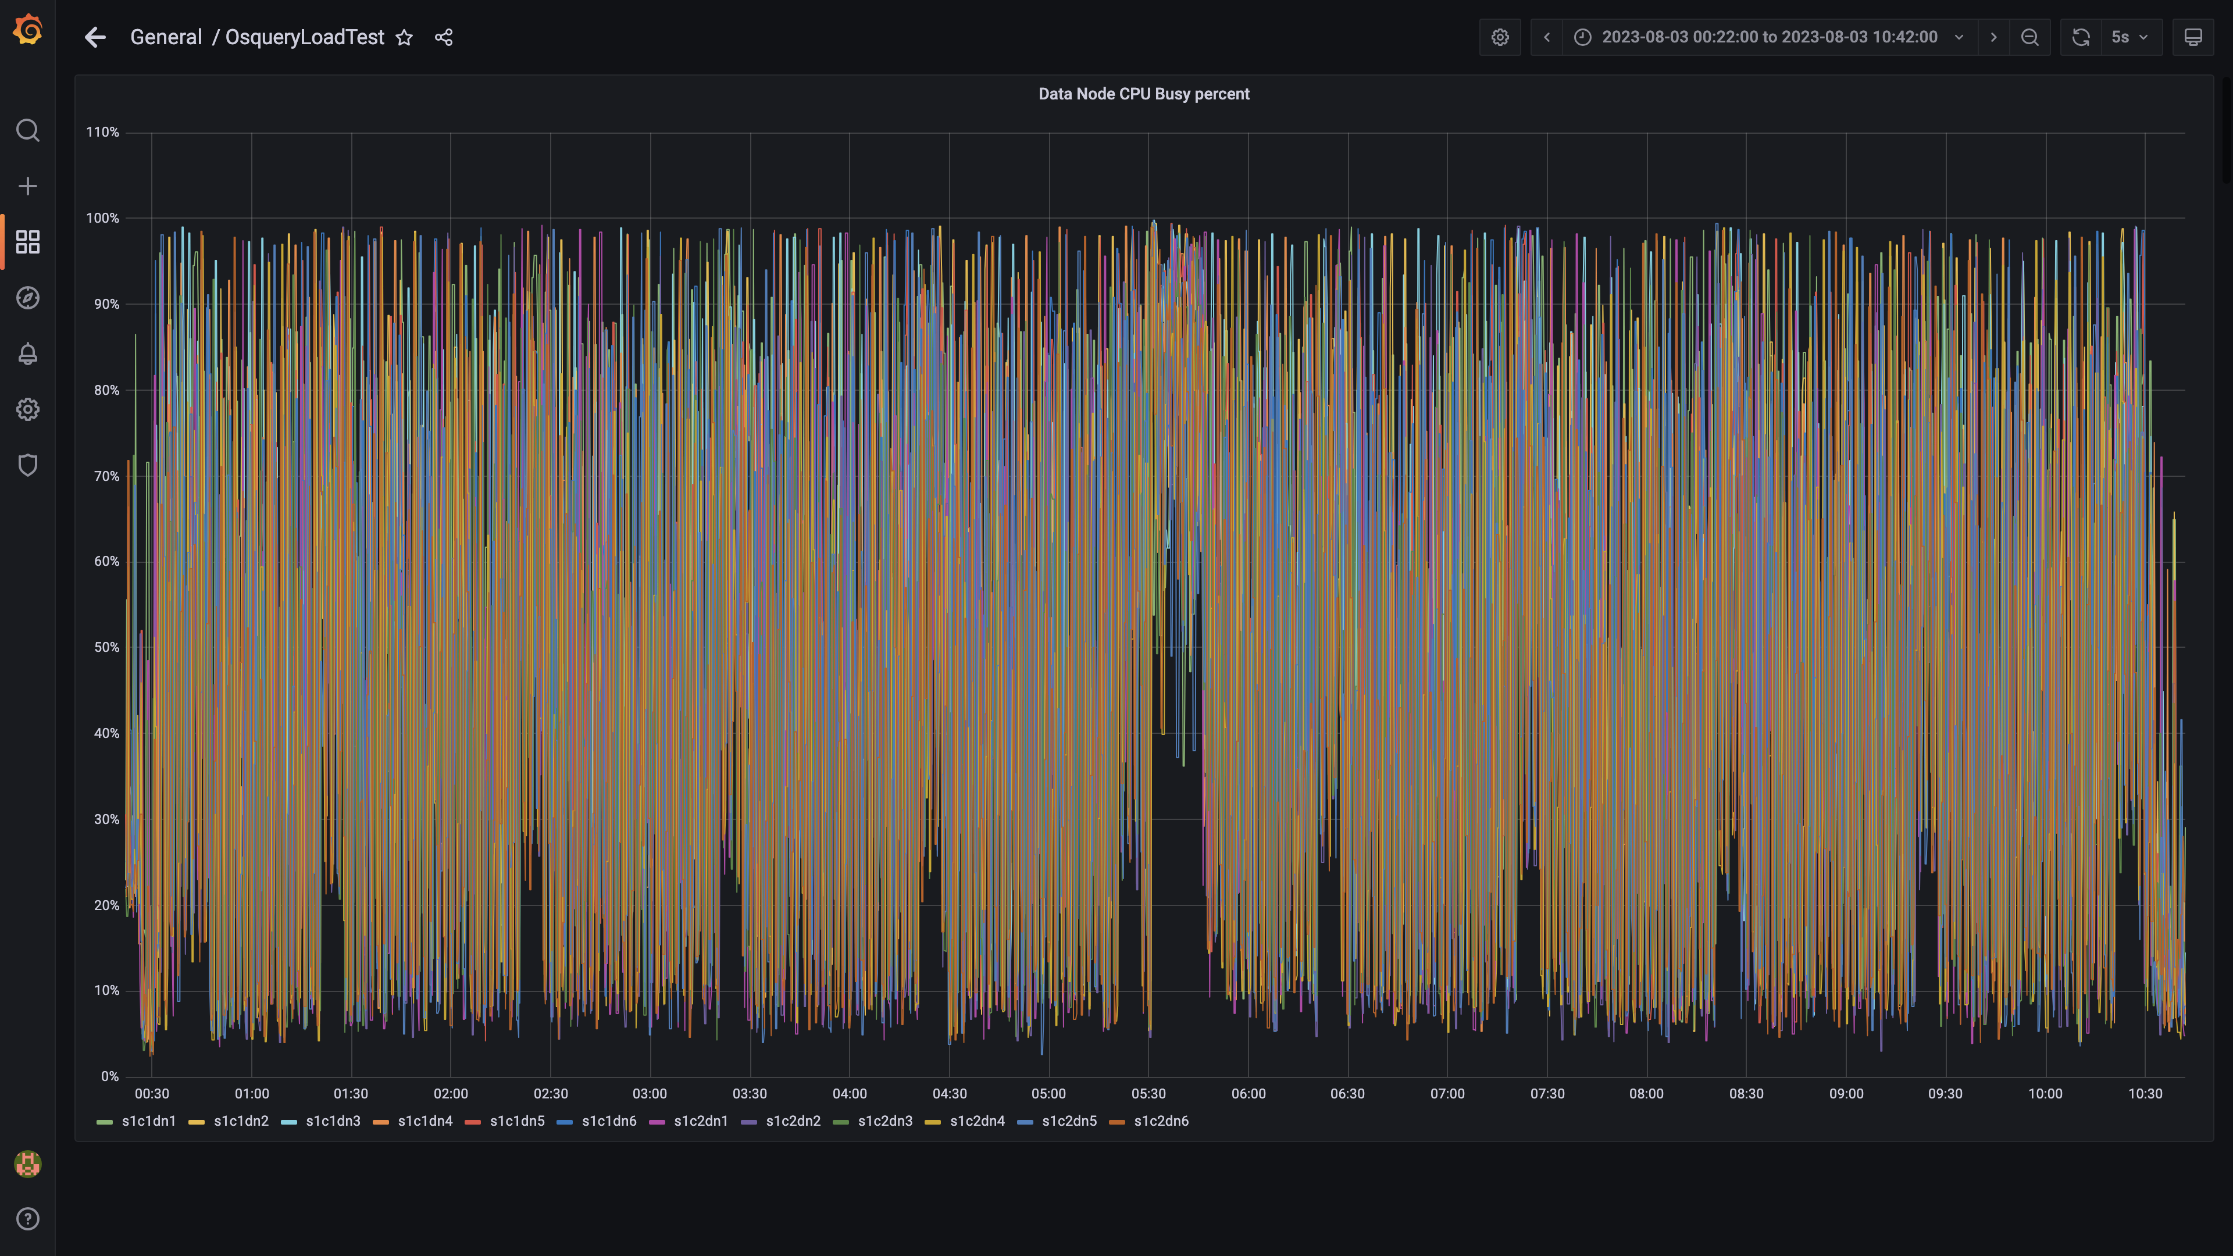

### Postgres-configdb cpu used percentage

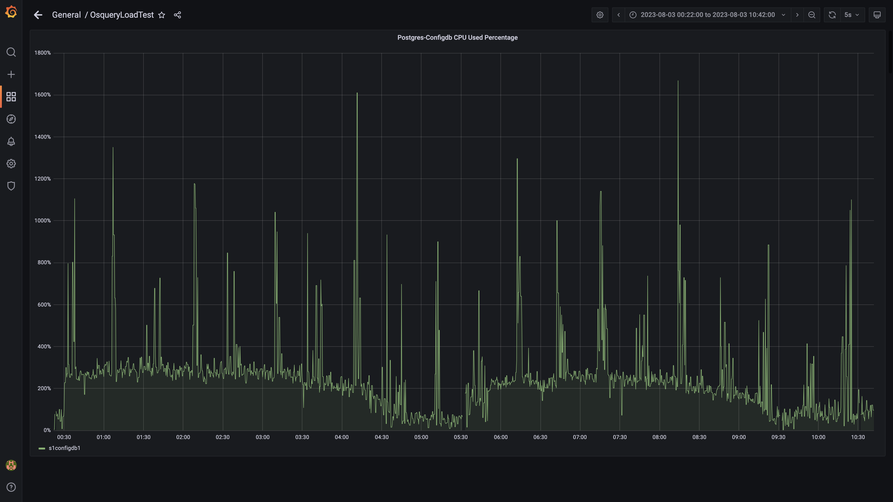

### Pgbouncer cpu used percentage

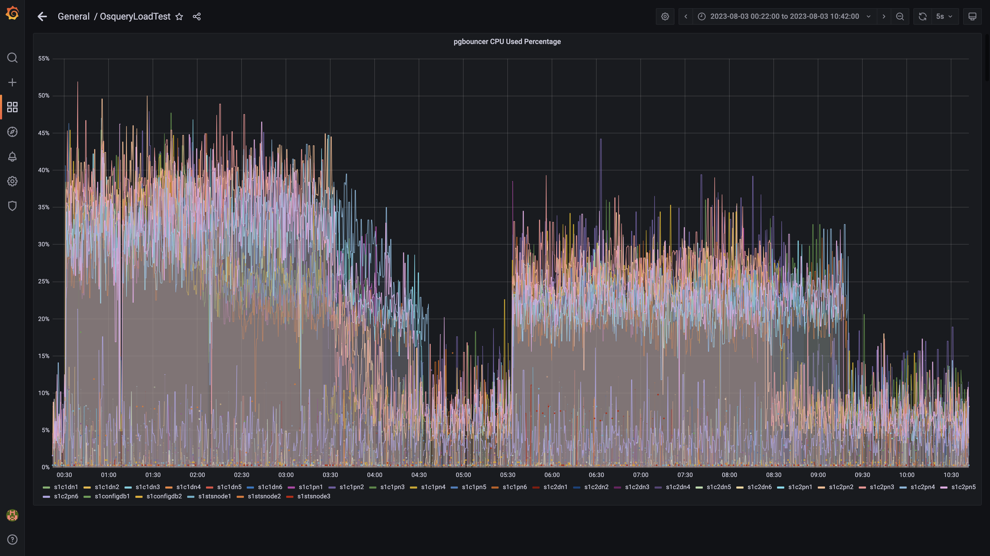

### Cpu consumed by eventsdbingestion

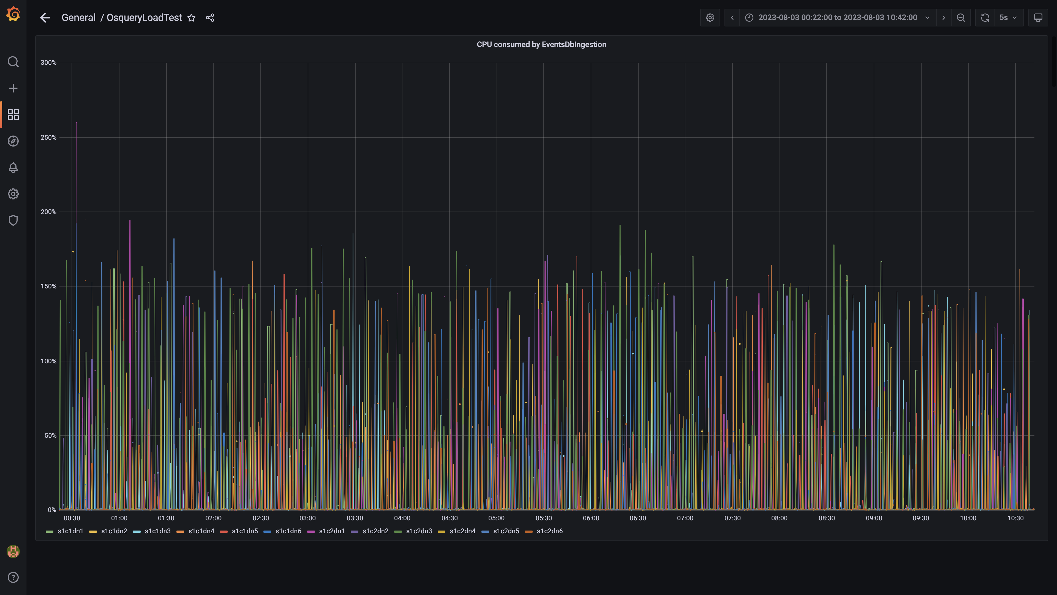

### Cpu consumed by pushgateway

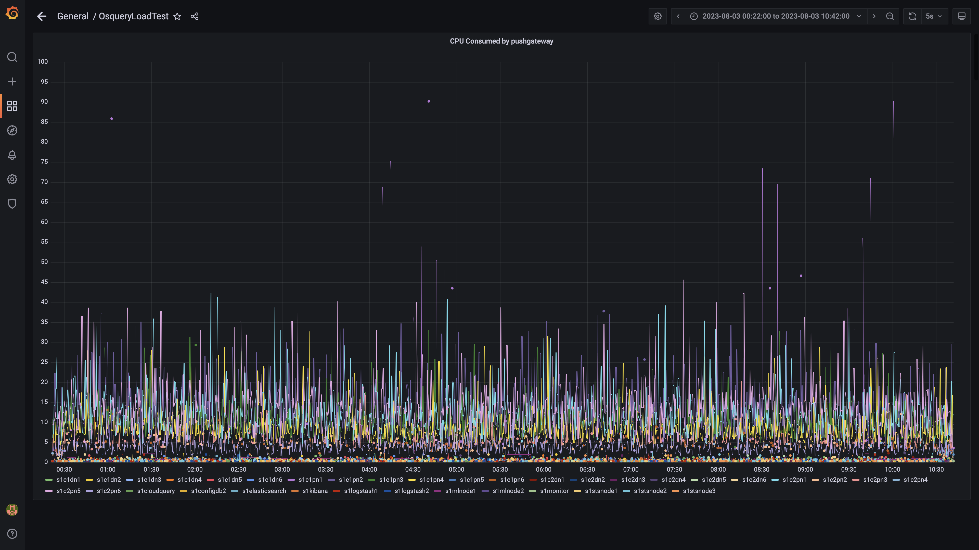

### Cpu consumed by ruleengine

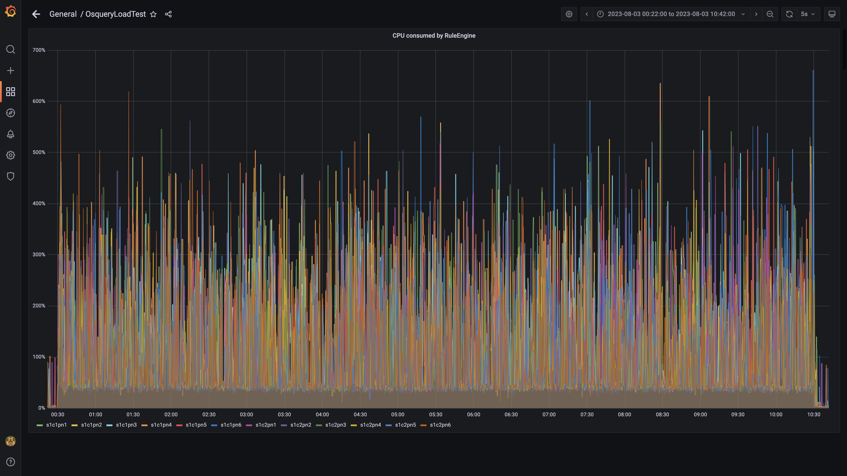

### Kafka cpu used percentage

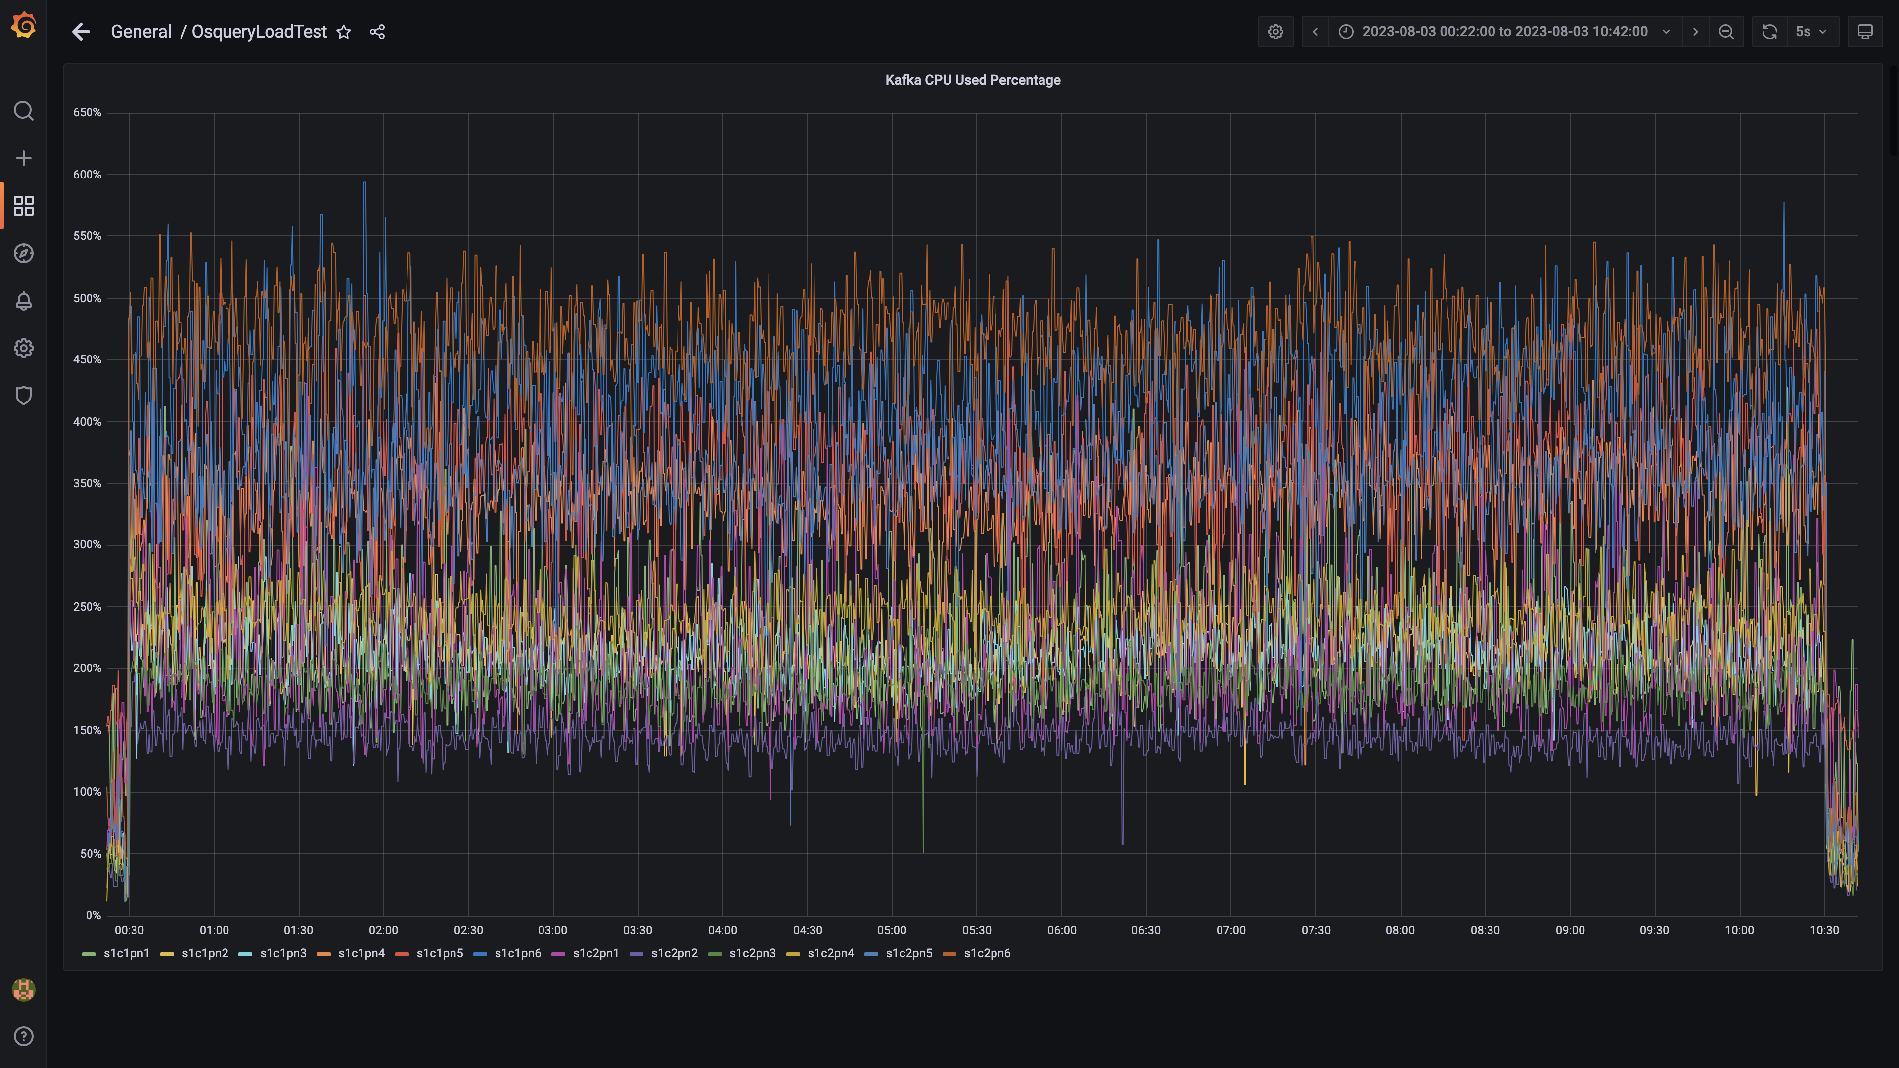

### Cpu used by data-archival

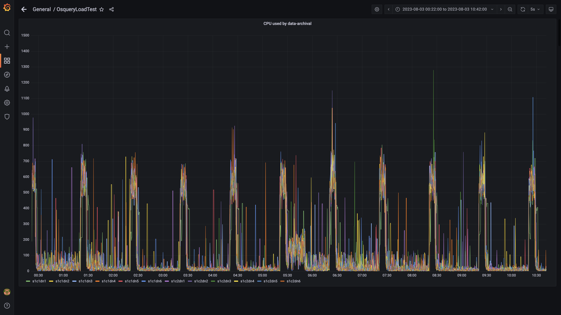

### Cpu consumed by osqueryingestion

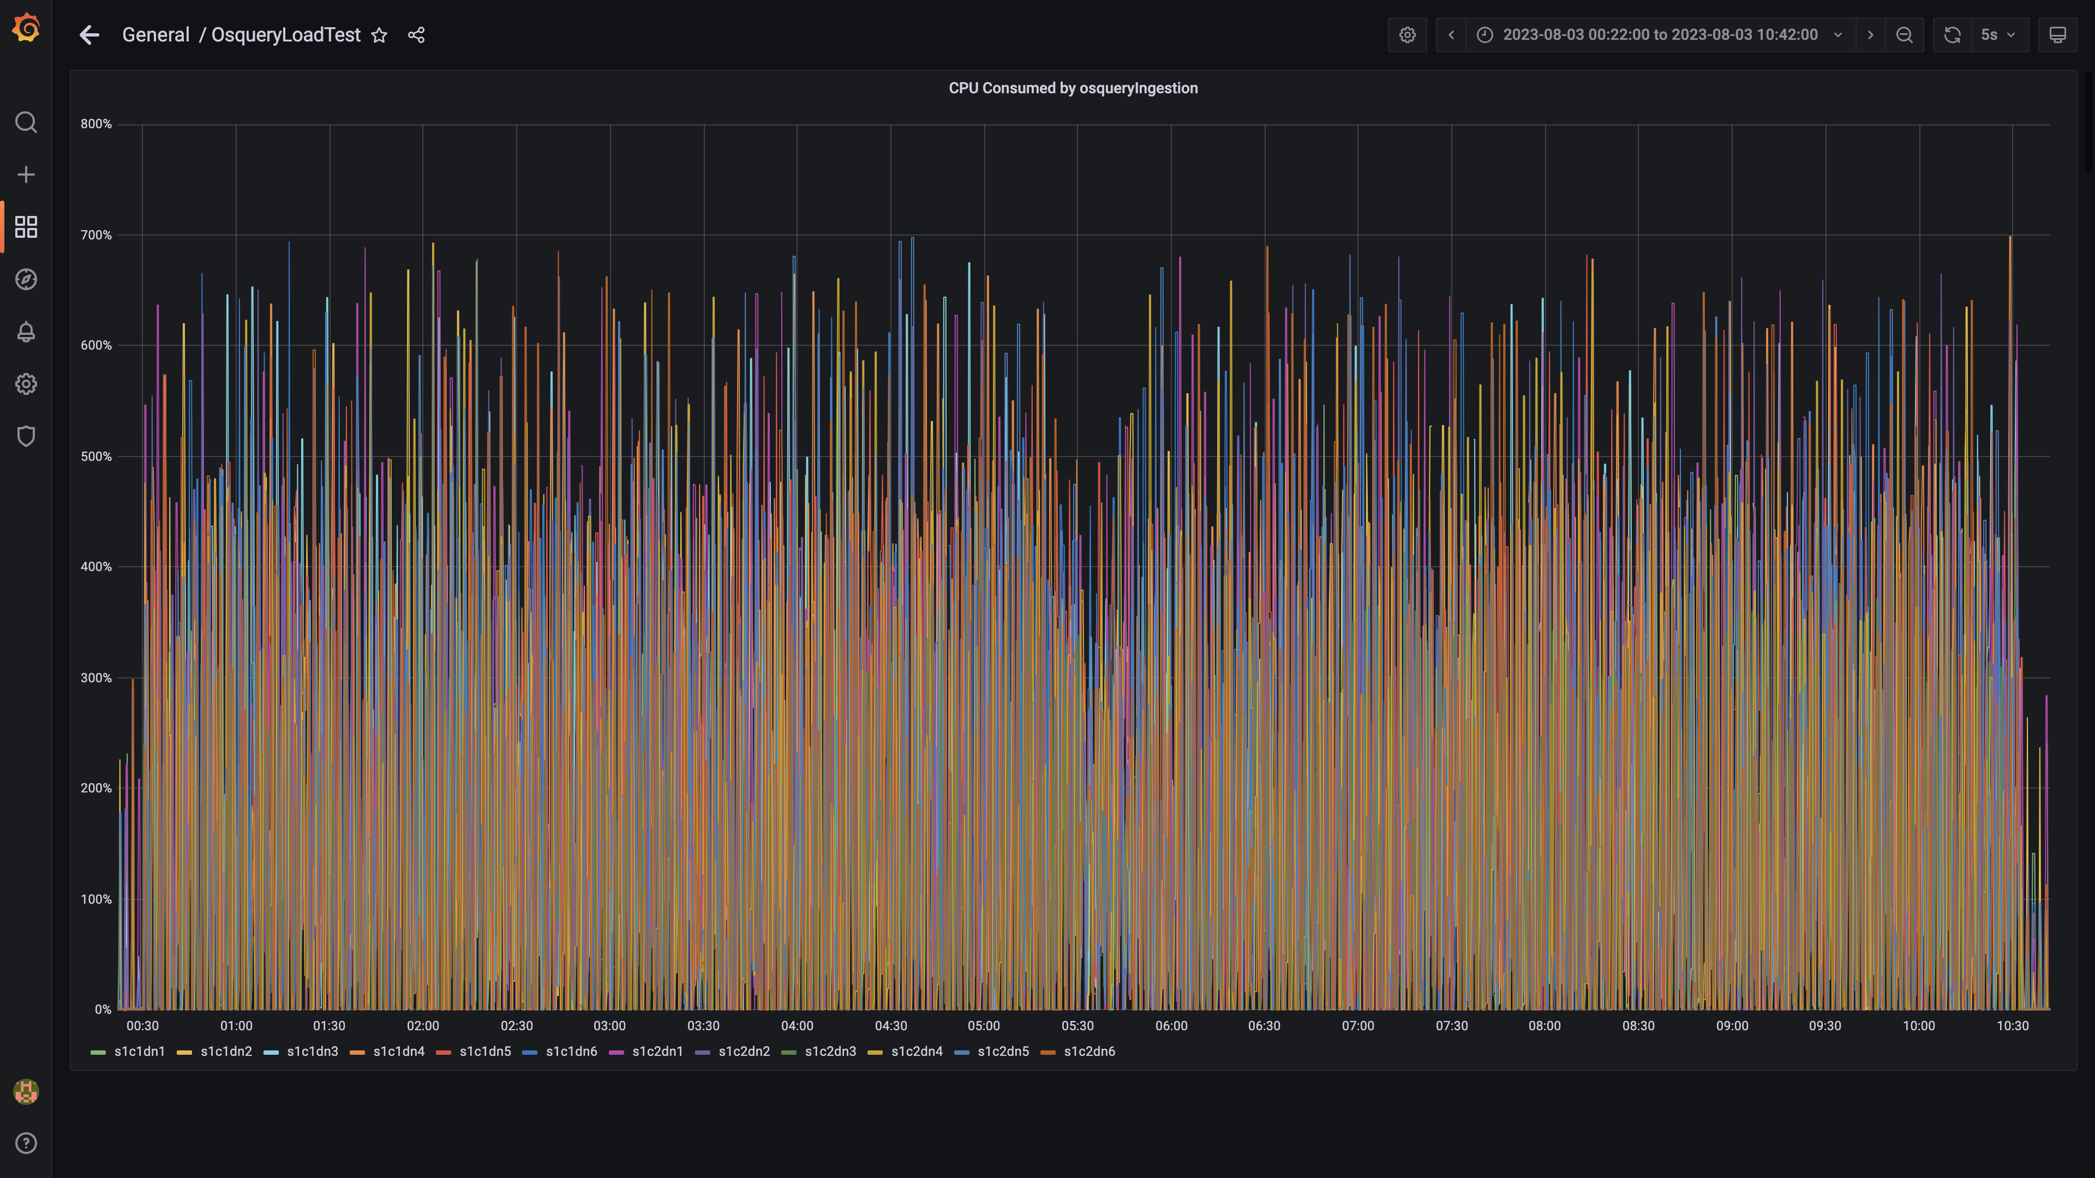

### Cpu consumed by redis server

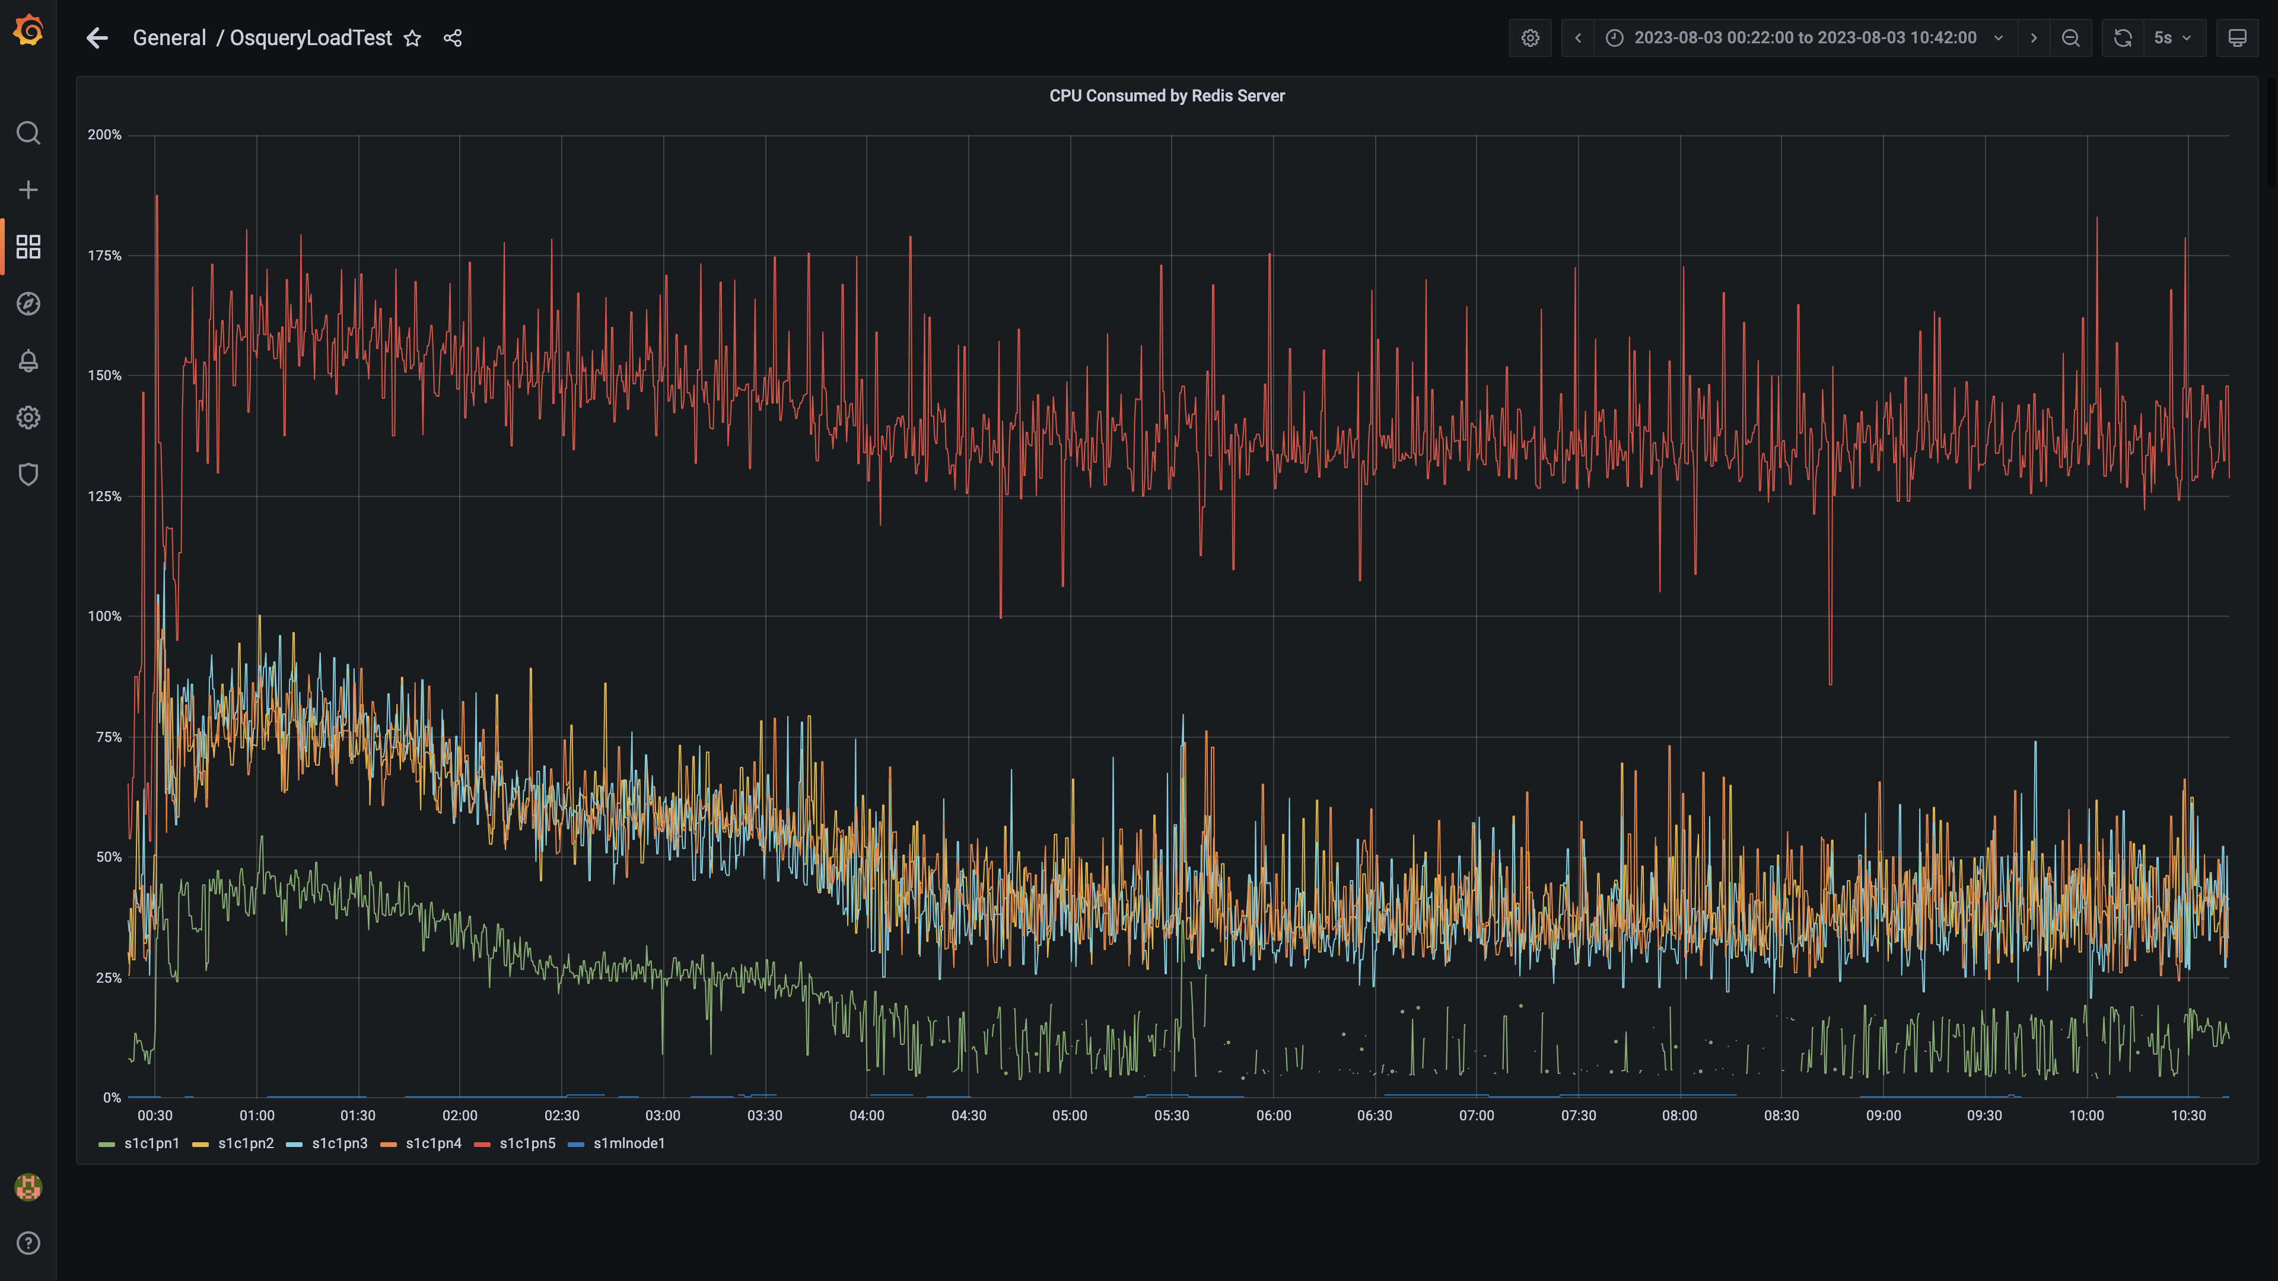

### Cpu consumed by orc-compaction

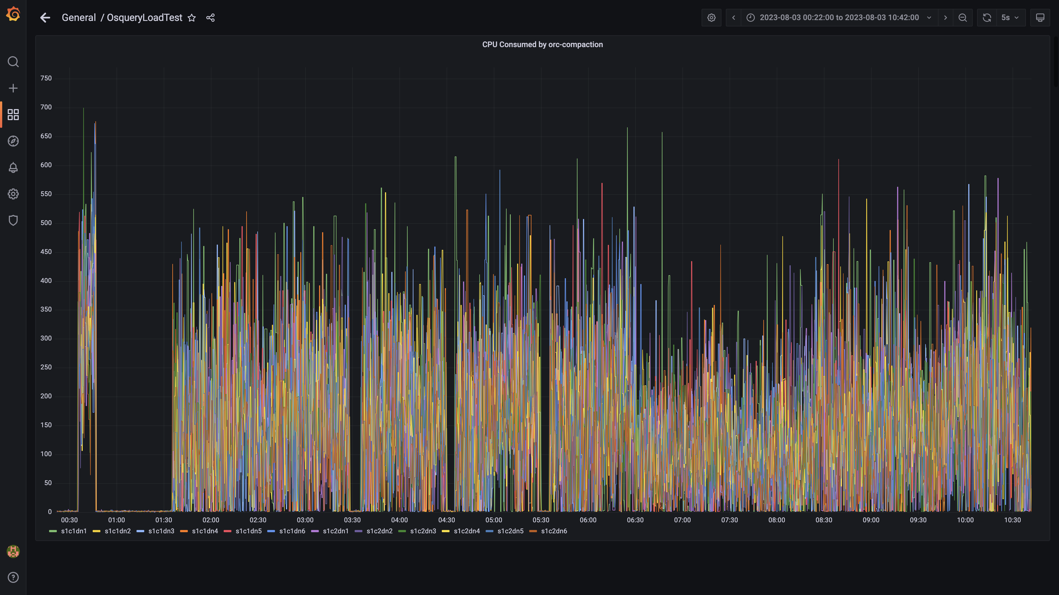

### Cpu consumed by spark-worker

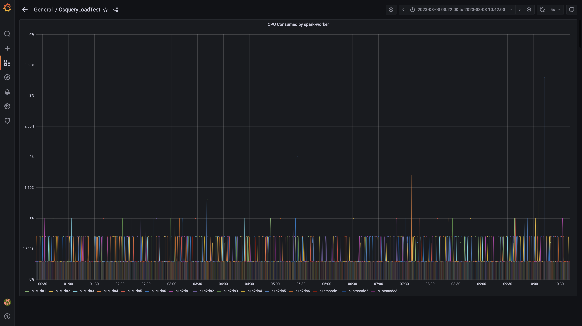

### Cpu consumed by logger

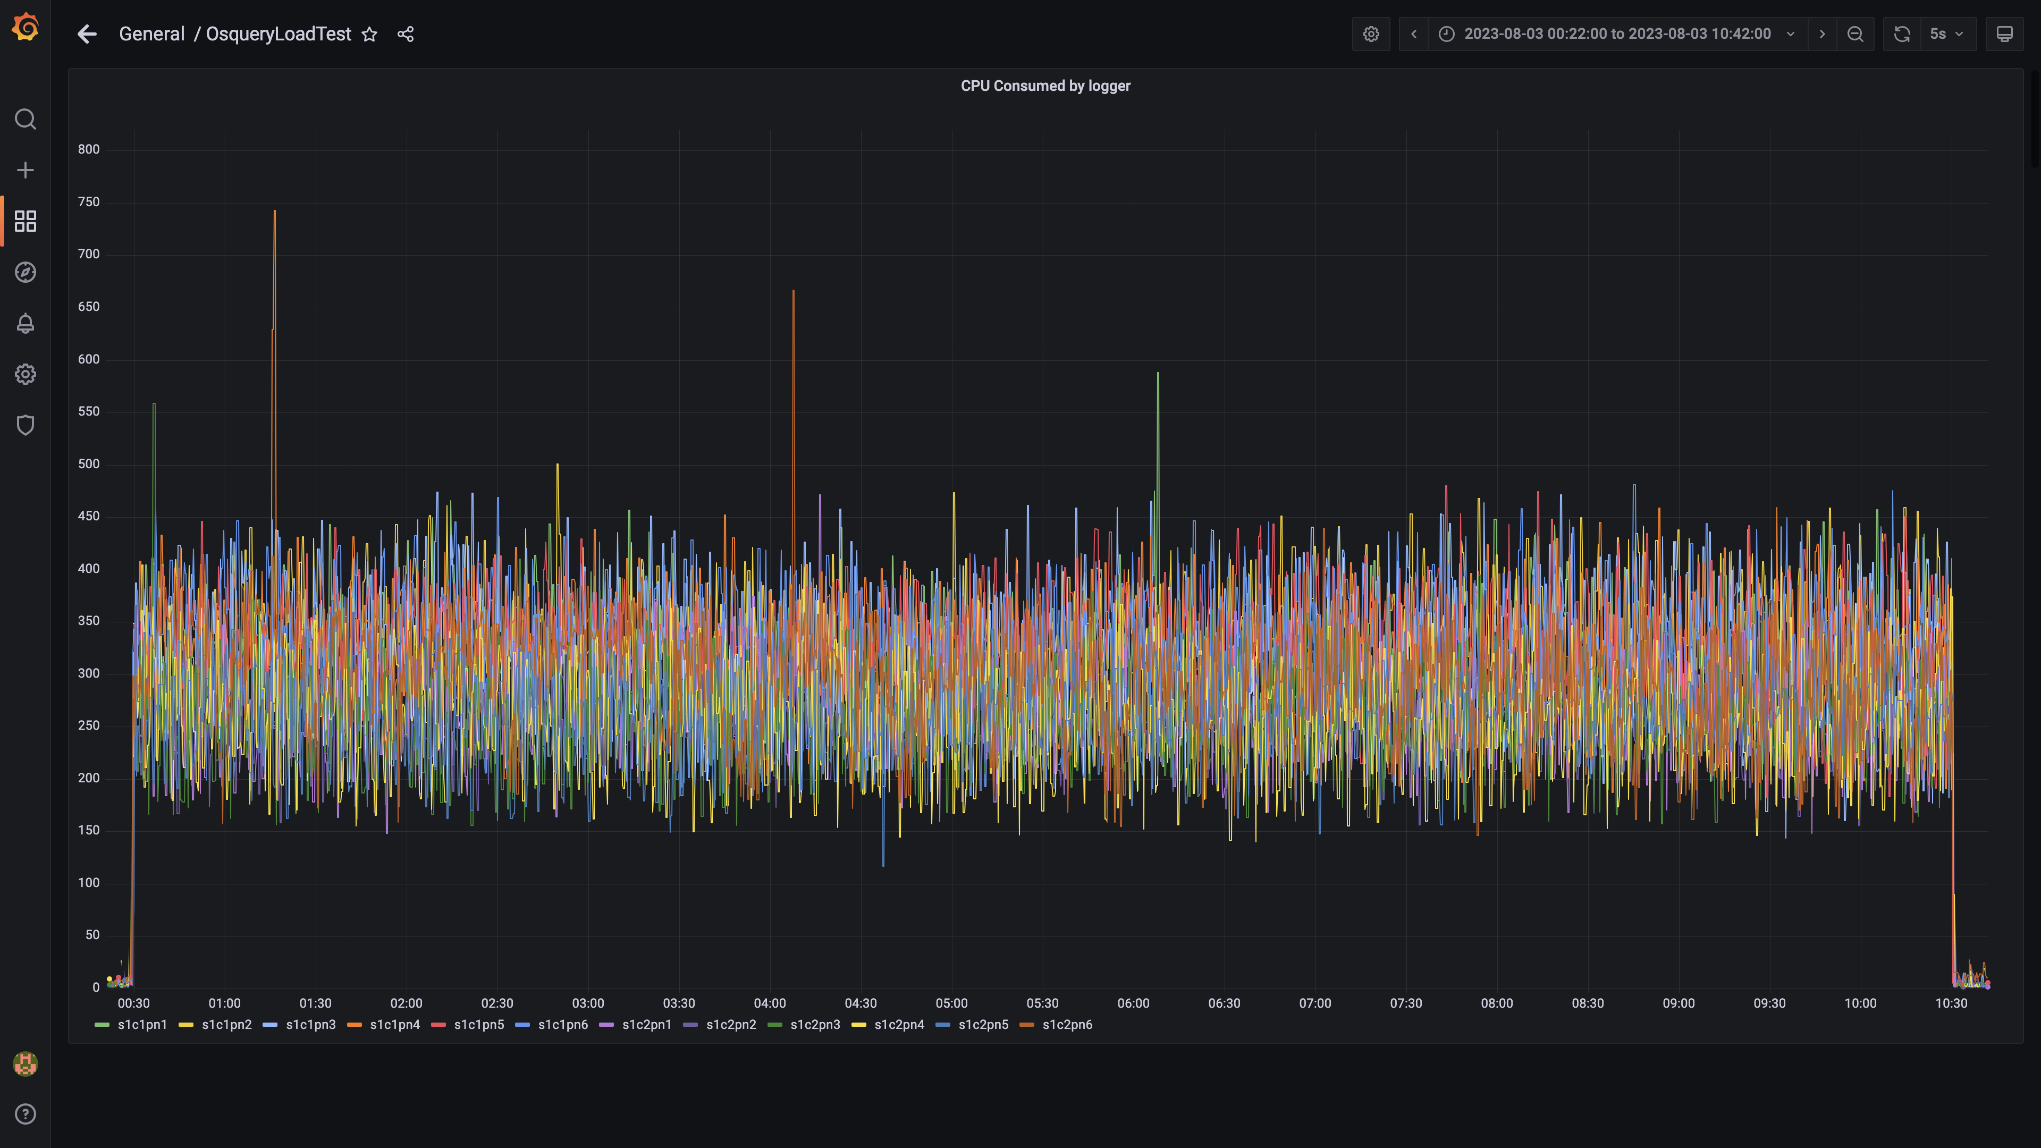

### Compliance summary consumer cpu consumption

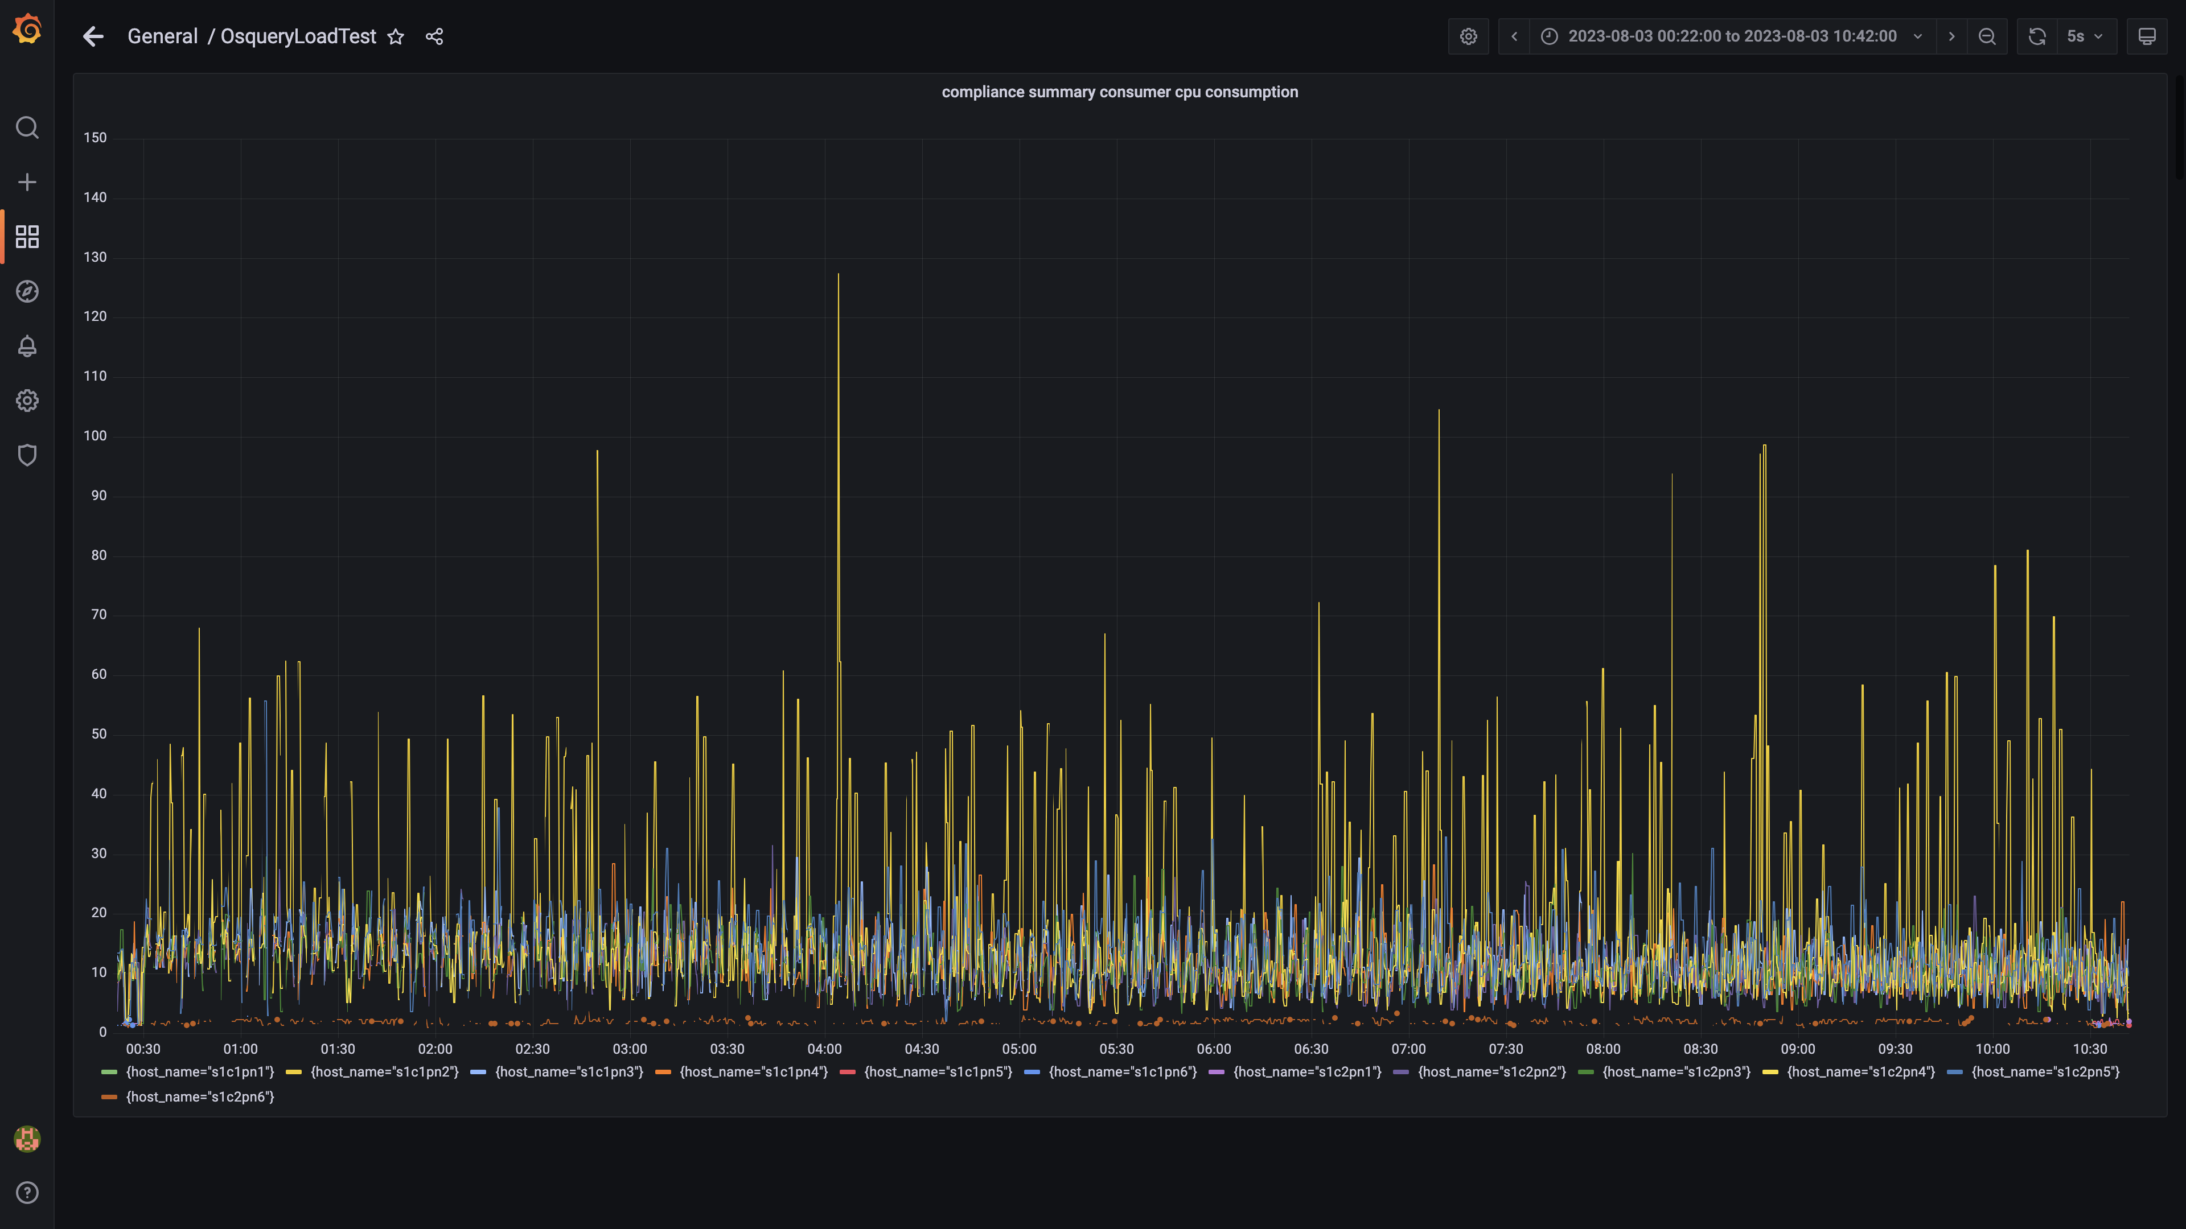

### Cpu consumed by trino

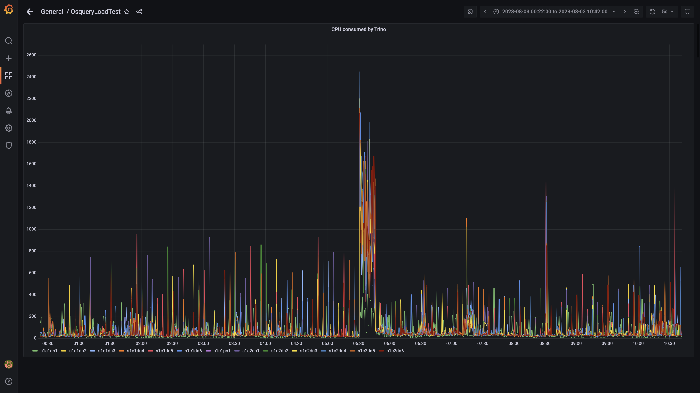

### Debezium cpu usage

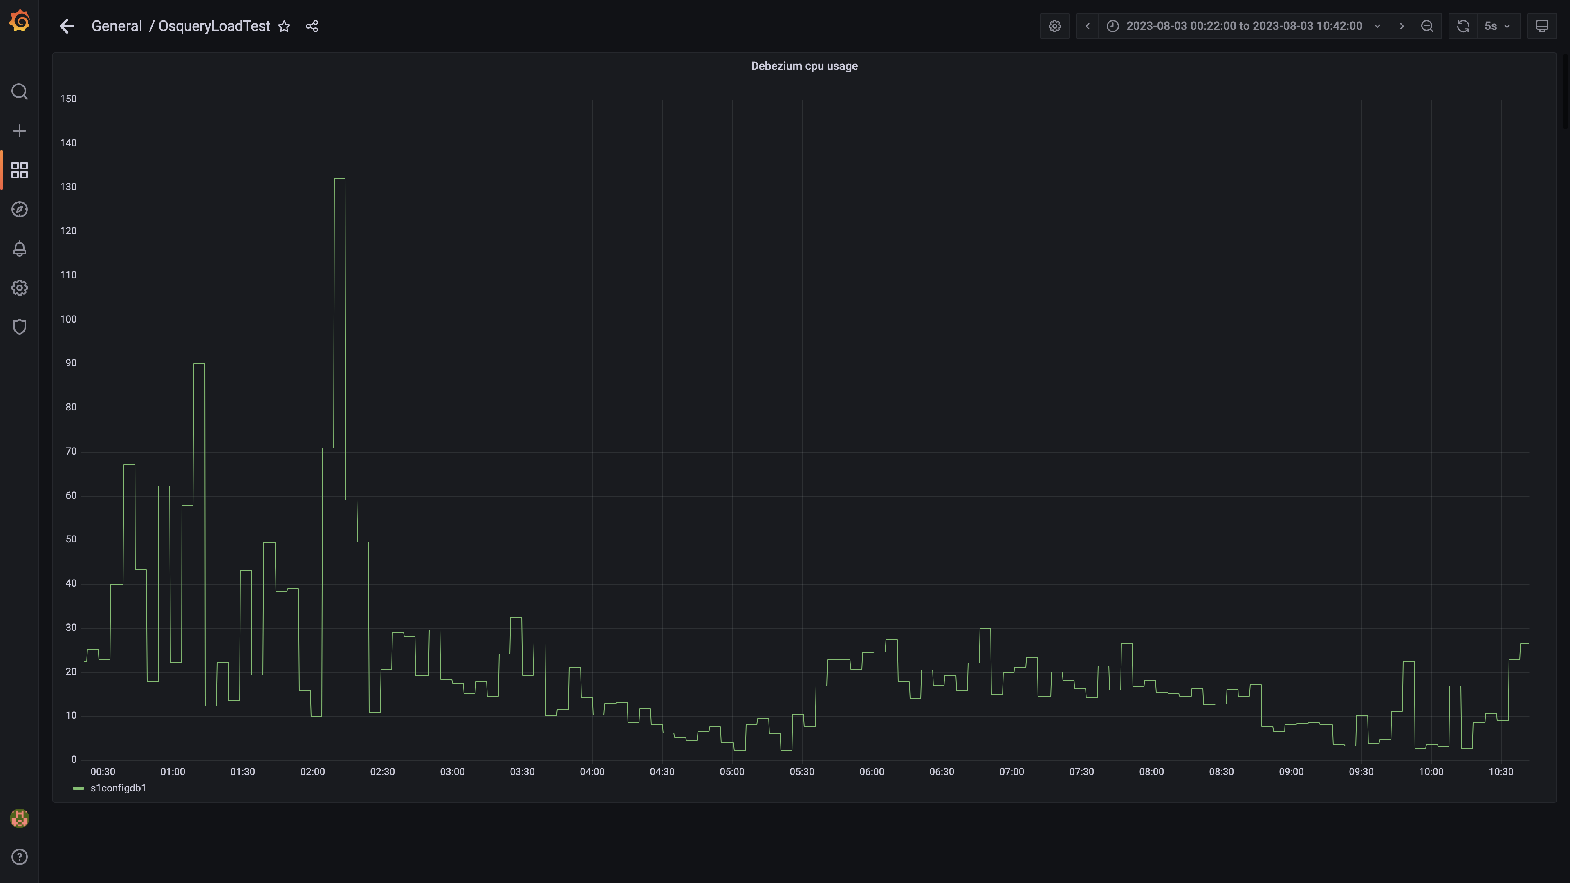

### Cpu consumed by spark-master

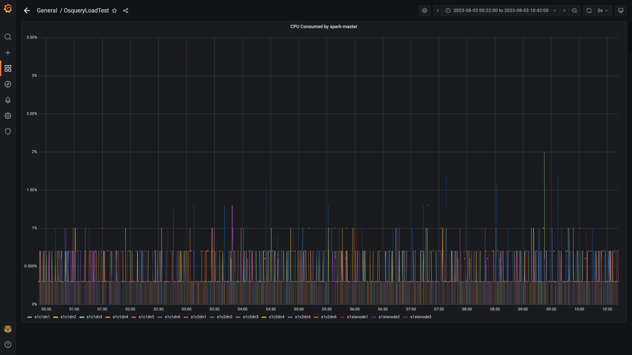

### Cpu consumed by tls

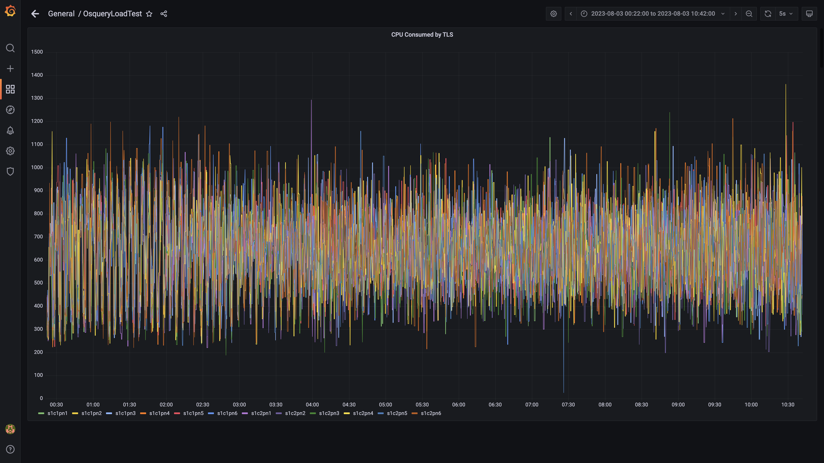

### Airflow cpu usage

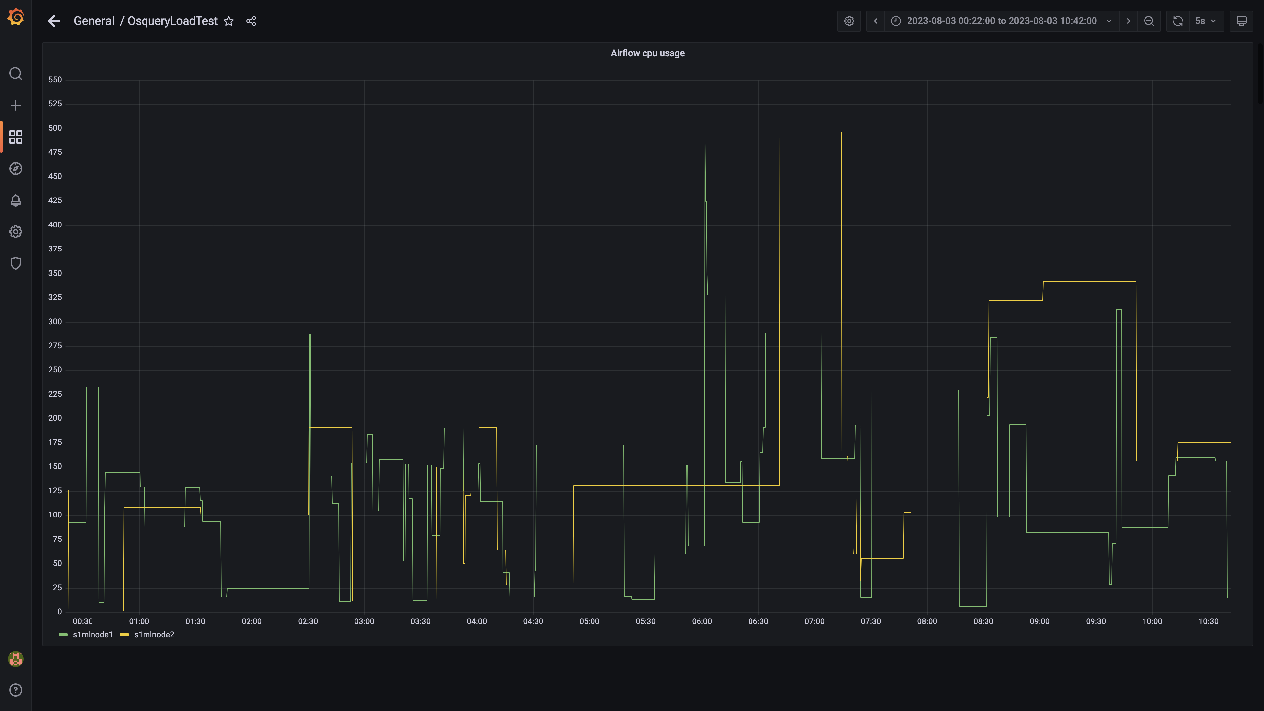

### Spark inject and drain rate agent osquery

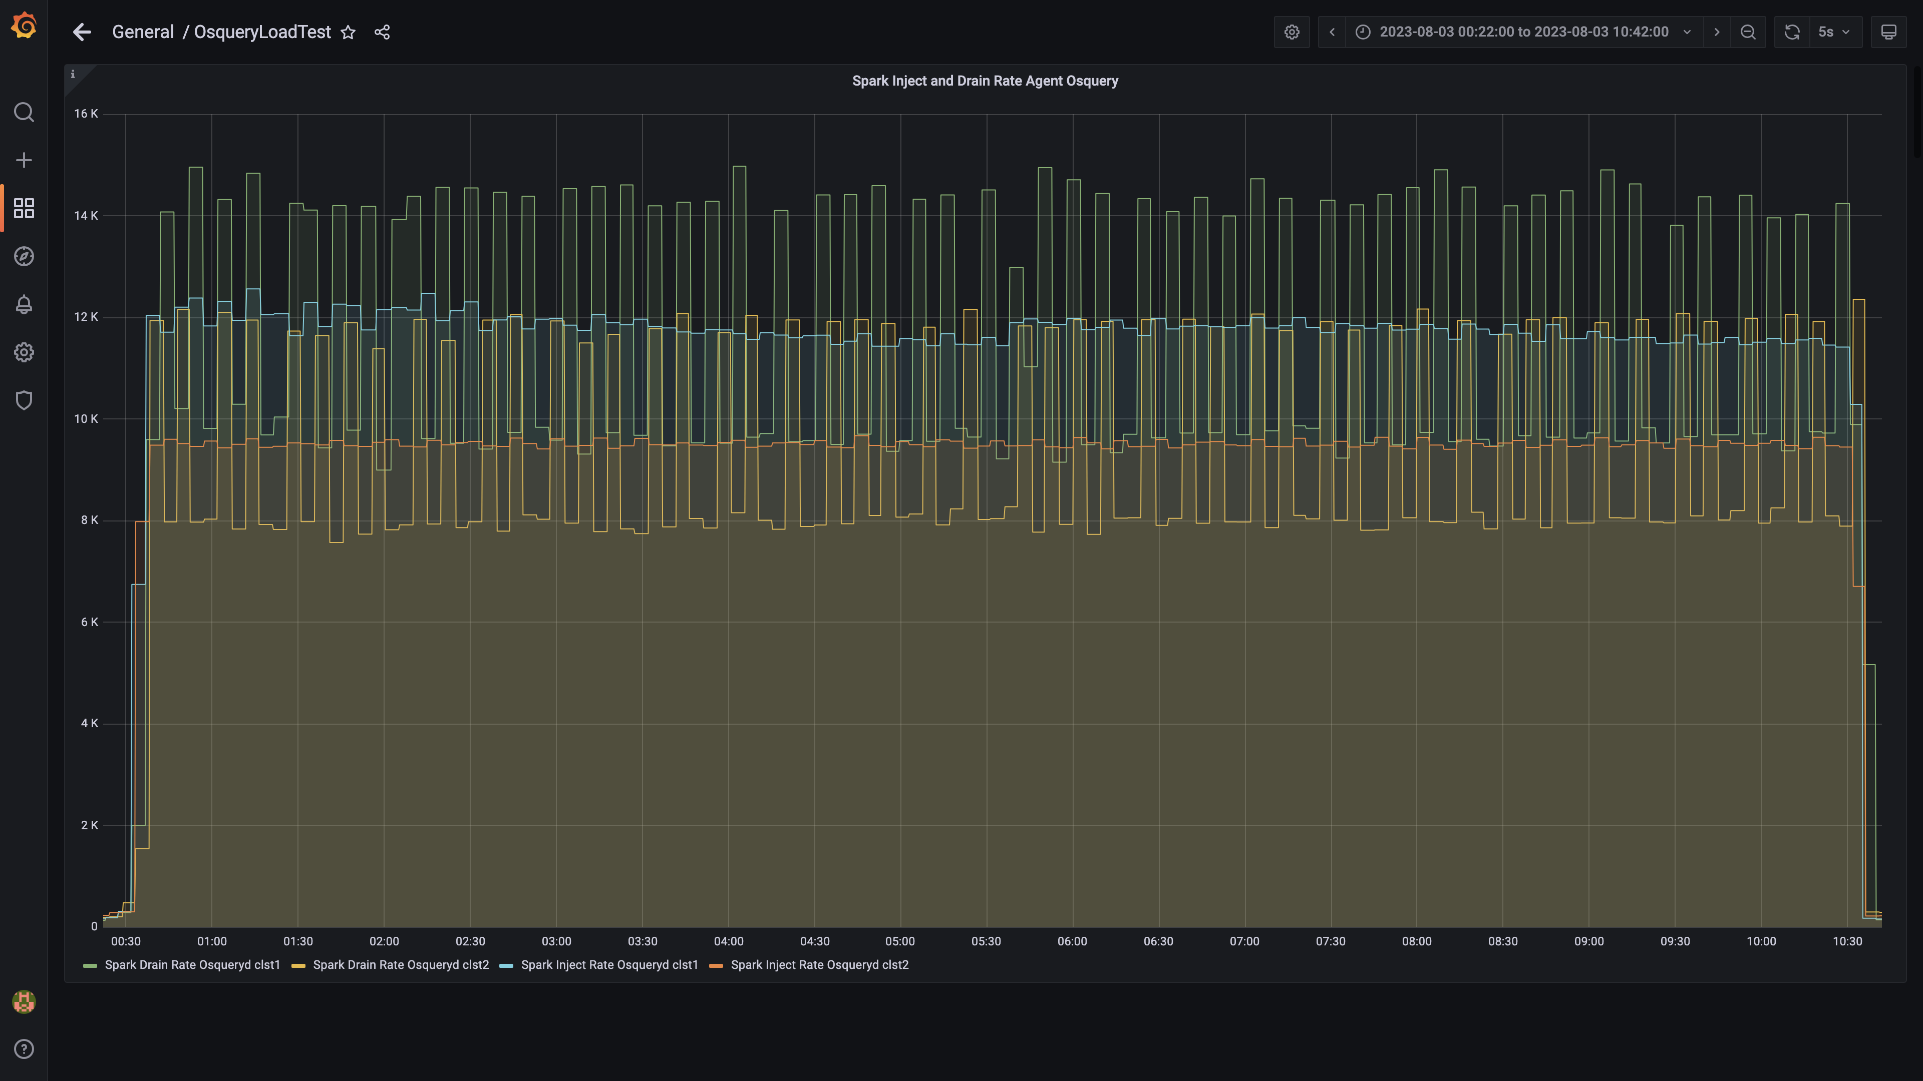

### Spark lag for agent osquery

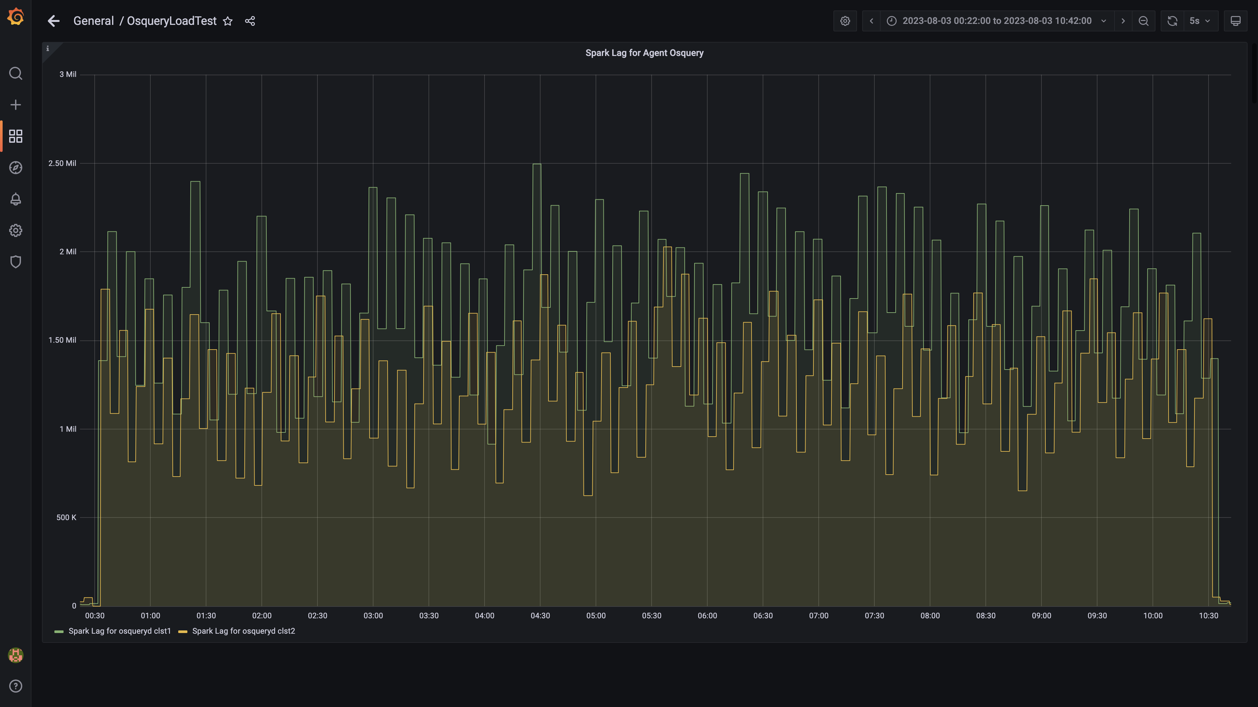

### Spark inject and drain rate events

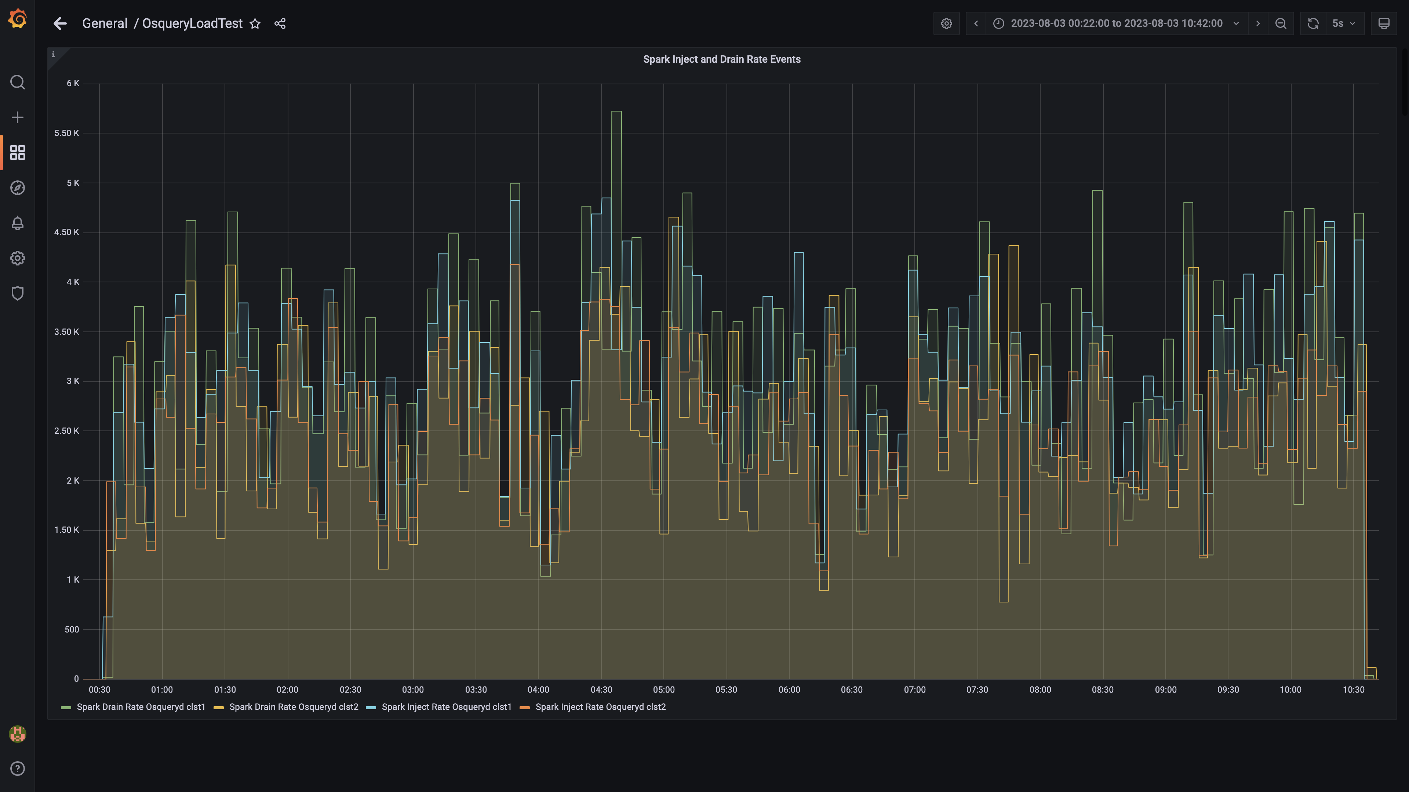

### Spark lag for events

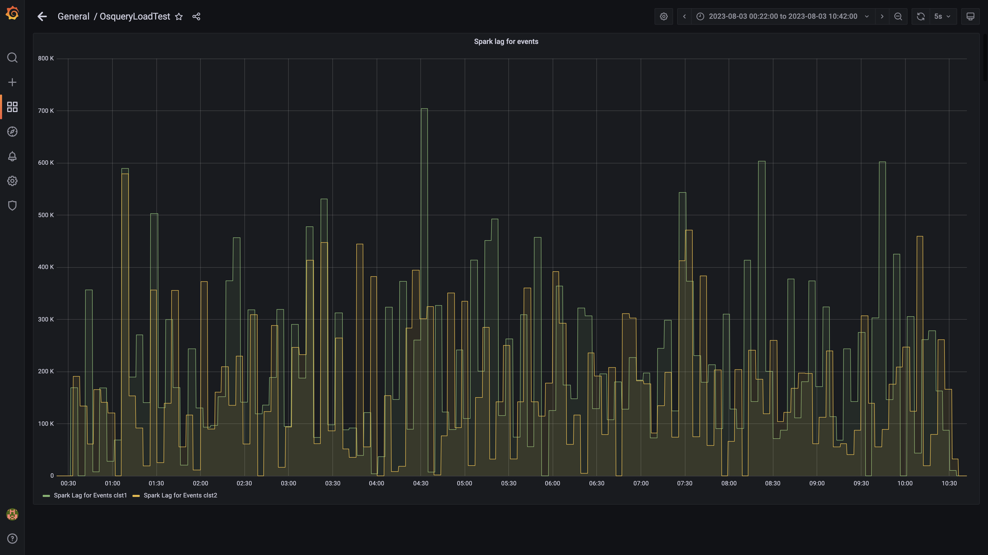

### Inject and drain rate db-alerts group

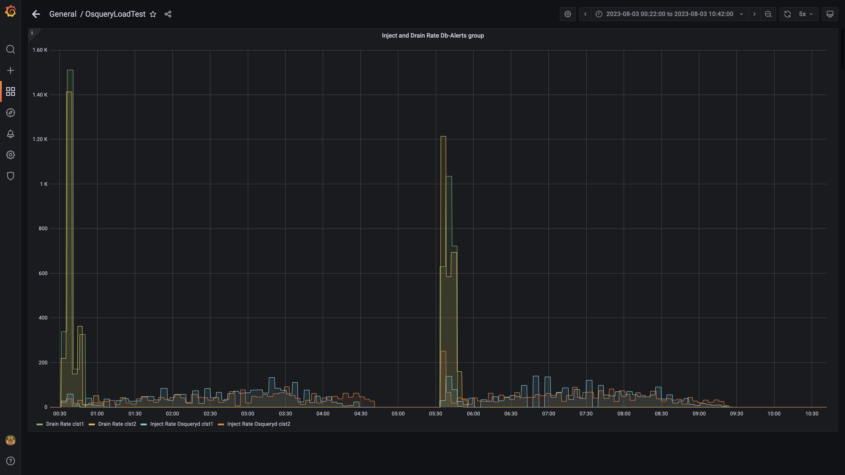

### Kafka lag for db-alerts group

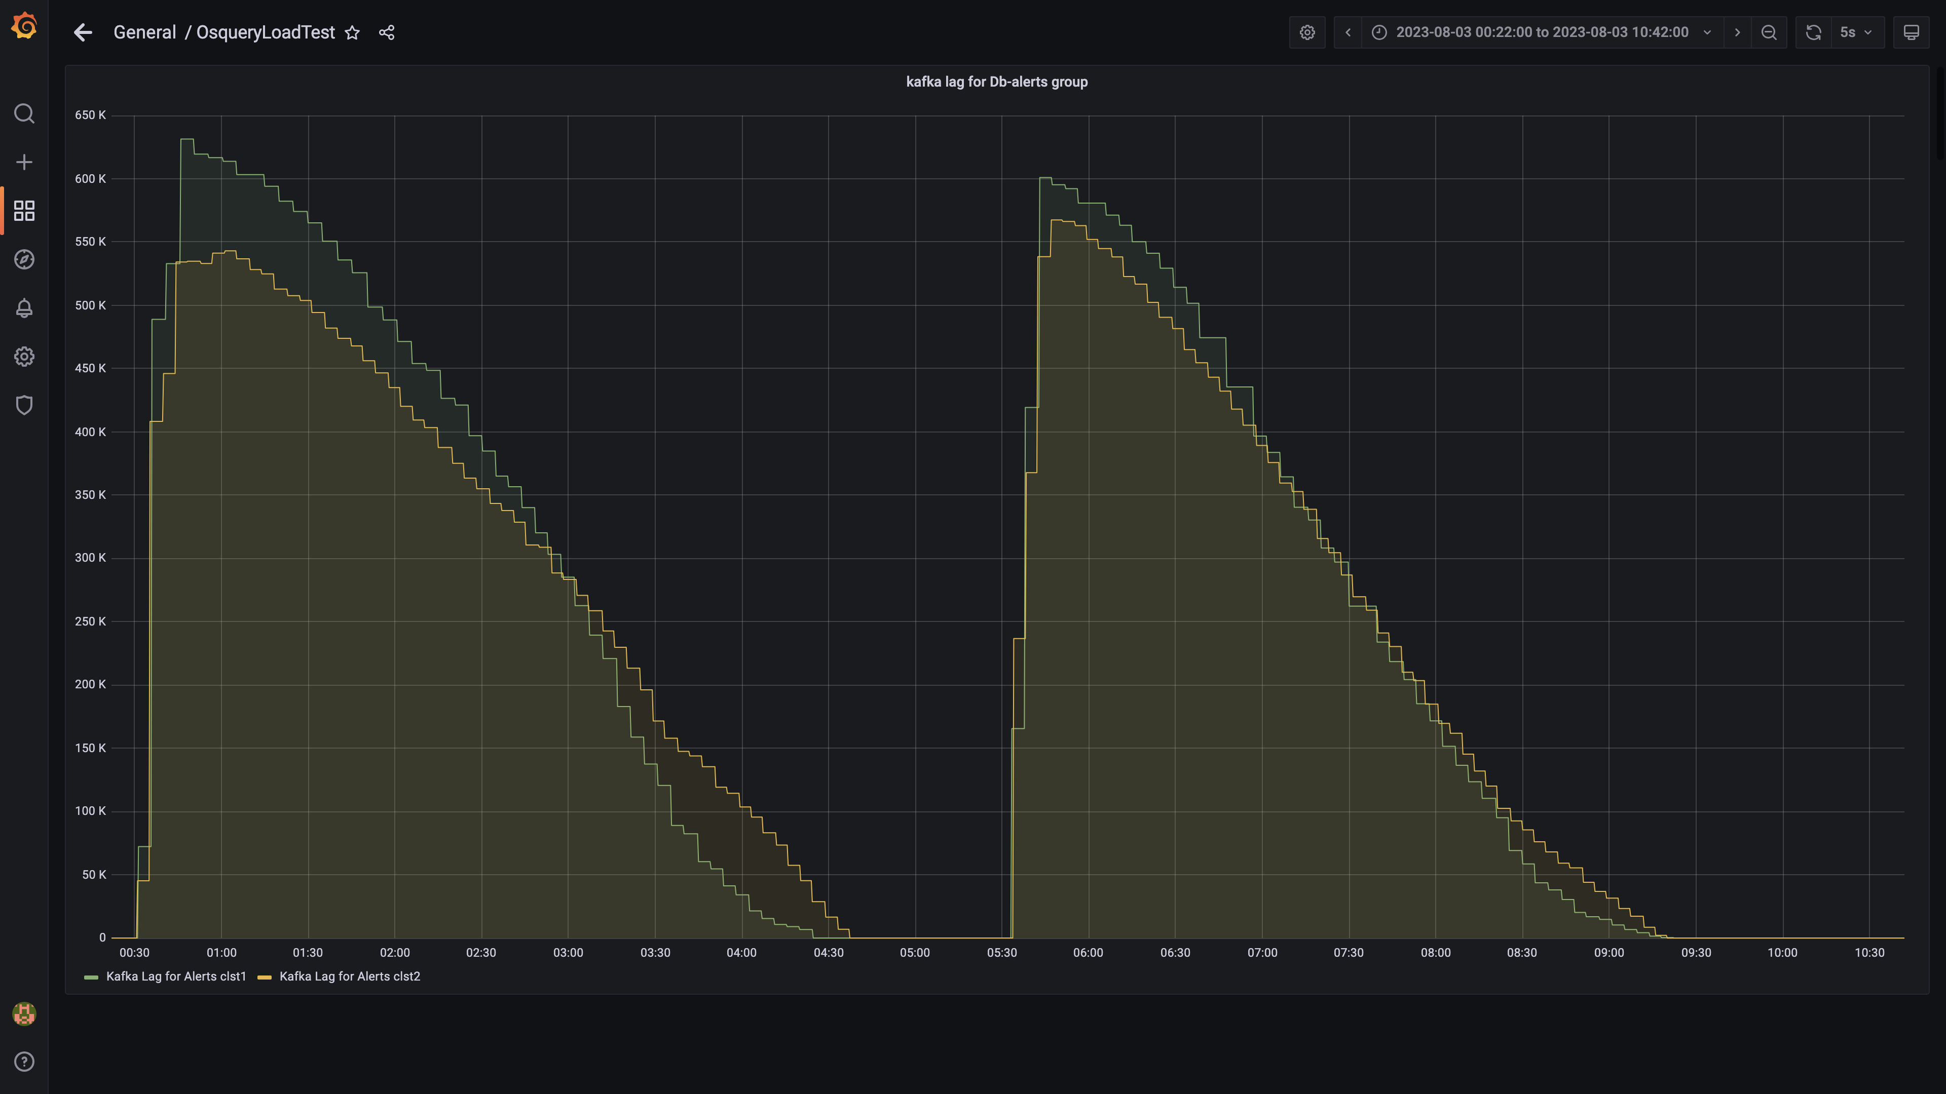

### Inject drain rates for ruleengine group

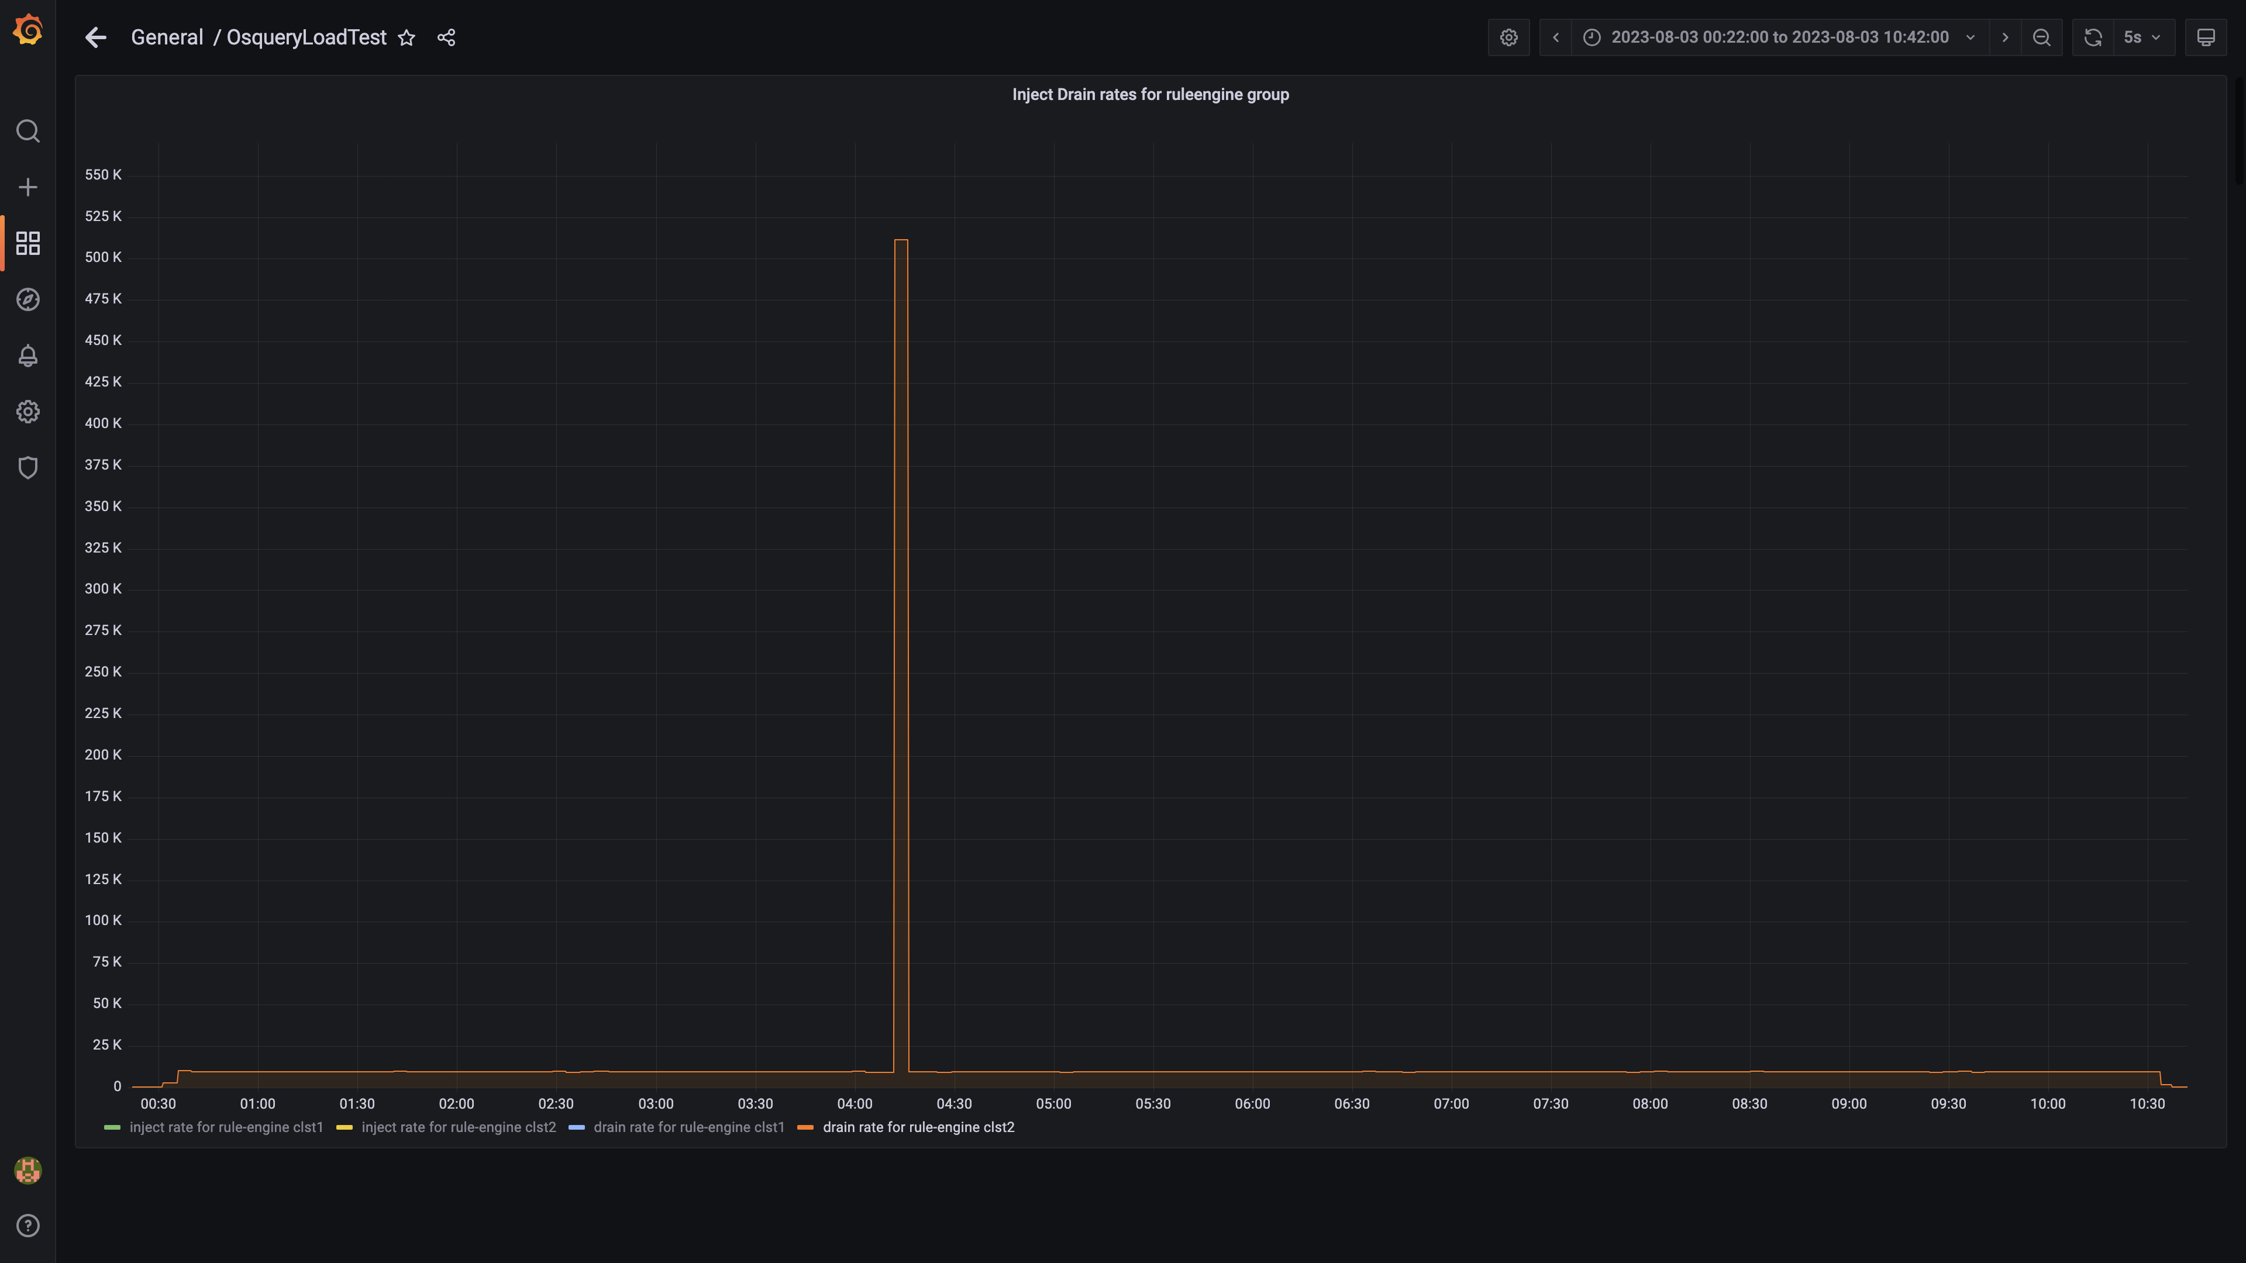

### Kafka lag for ruleengine group

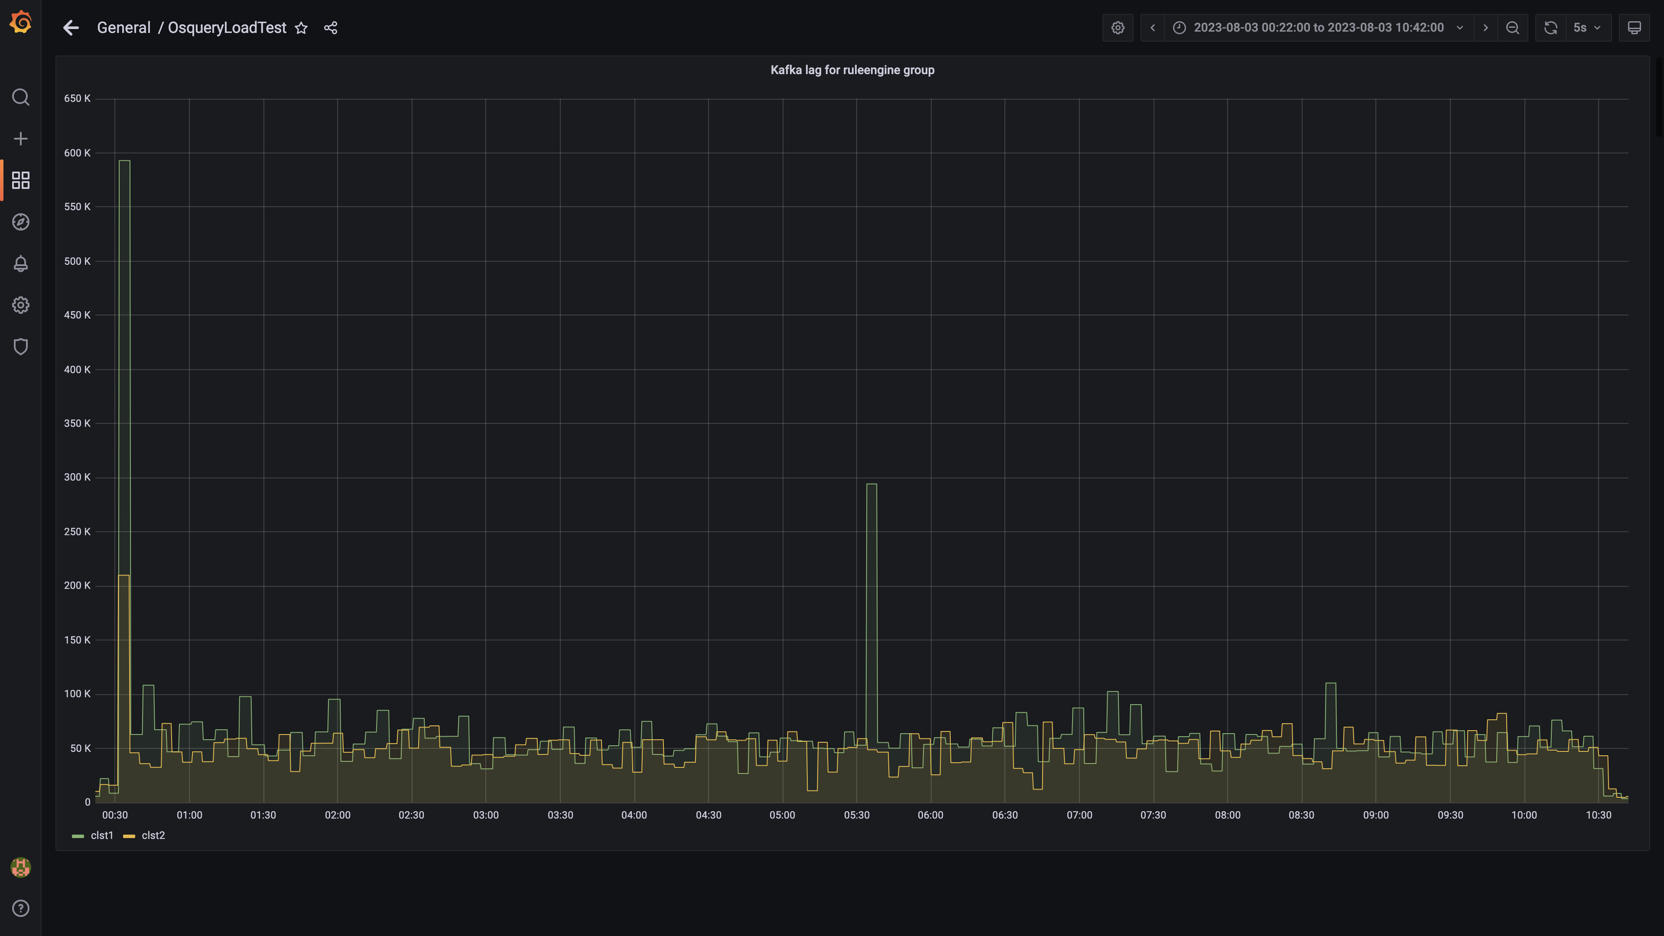

### Kafka inject and drain rates for debezium group

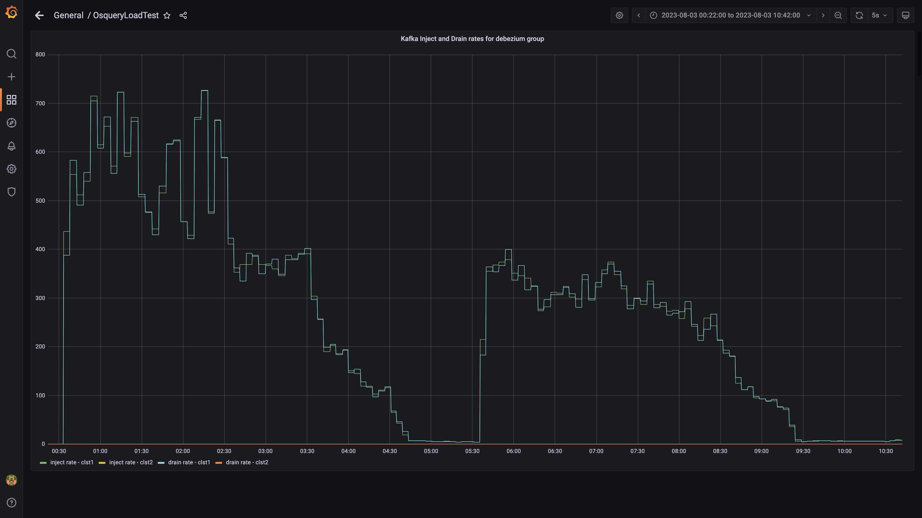

### Aggregate lag

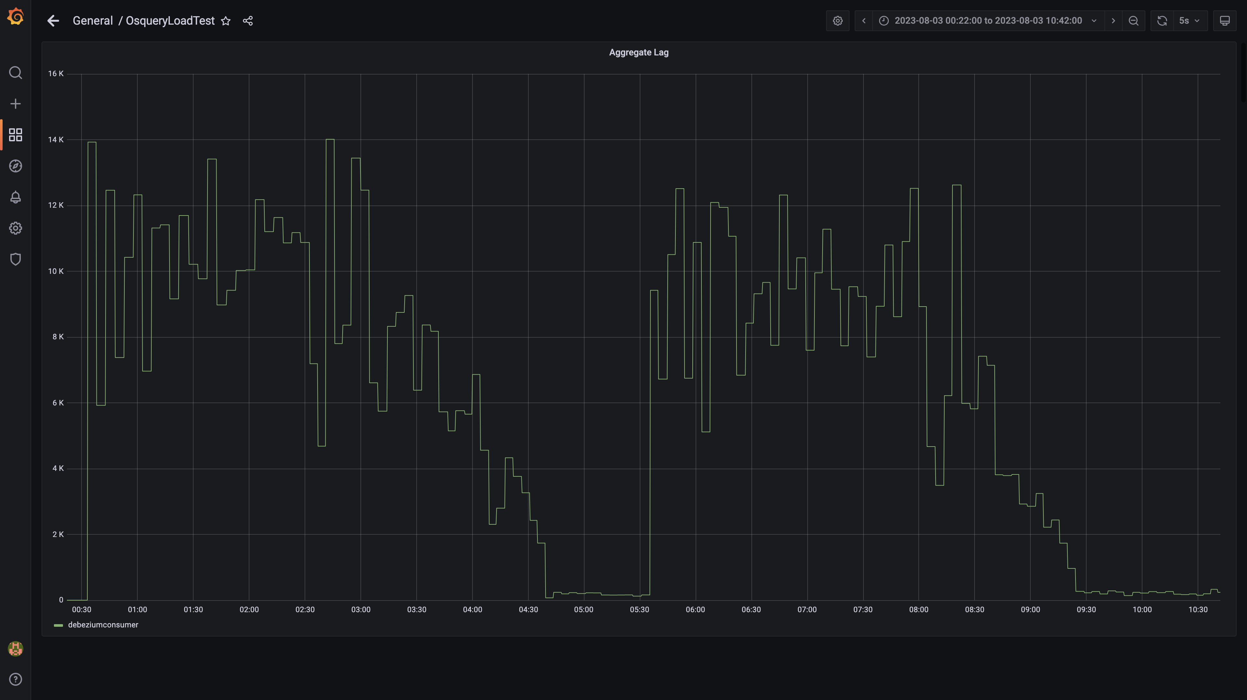

### Debezium replication lag

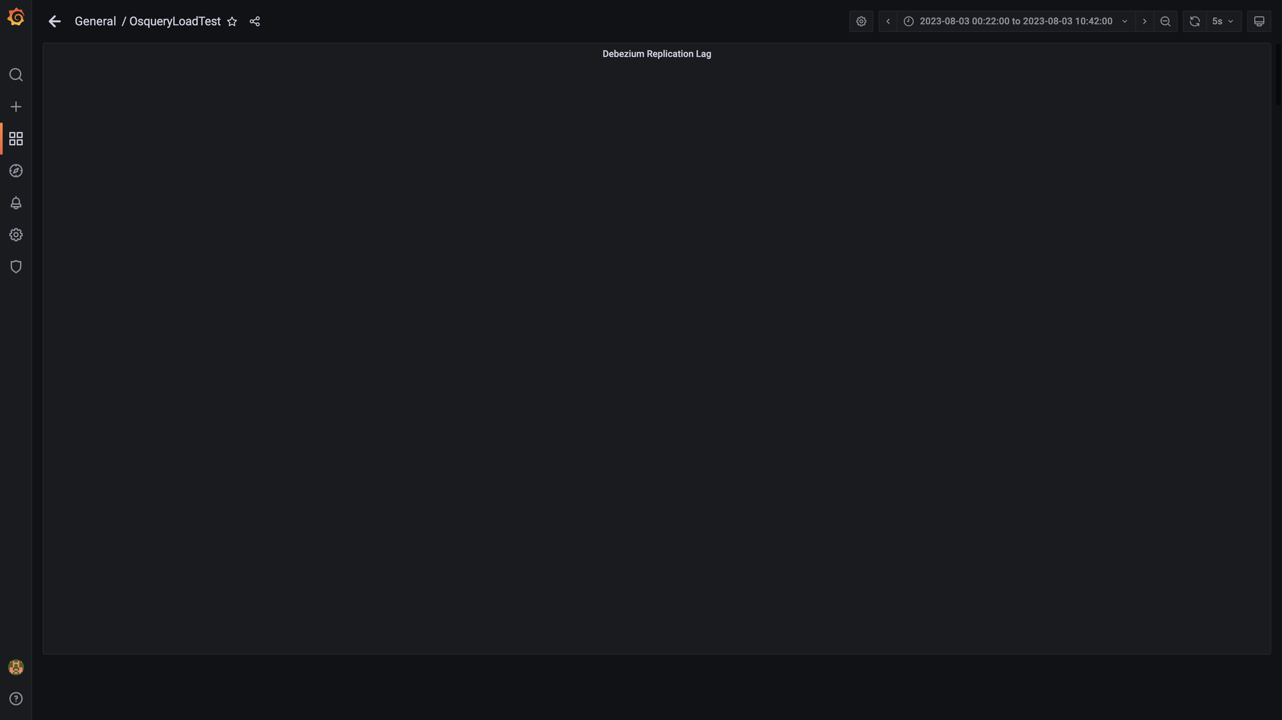

### Active client connections

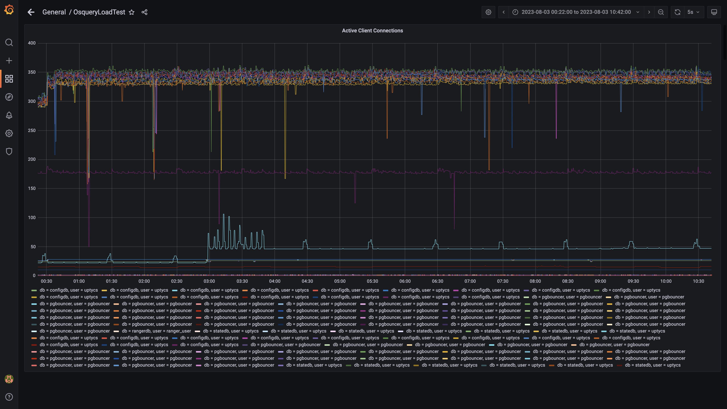

### Panel 130 not loaded in given time

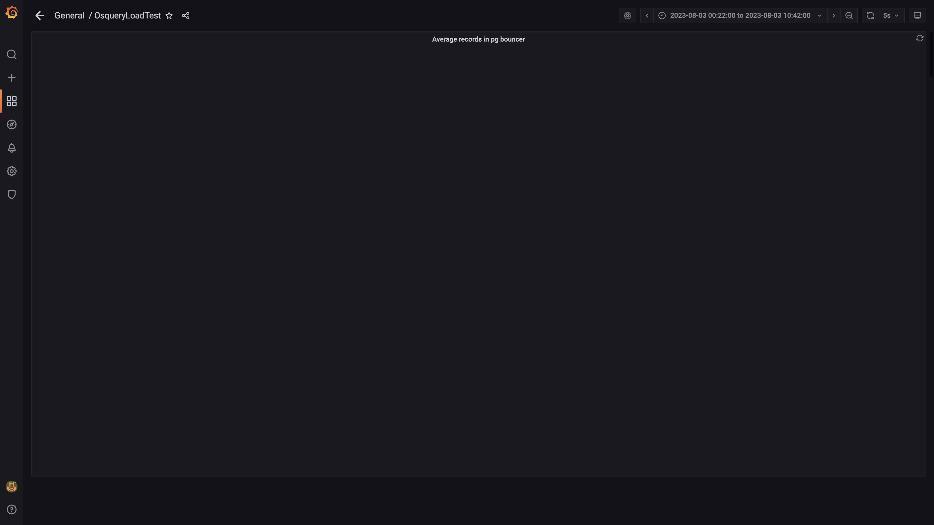

### Panel 128 not loaded in given time

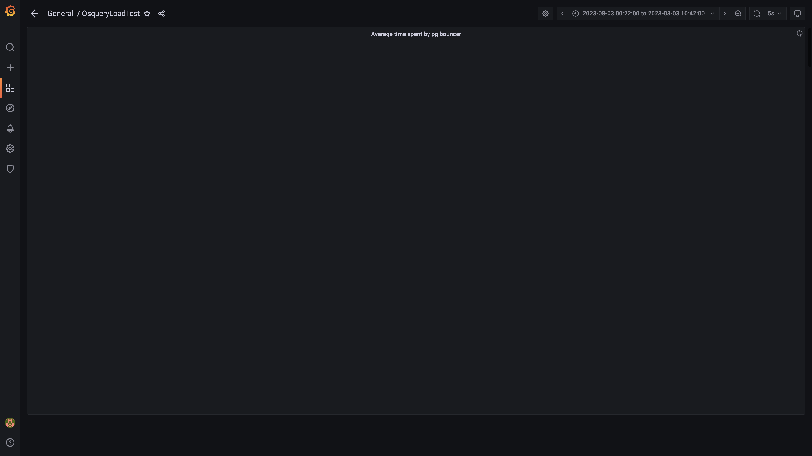

### Redis client connections for tls

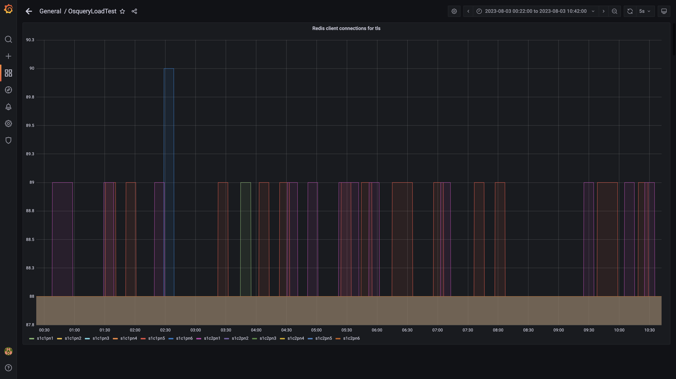

### Configdb pg wal folder size

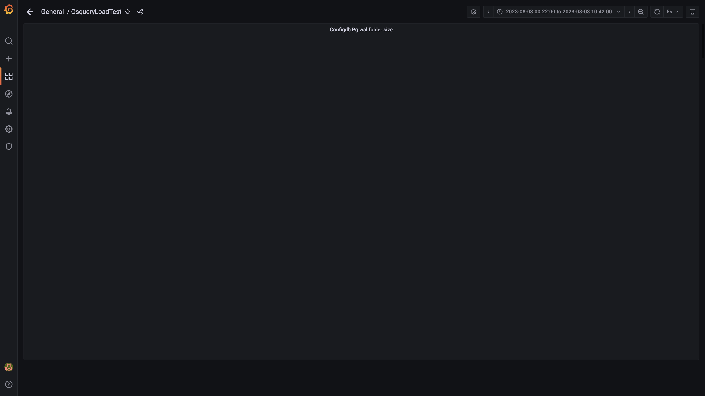

### Configdb number of wal files

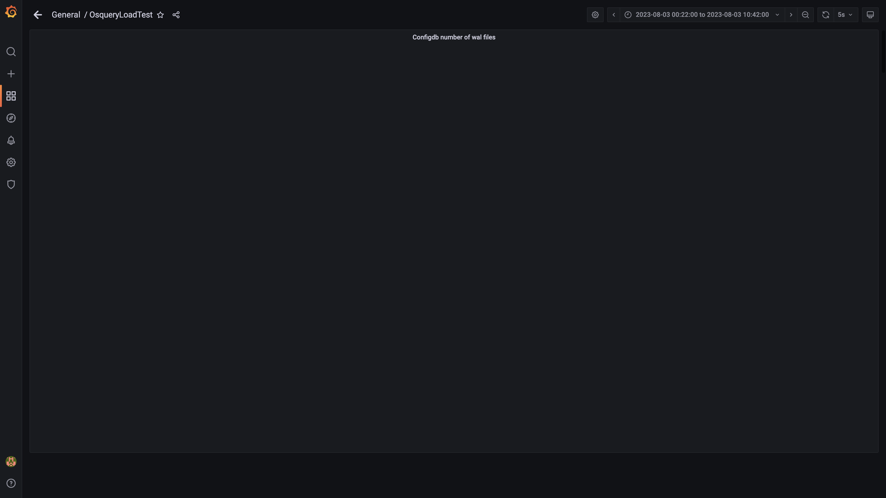

### Top 10 redis client connections by app

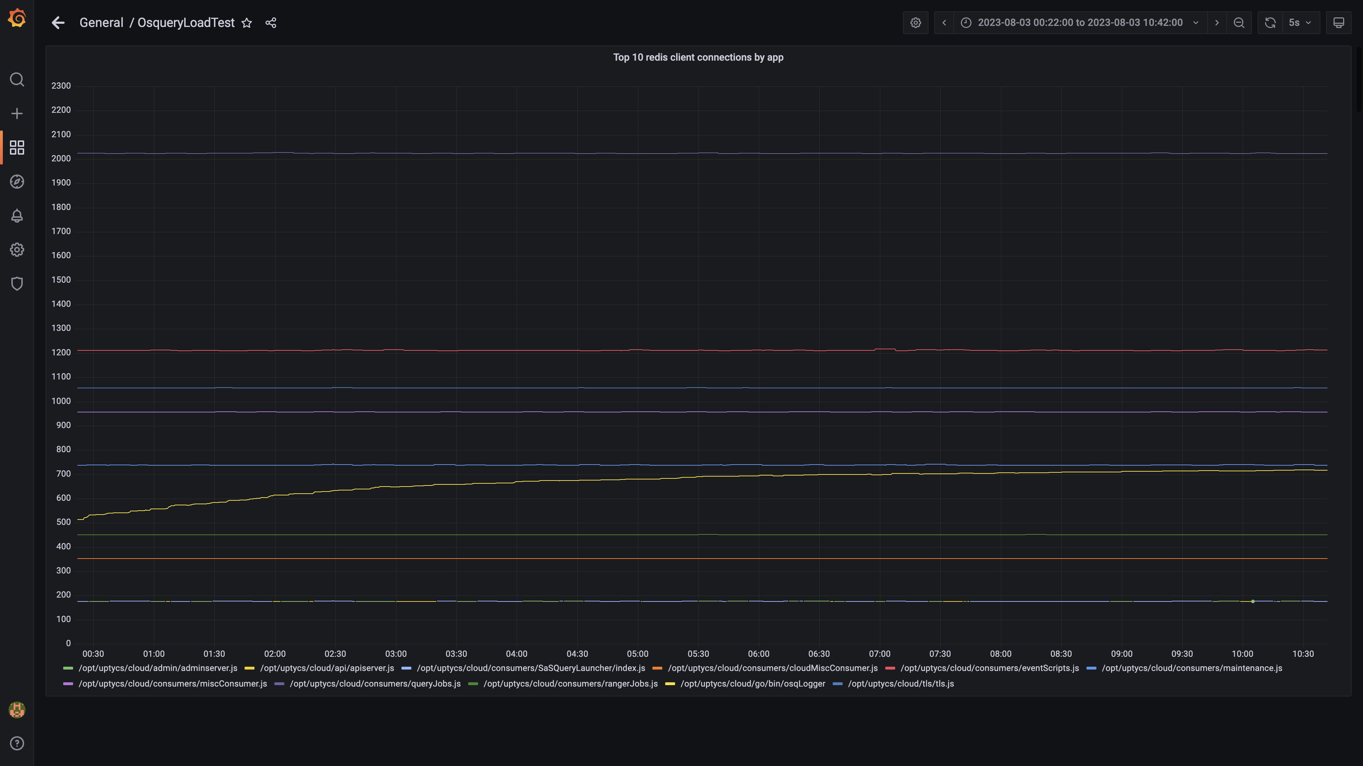

### Configdb folder size

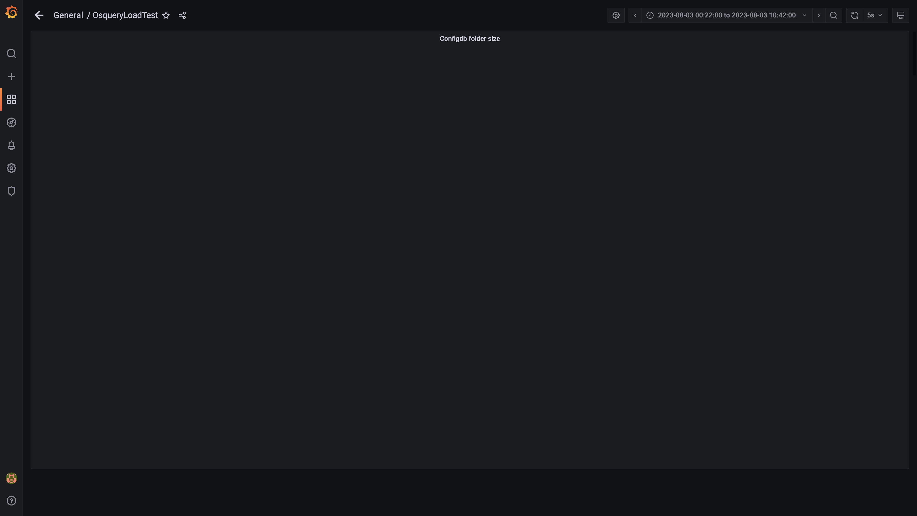

### Cpu and memory usages

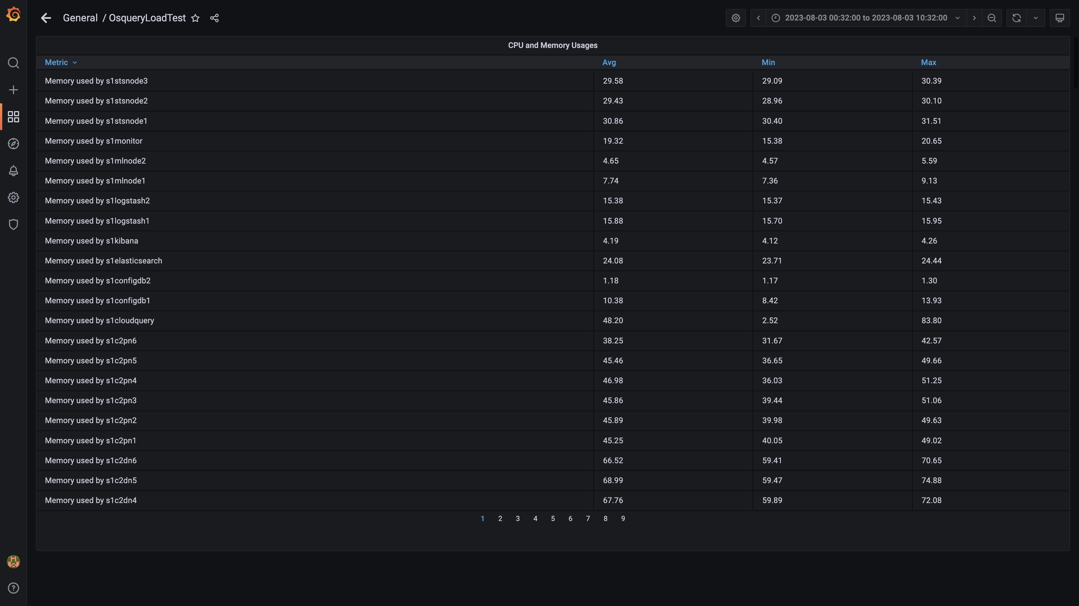

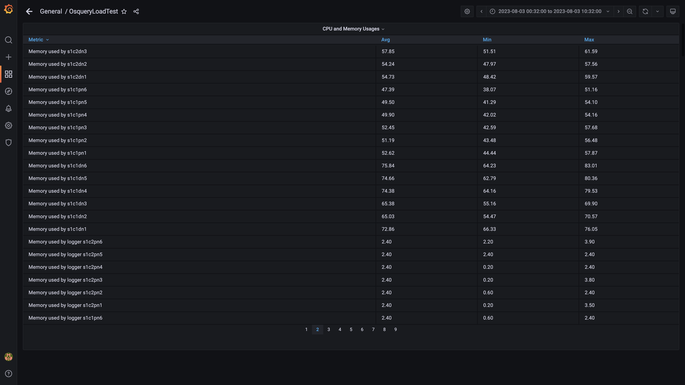

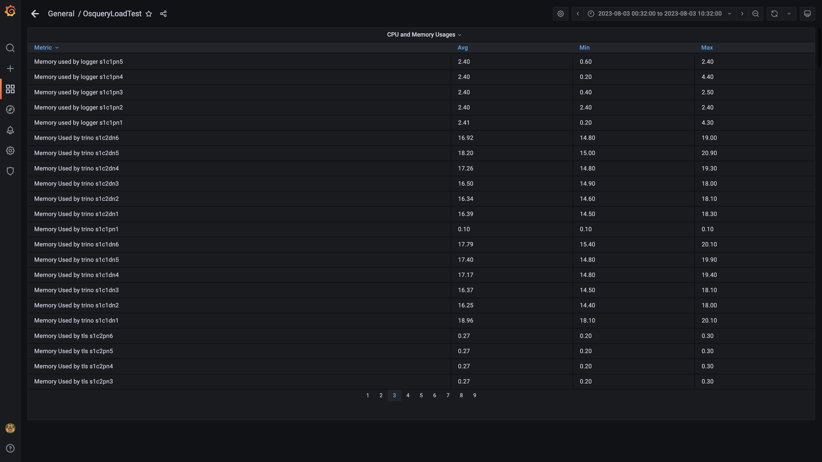

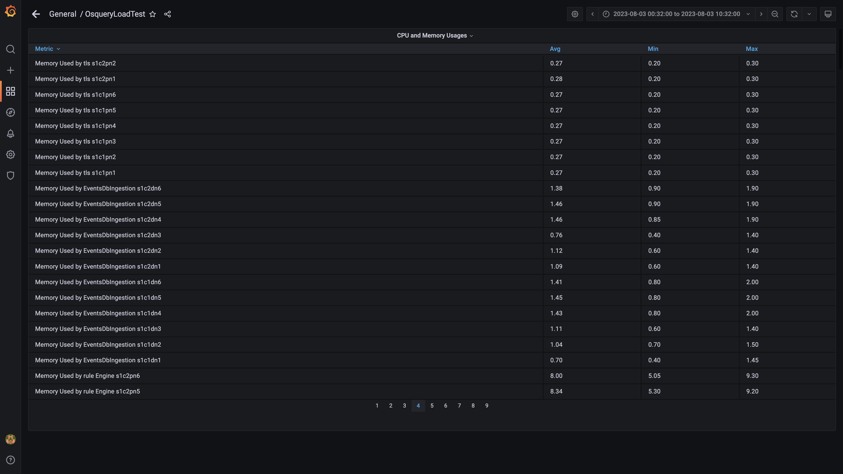

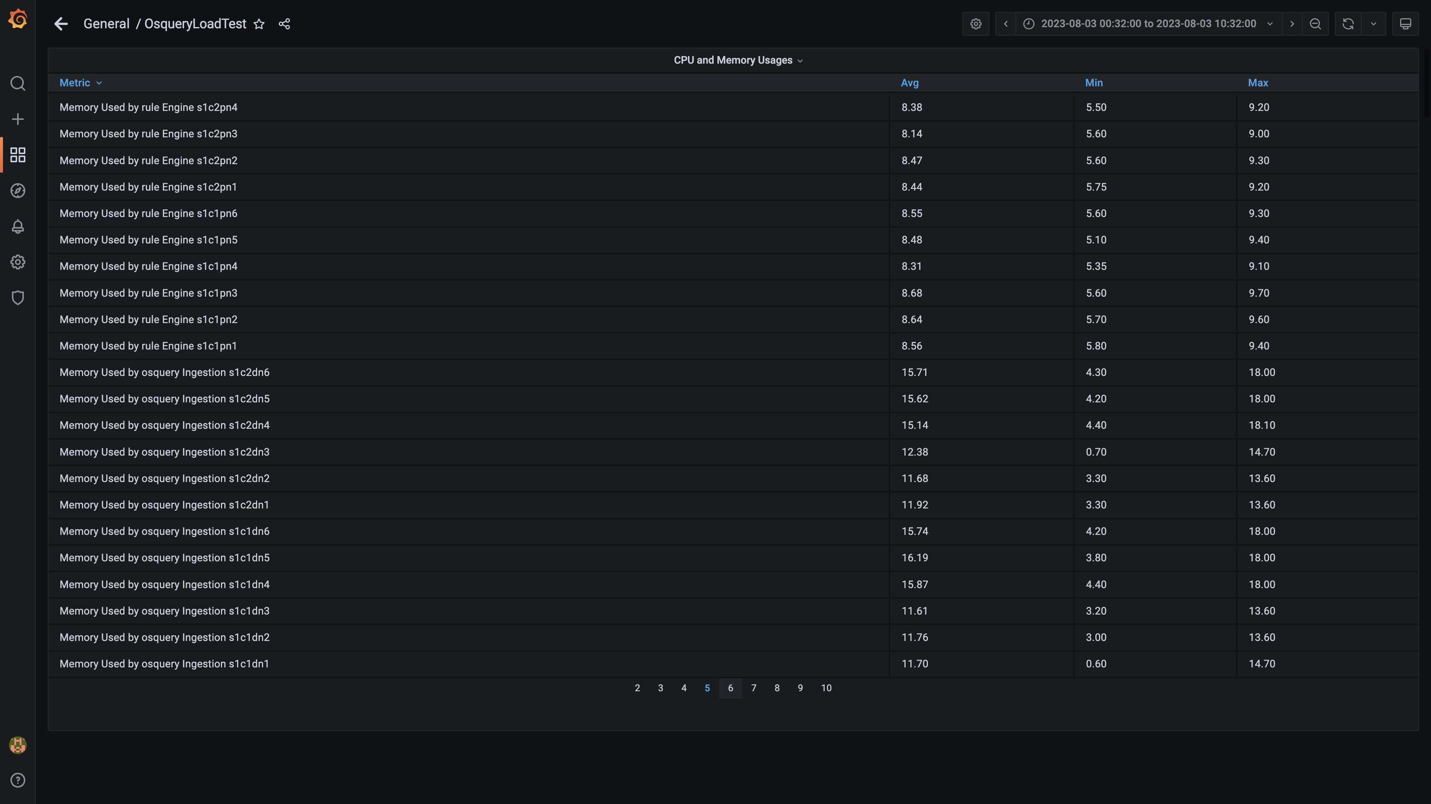

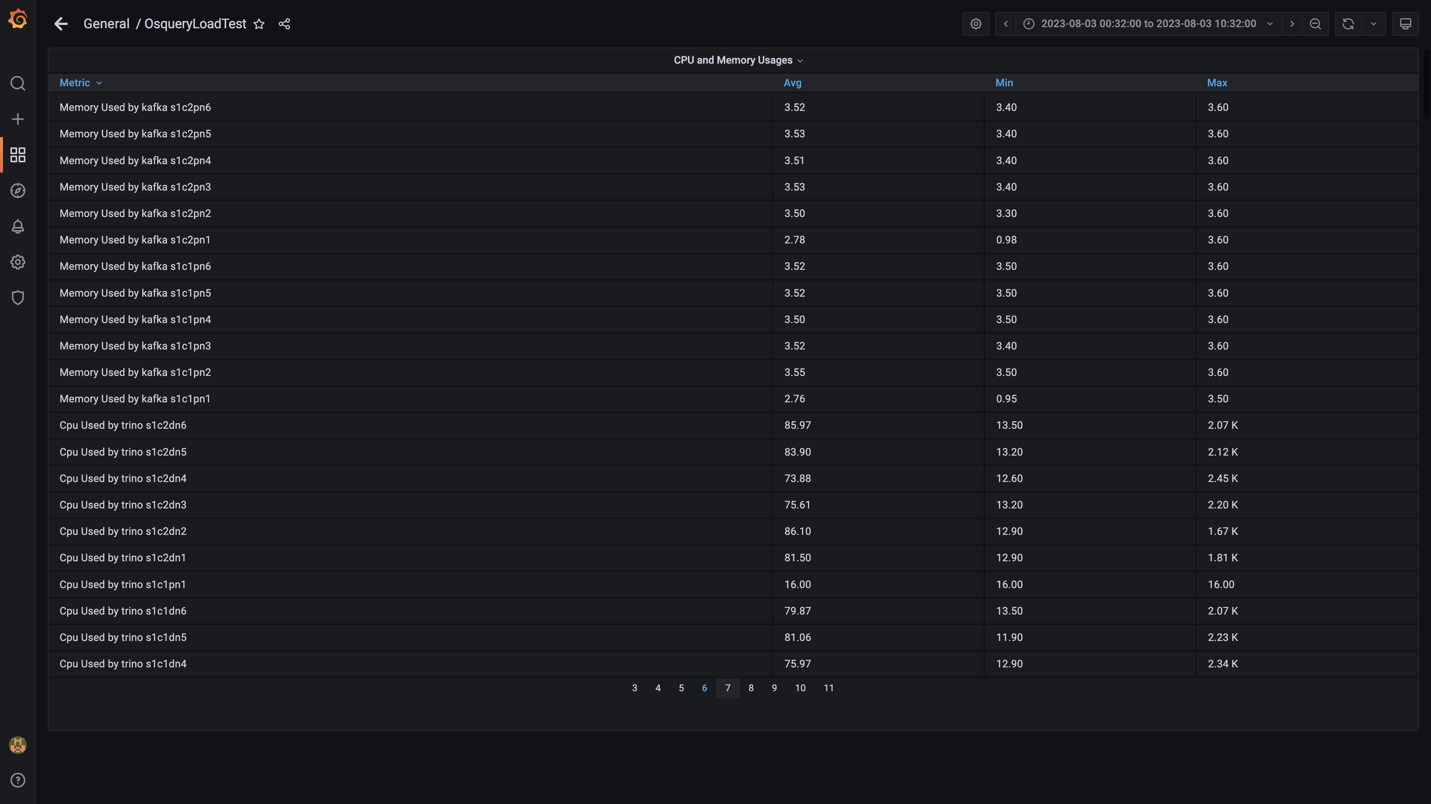

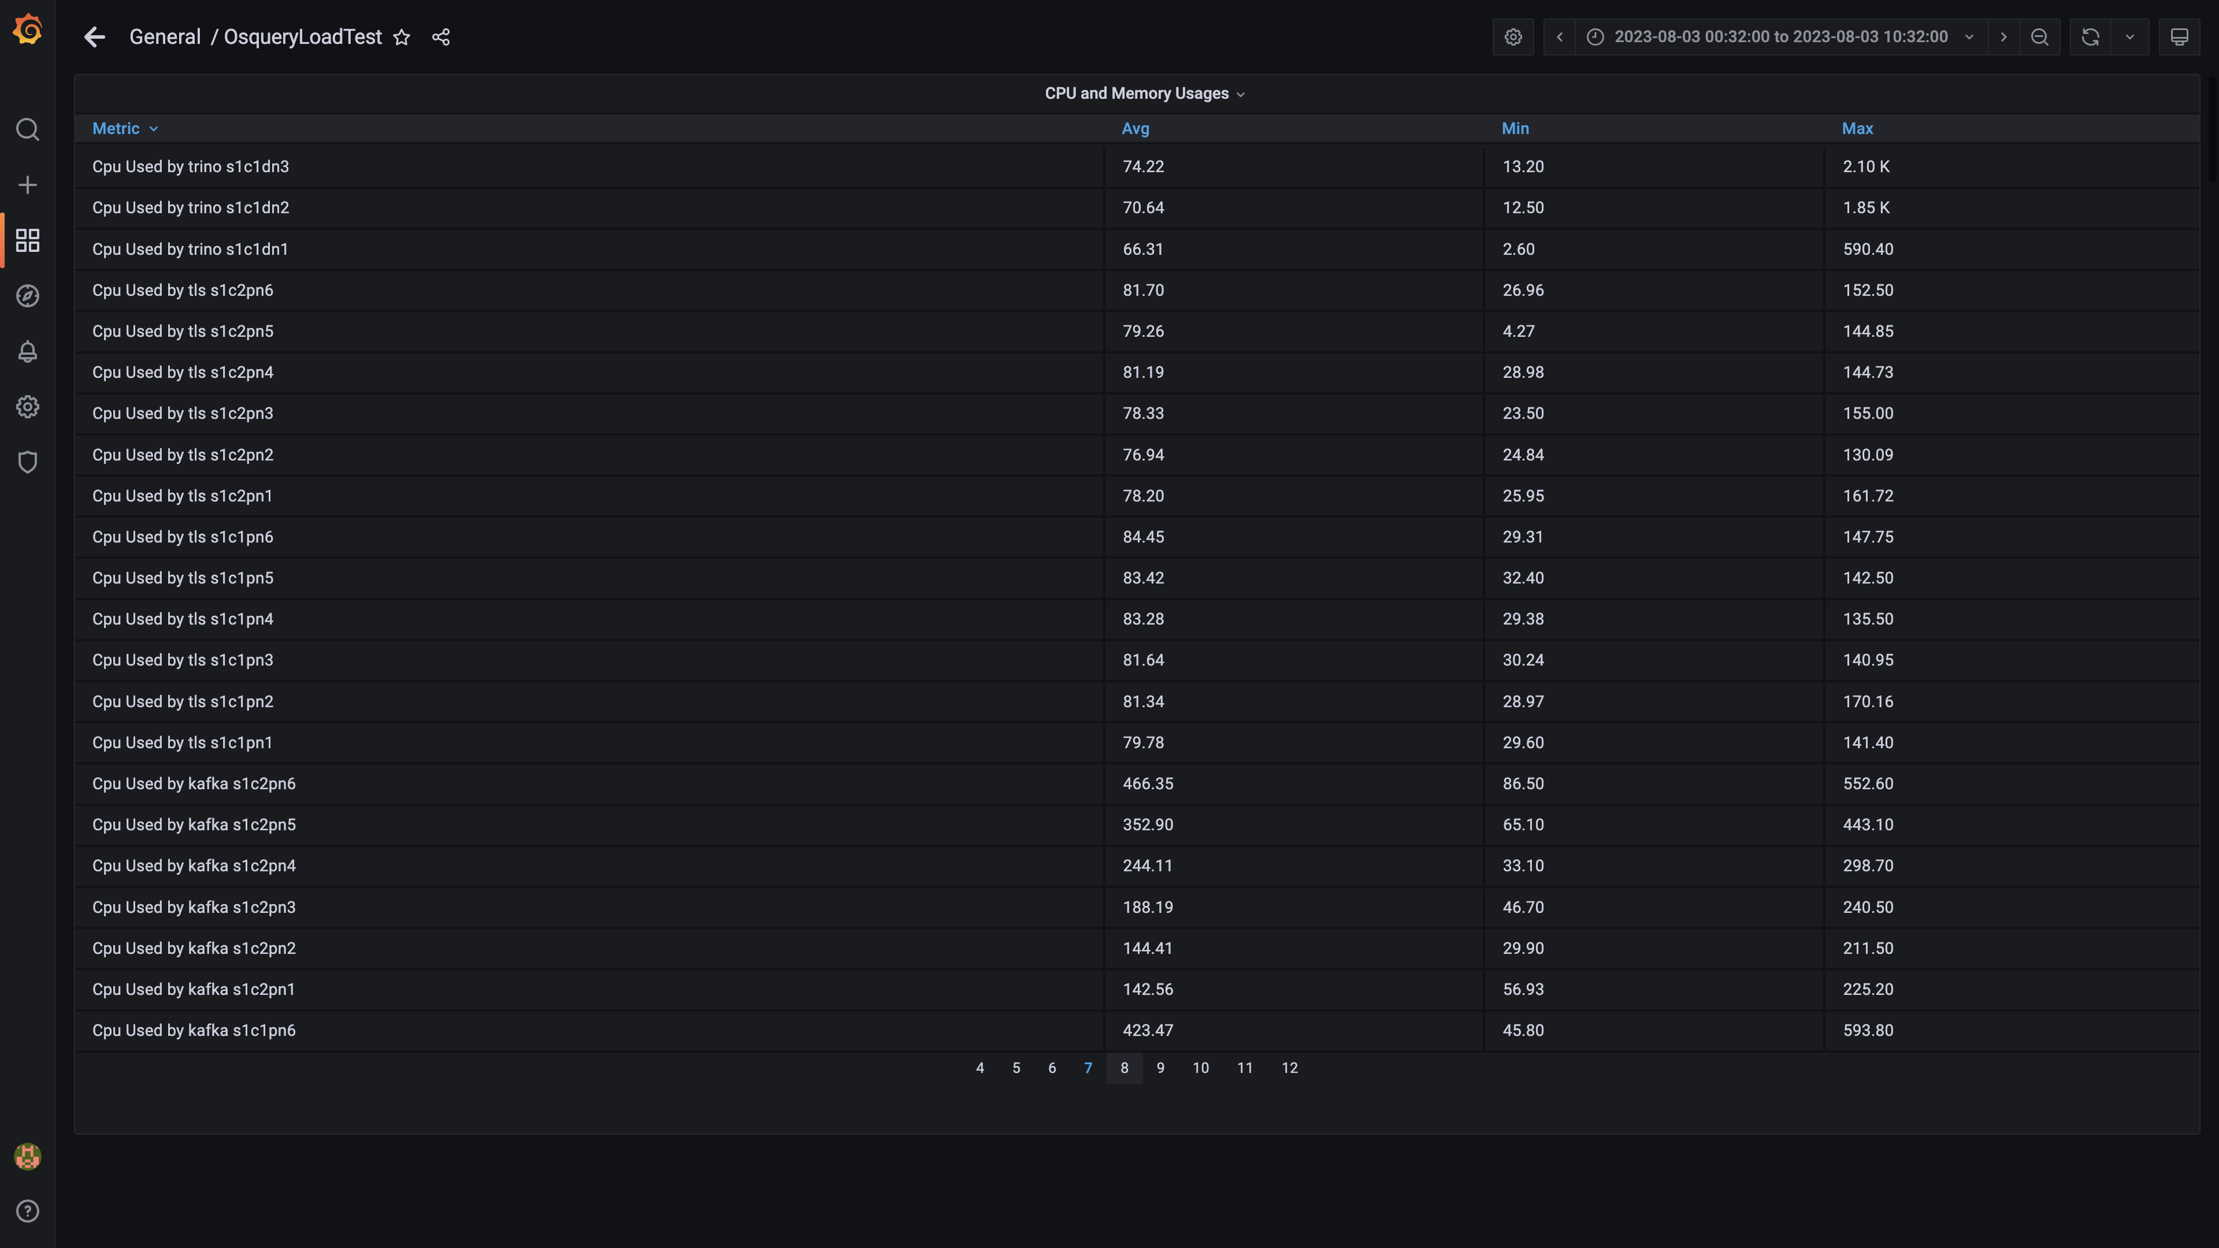

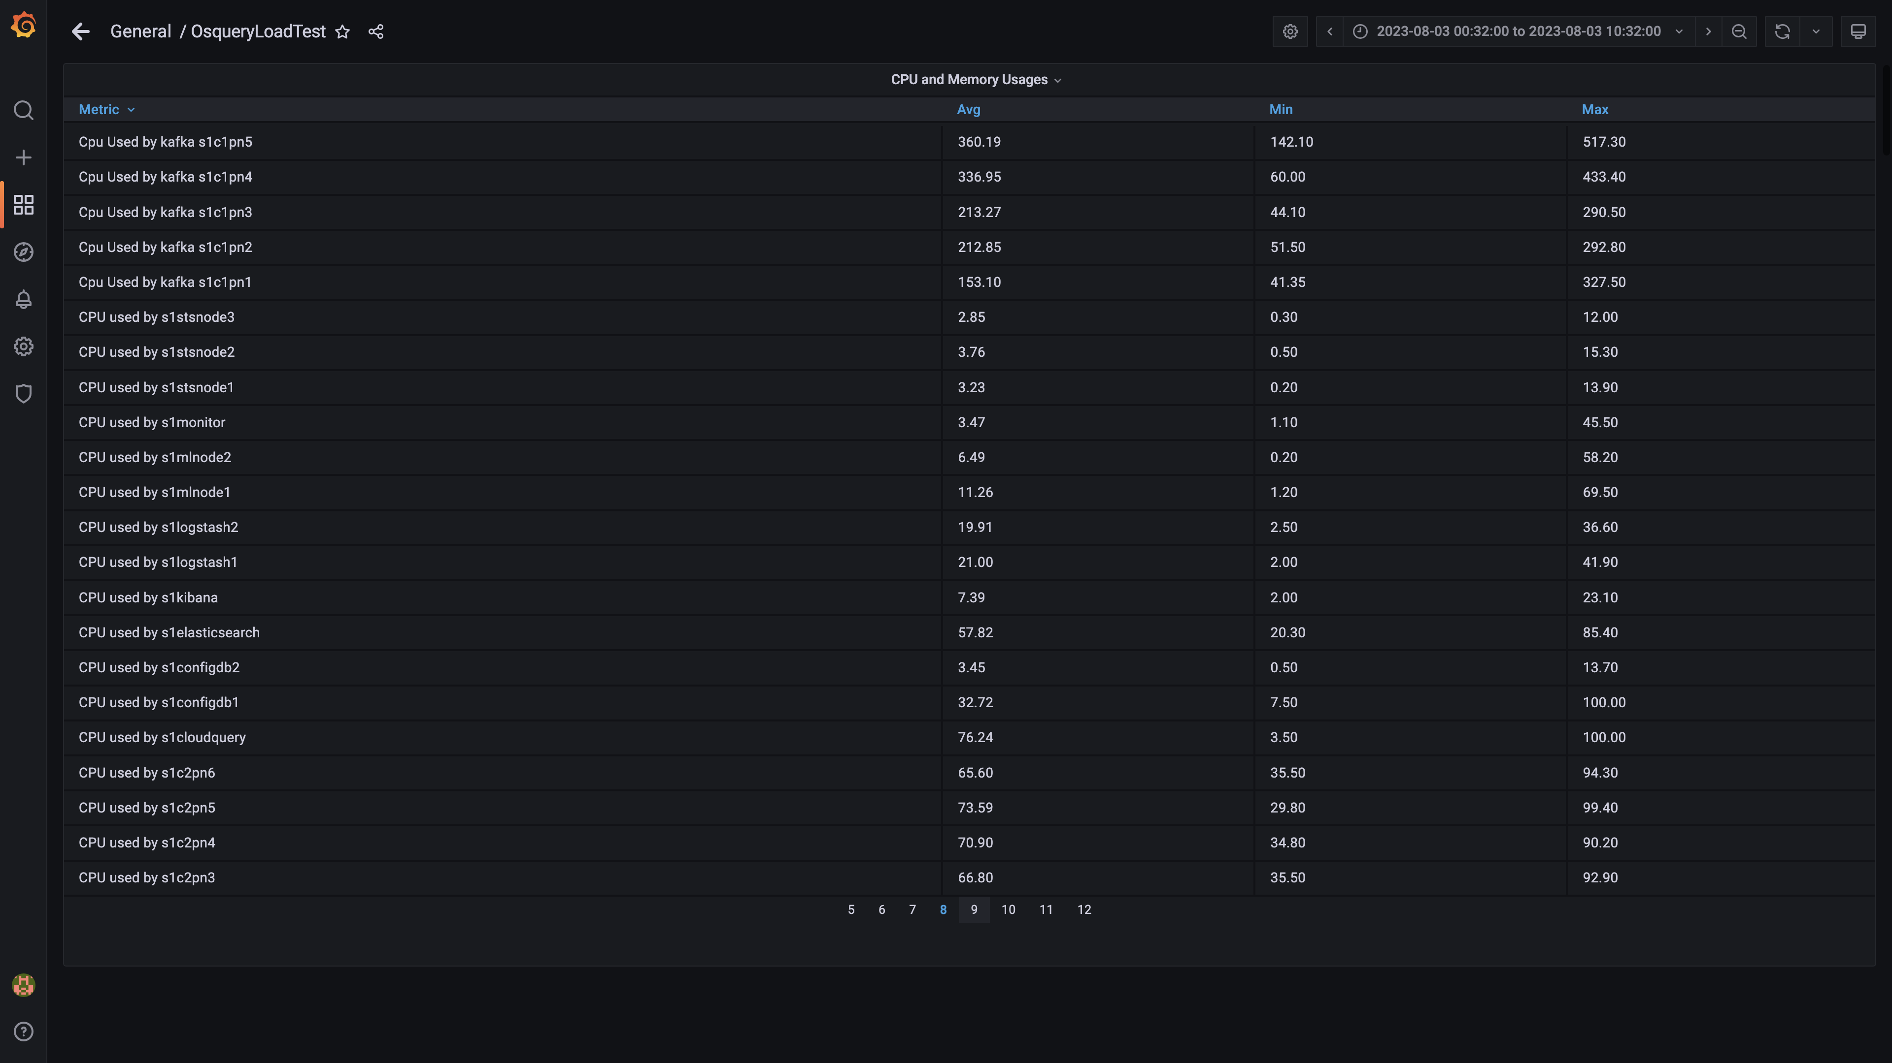

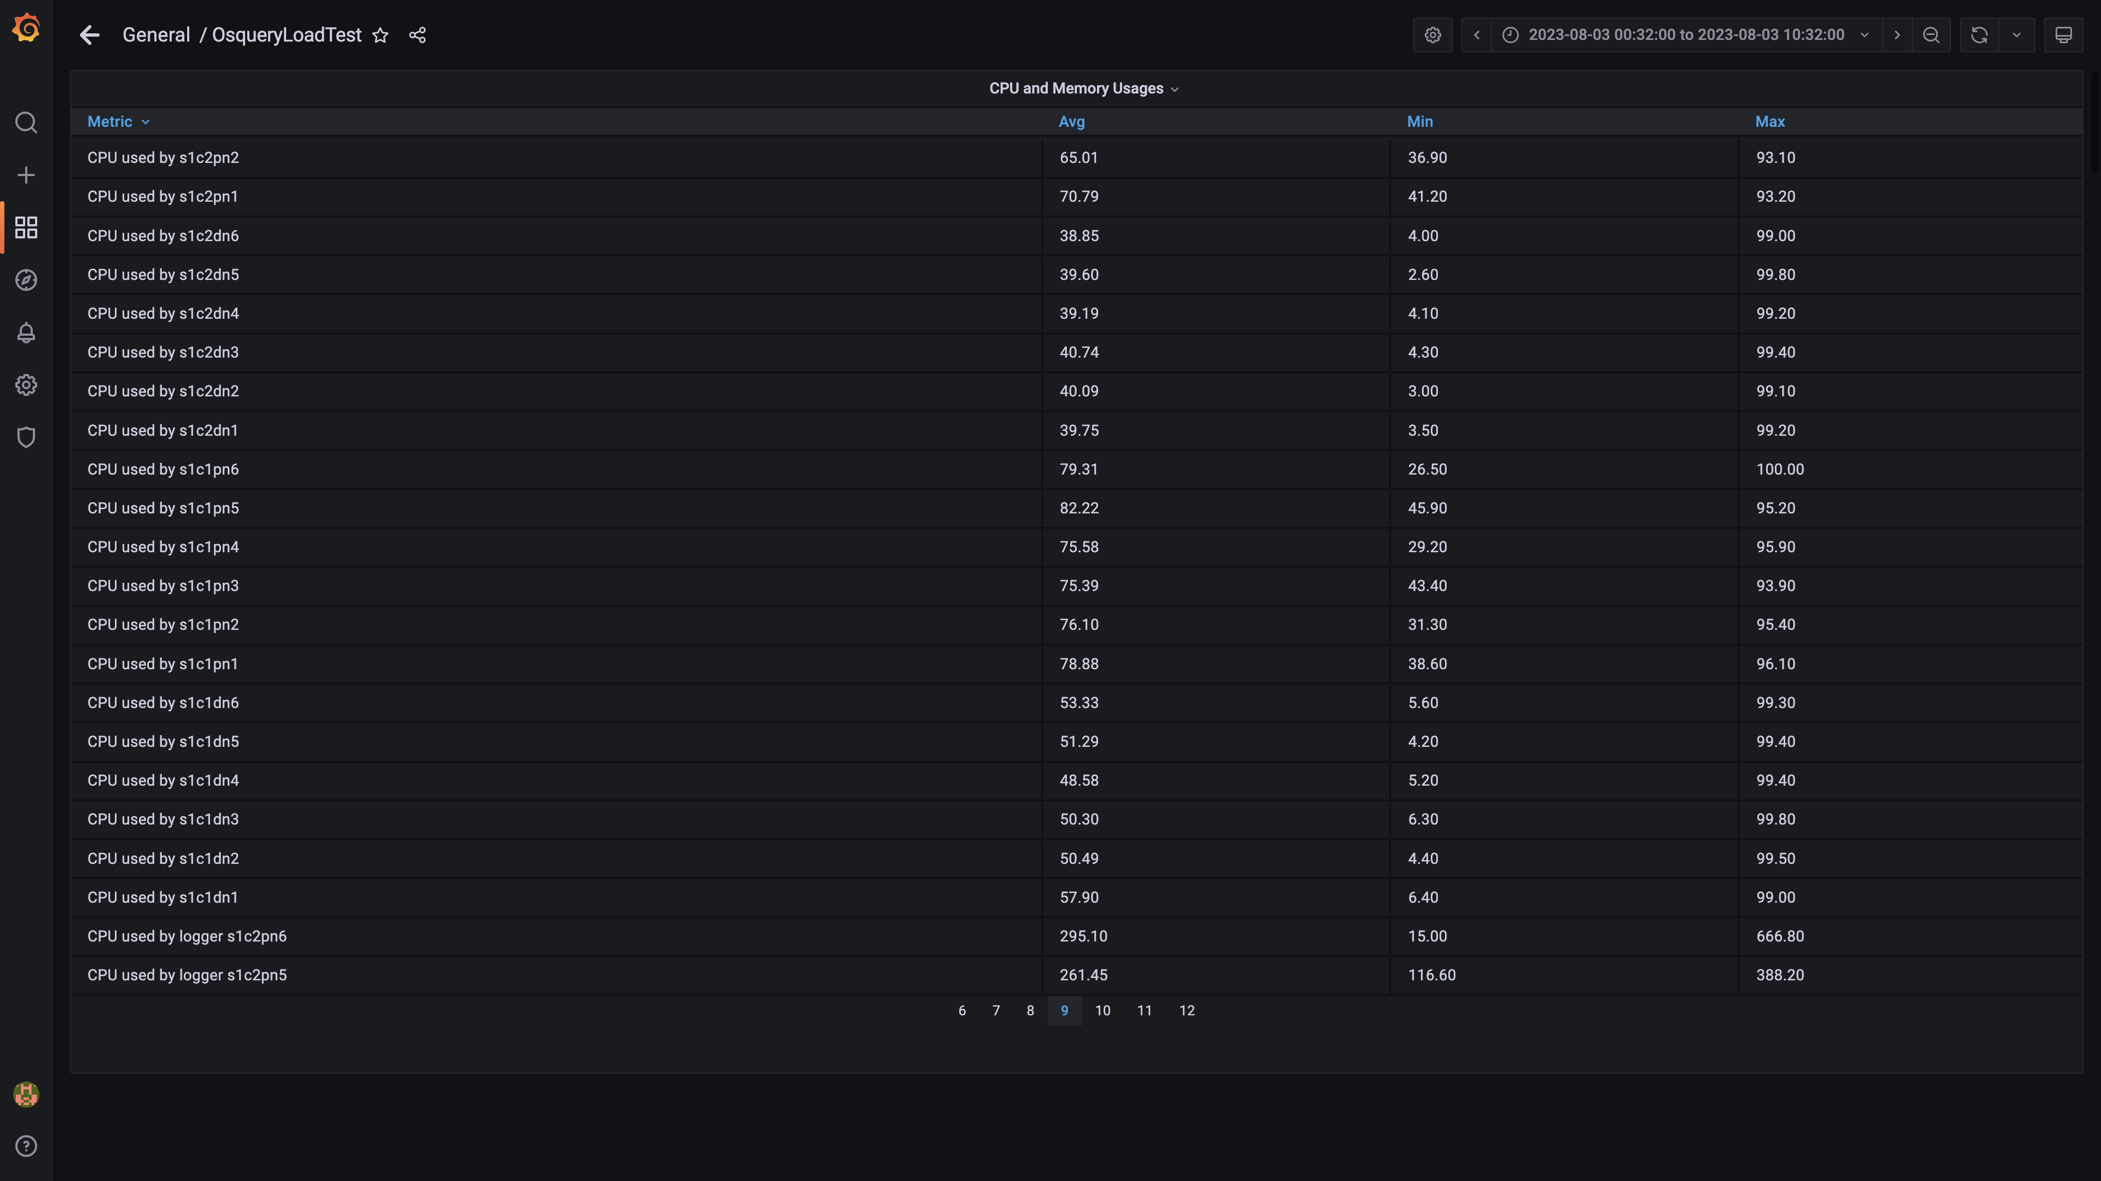

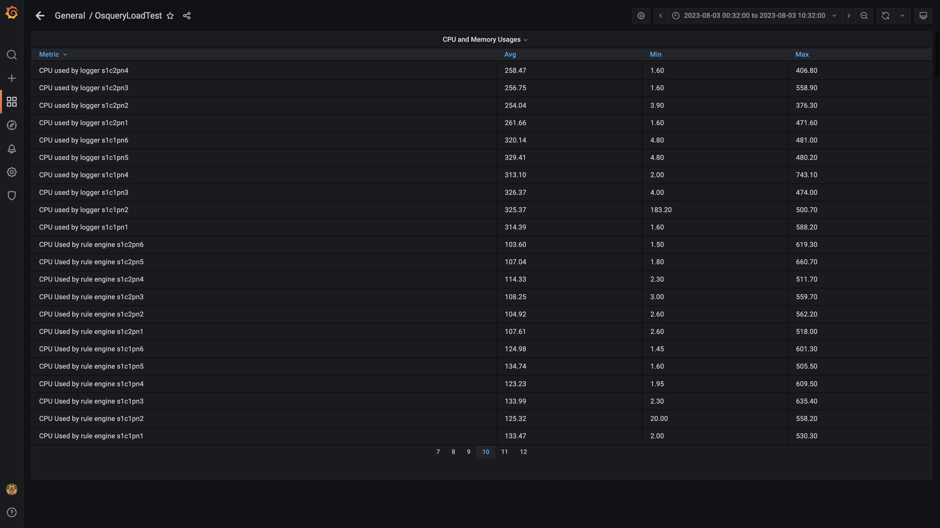

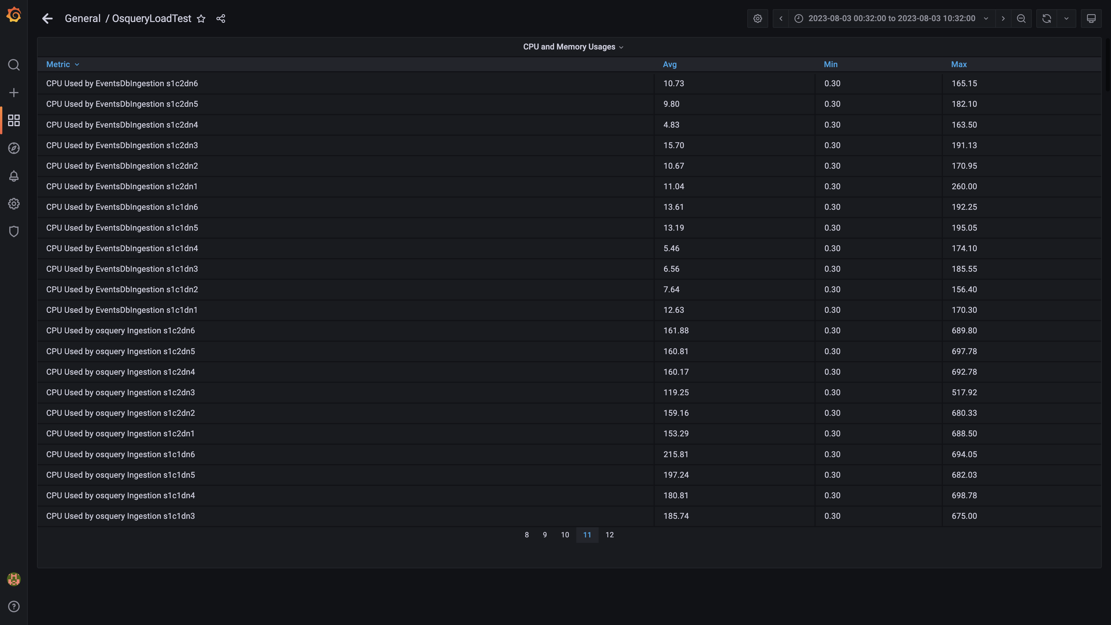

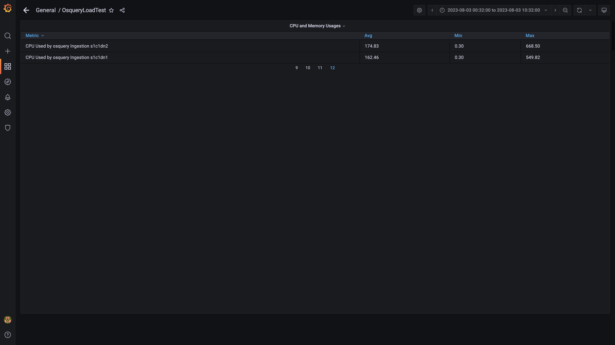

### Overall container memory and cpu usage

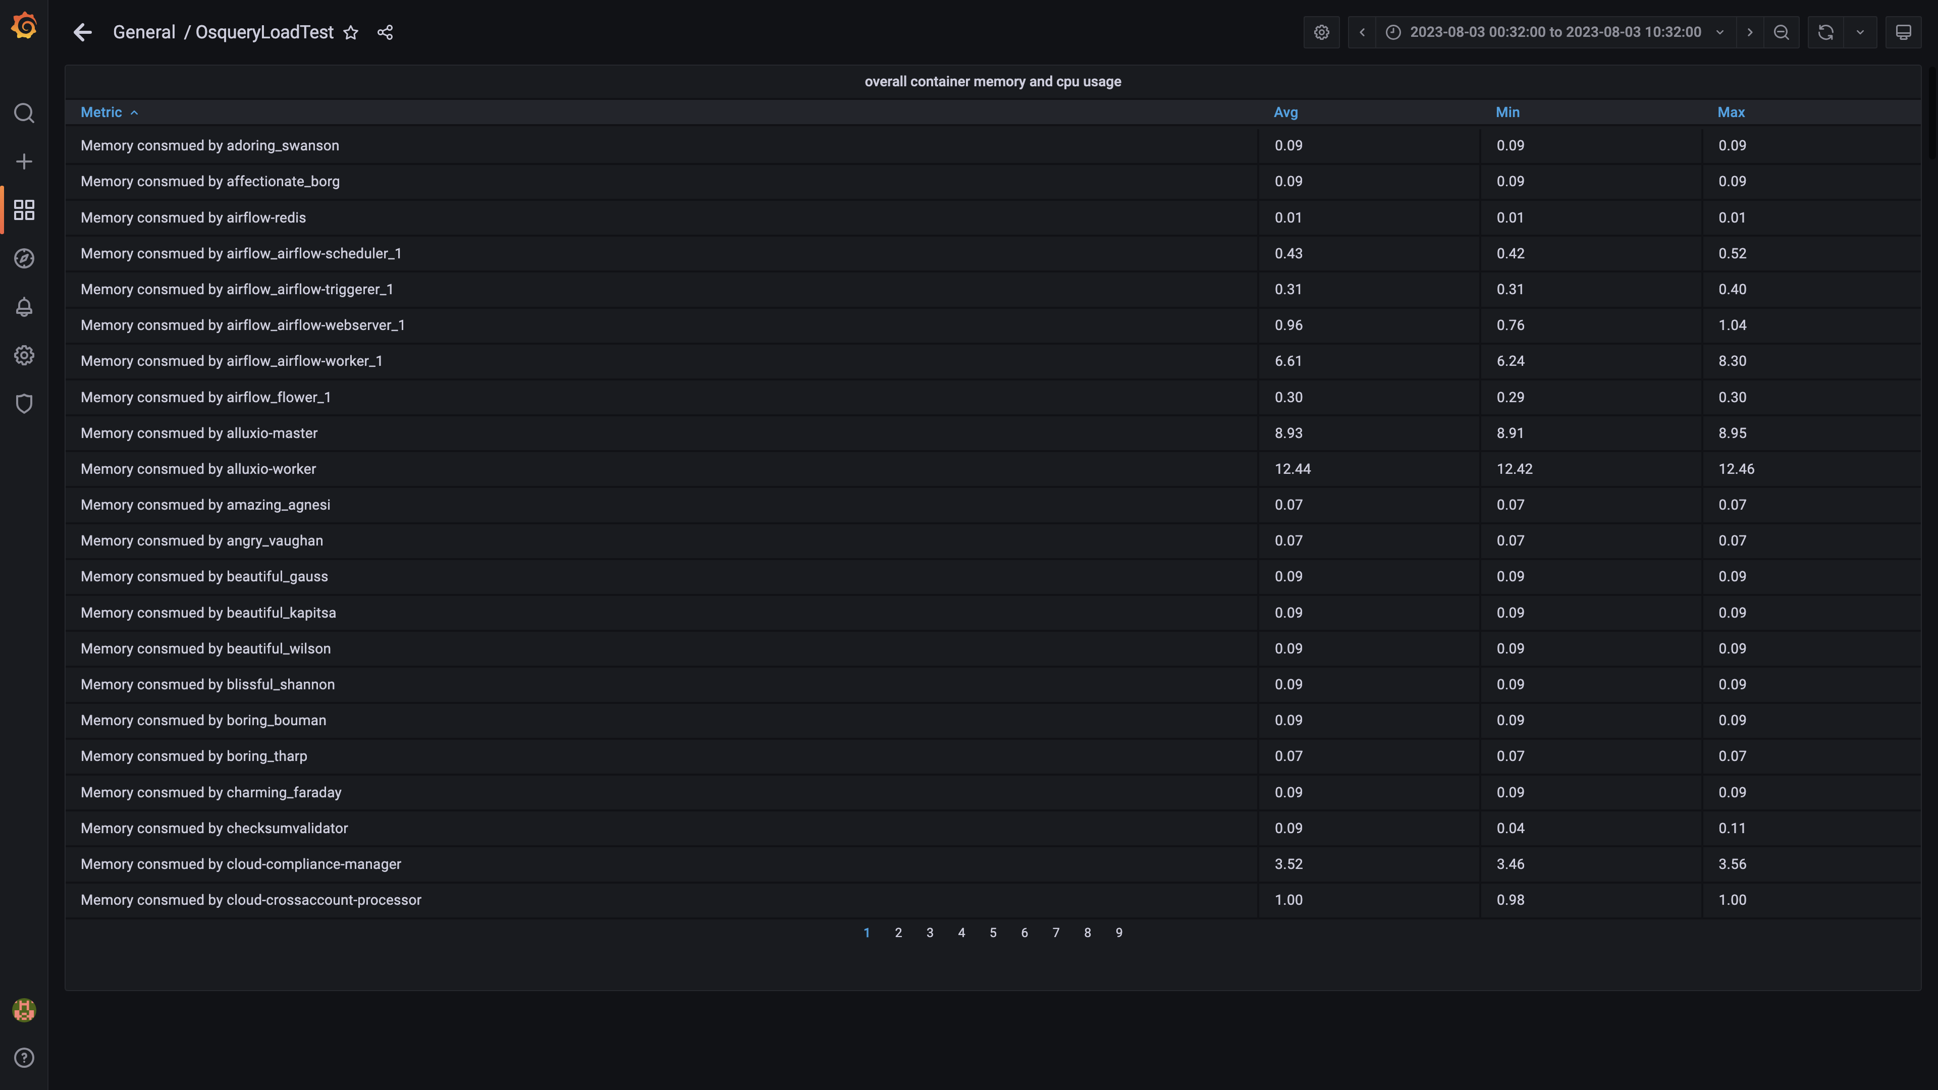

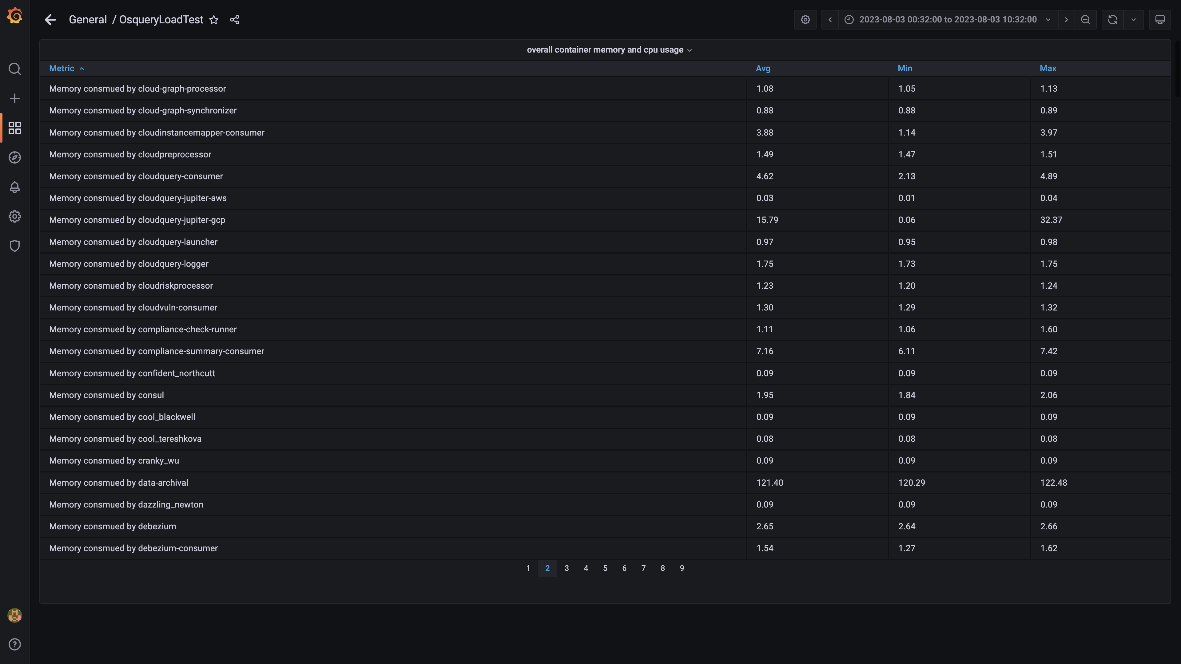

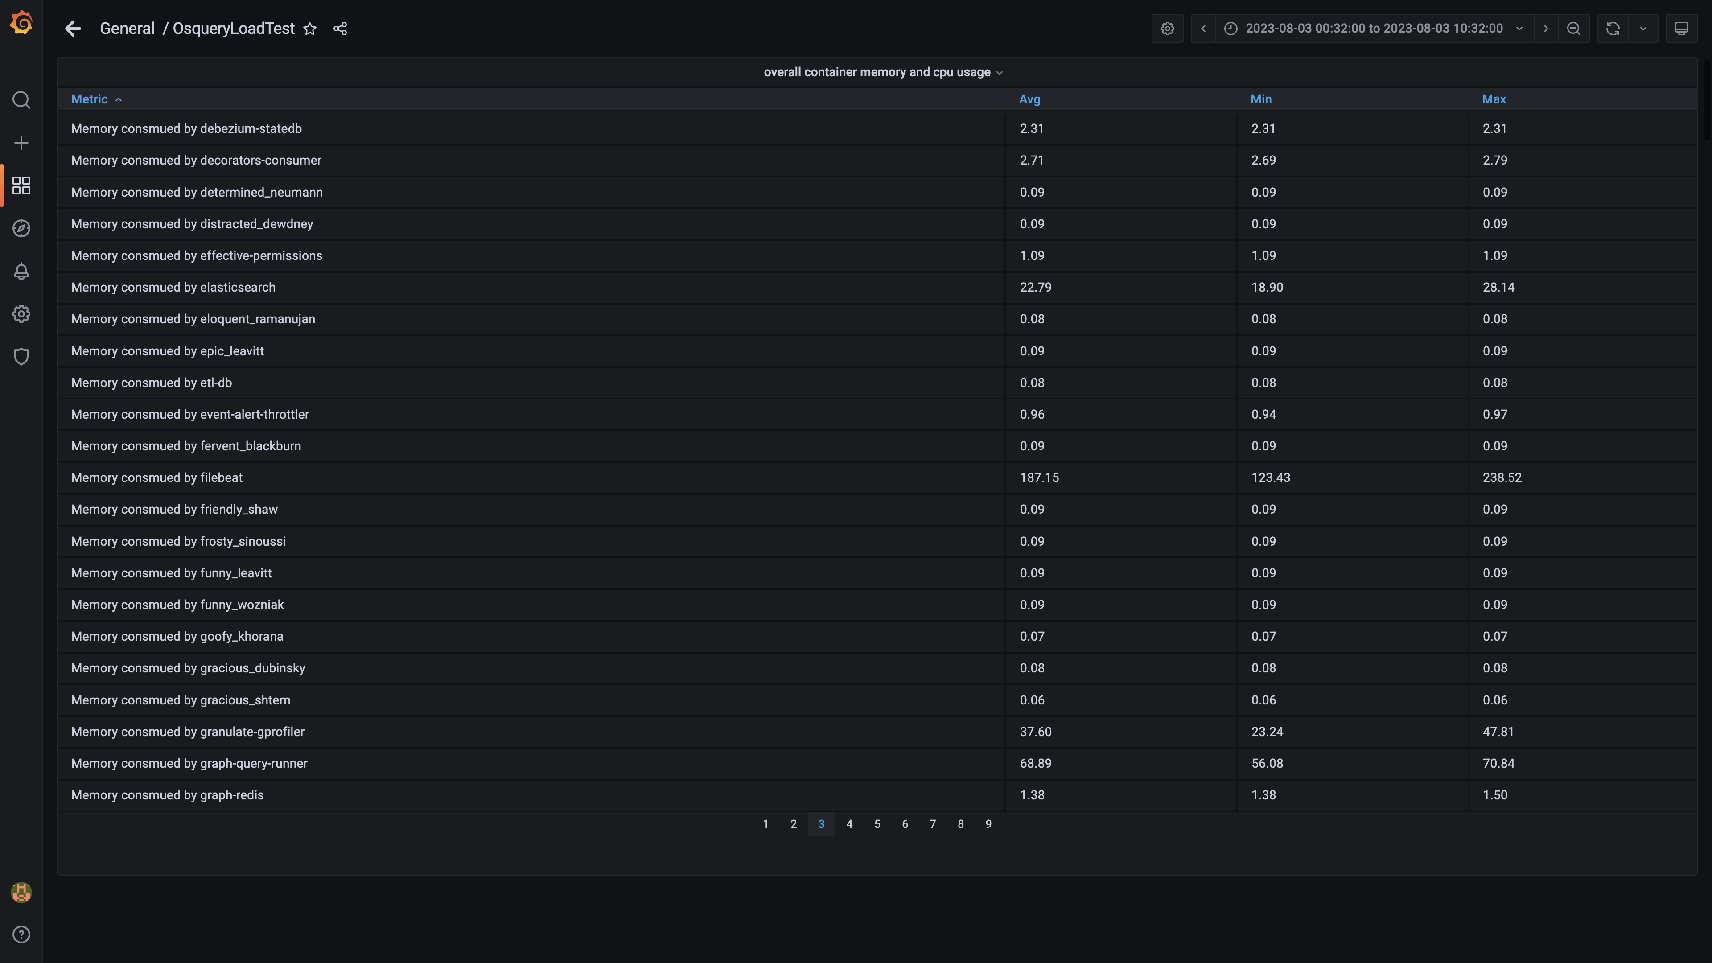

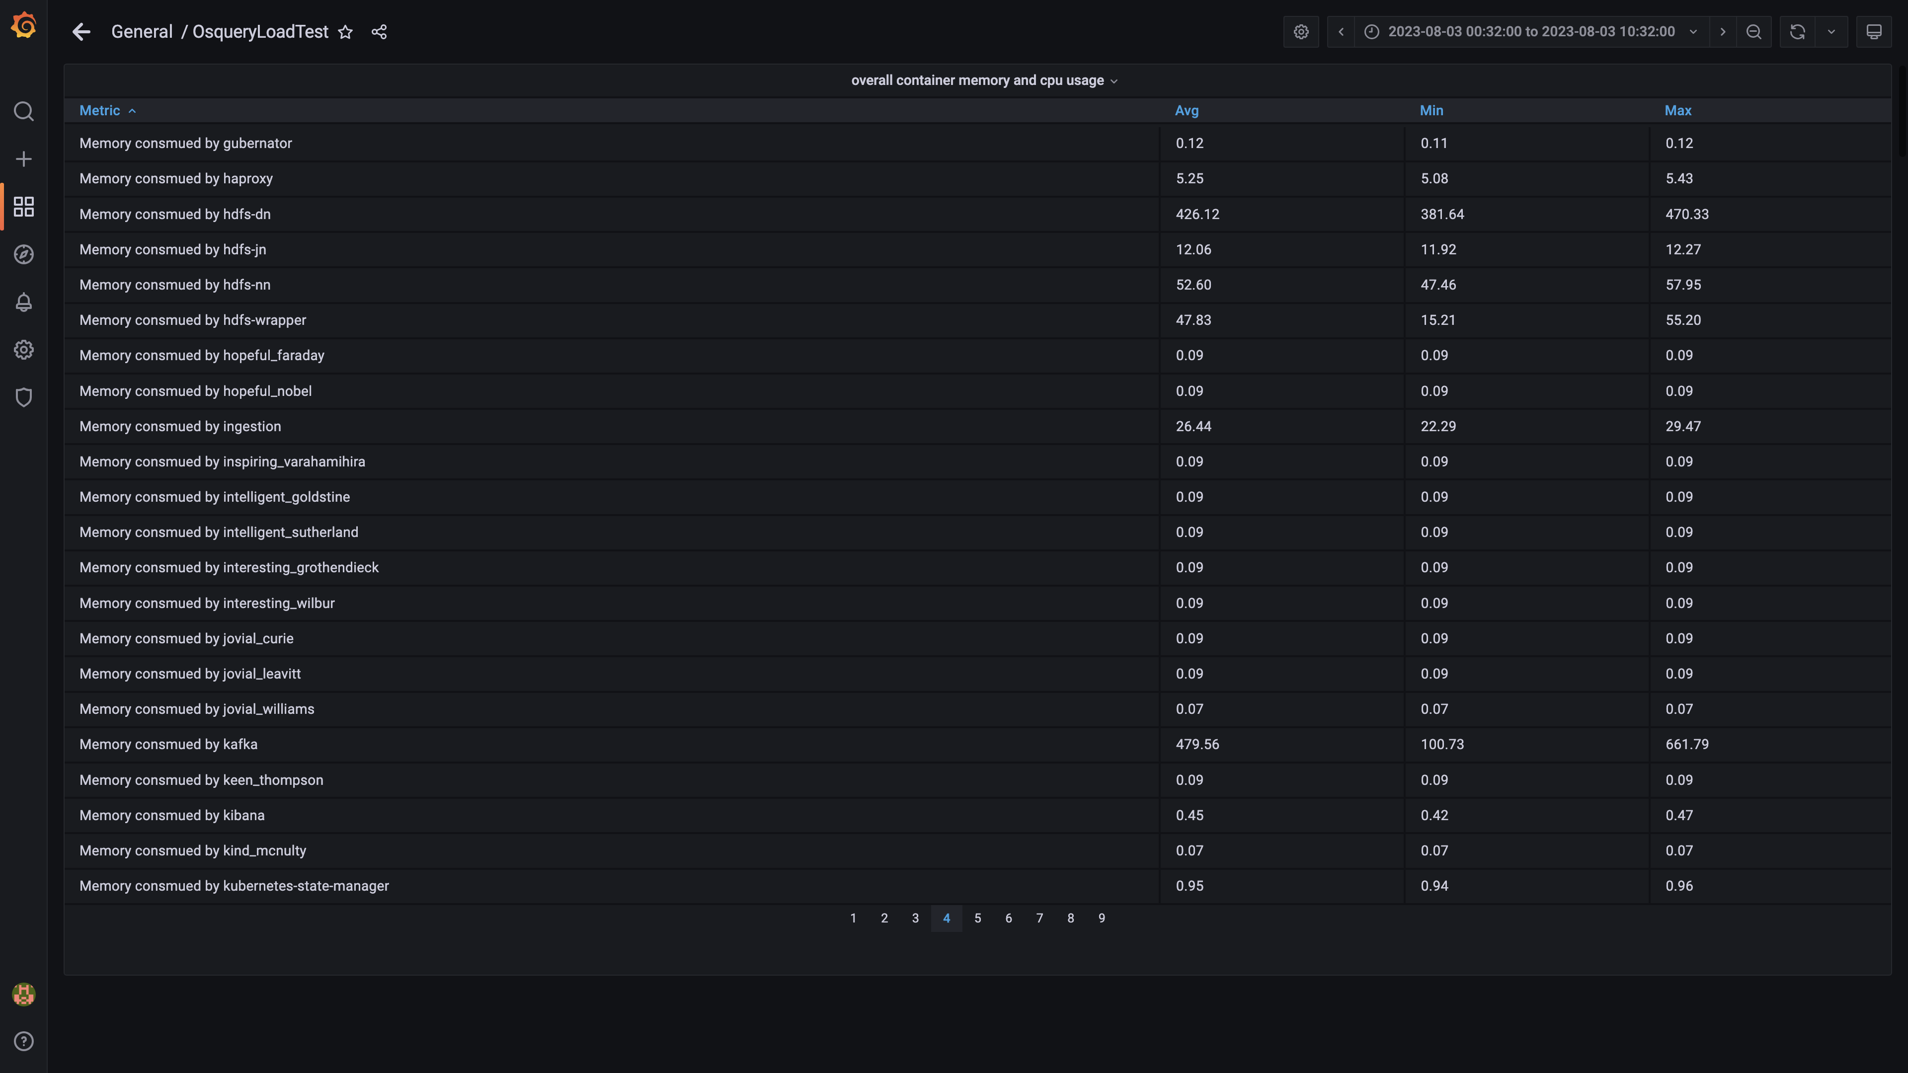

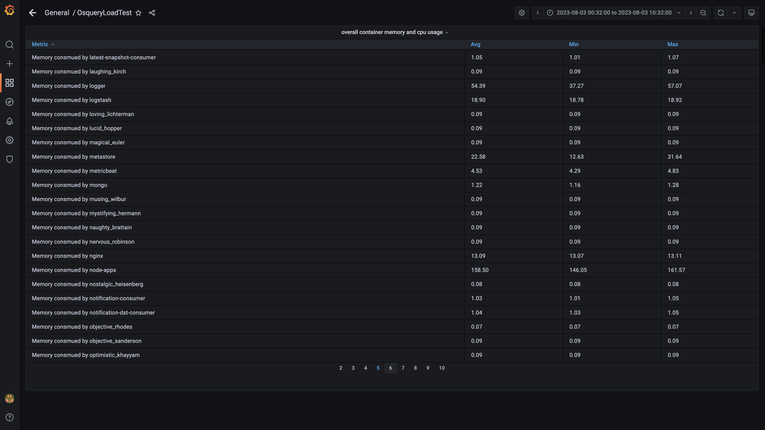

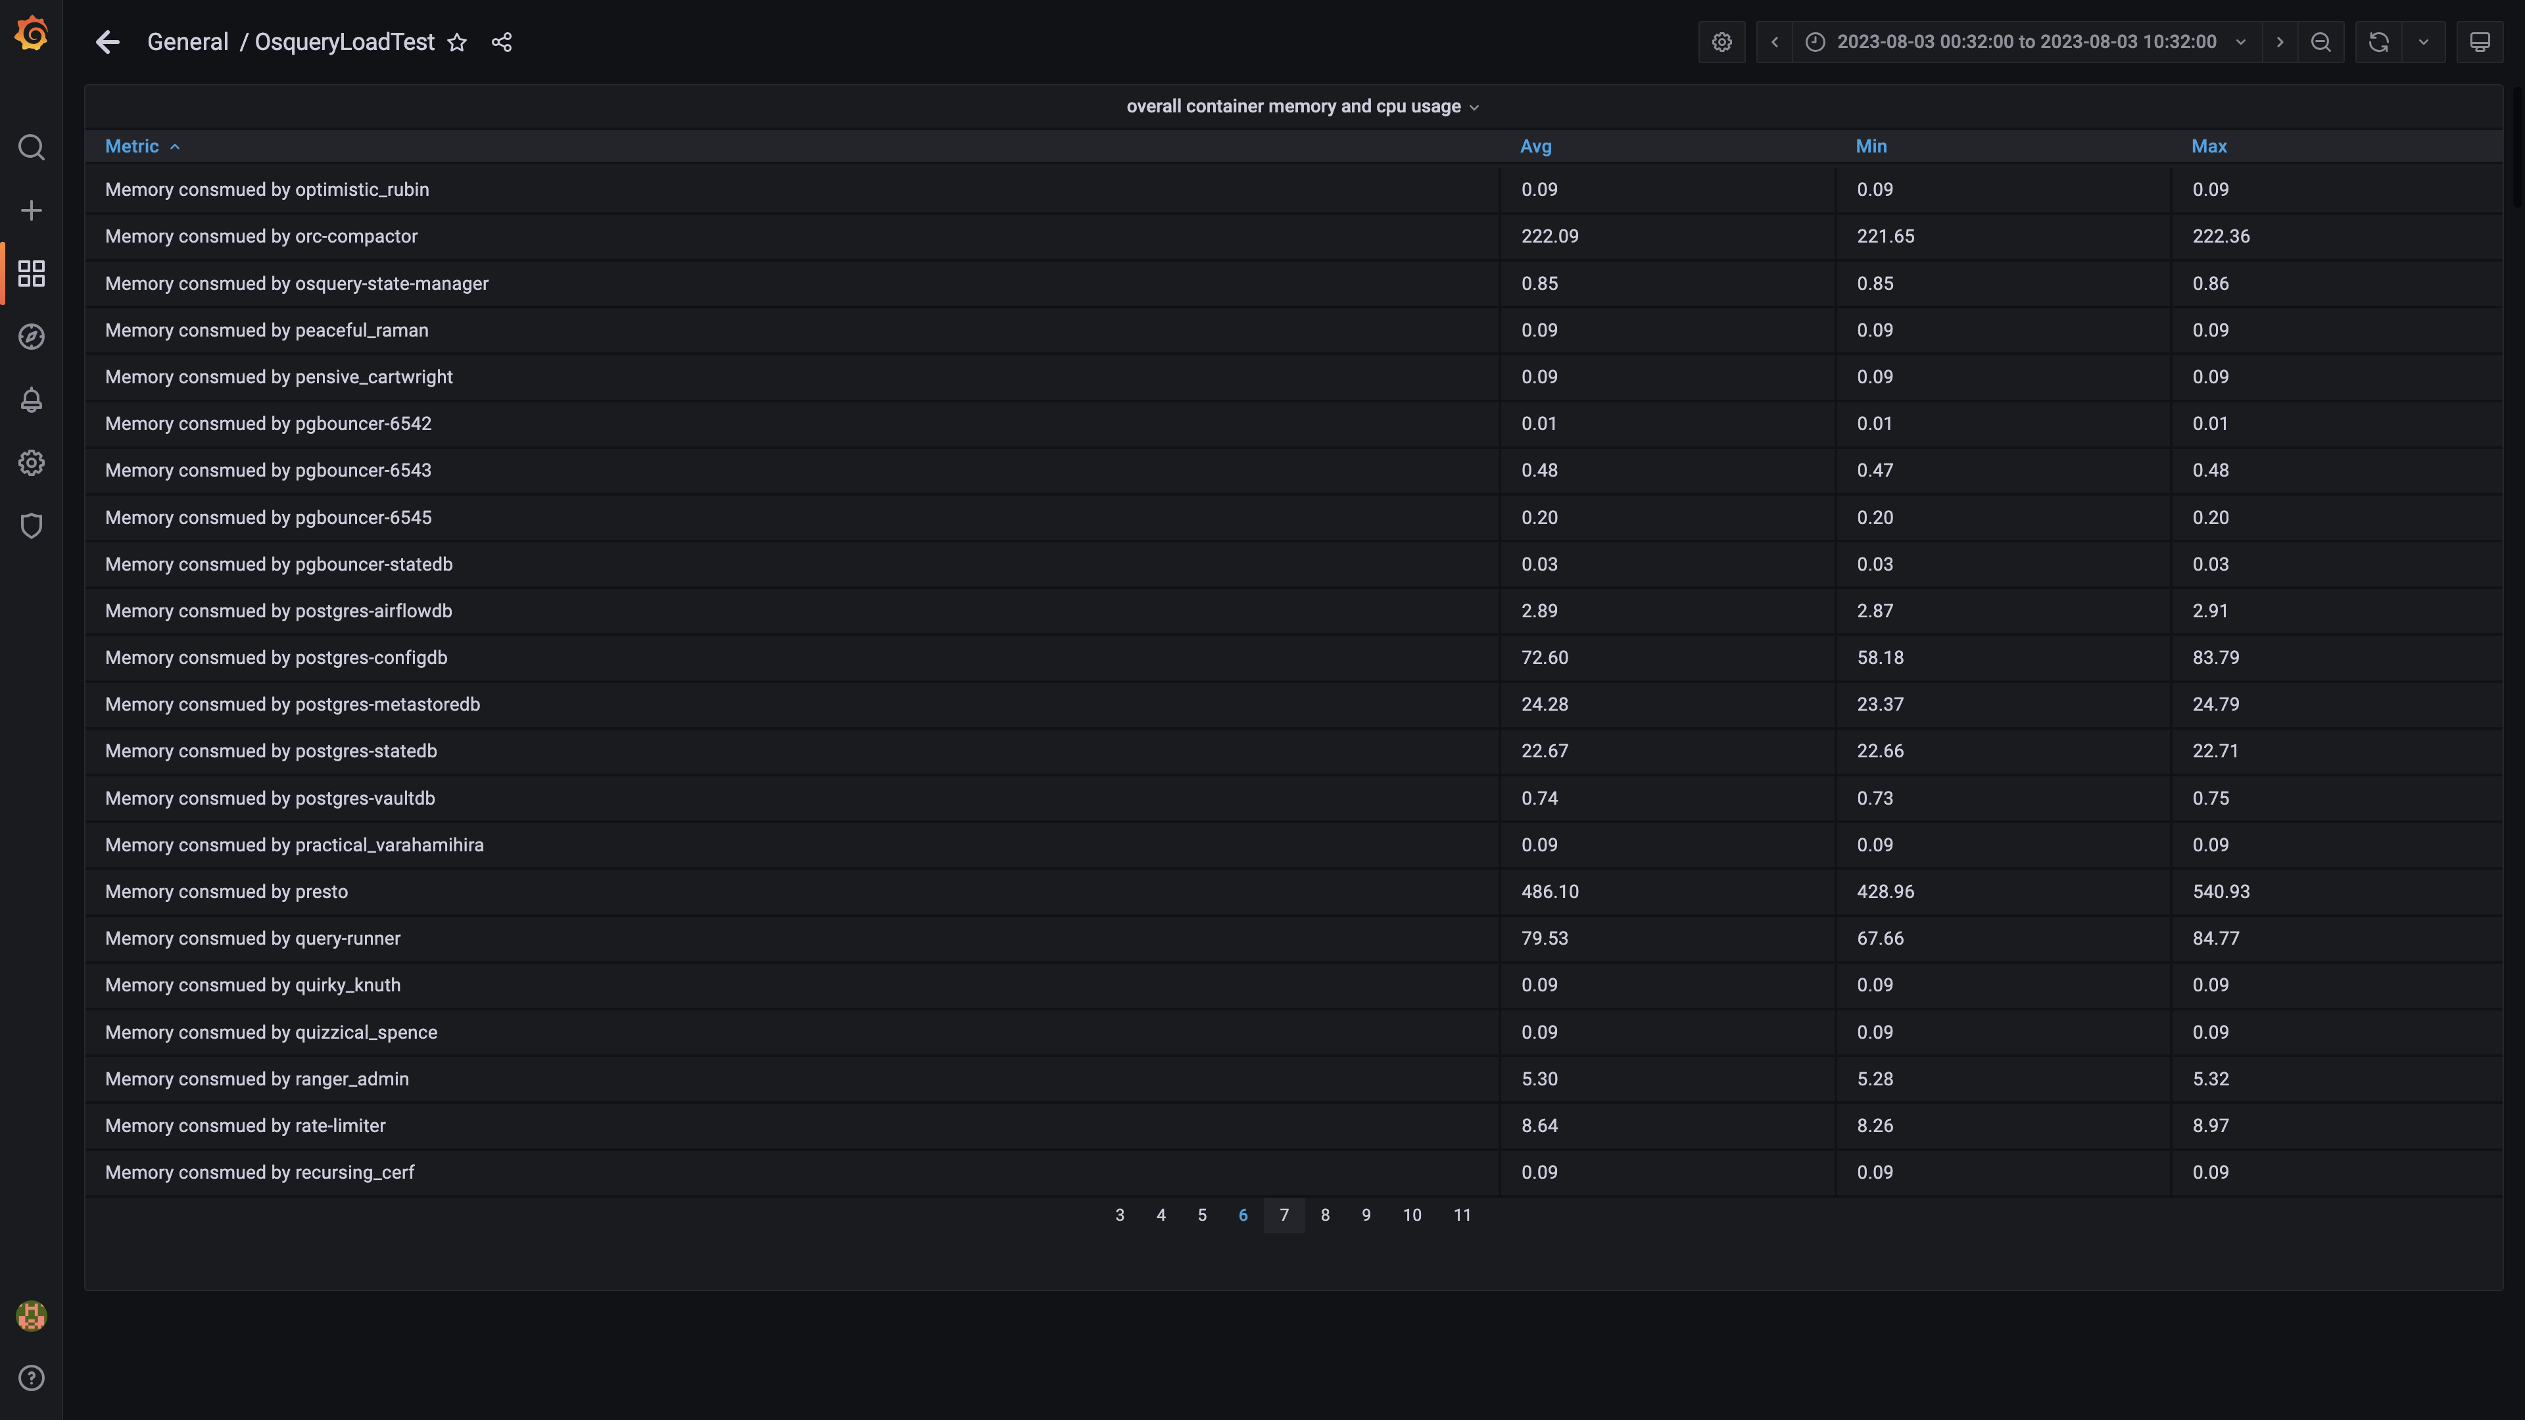

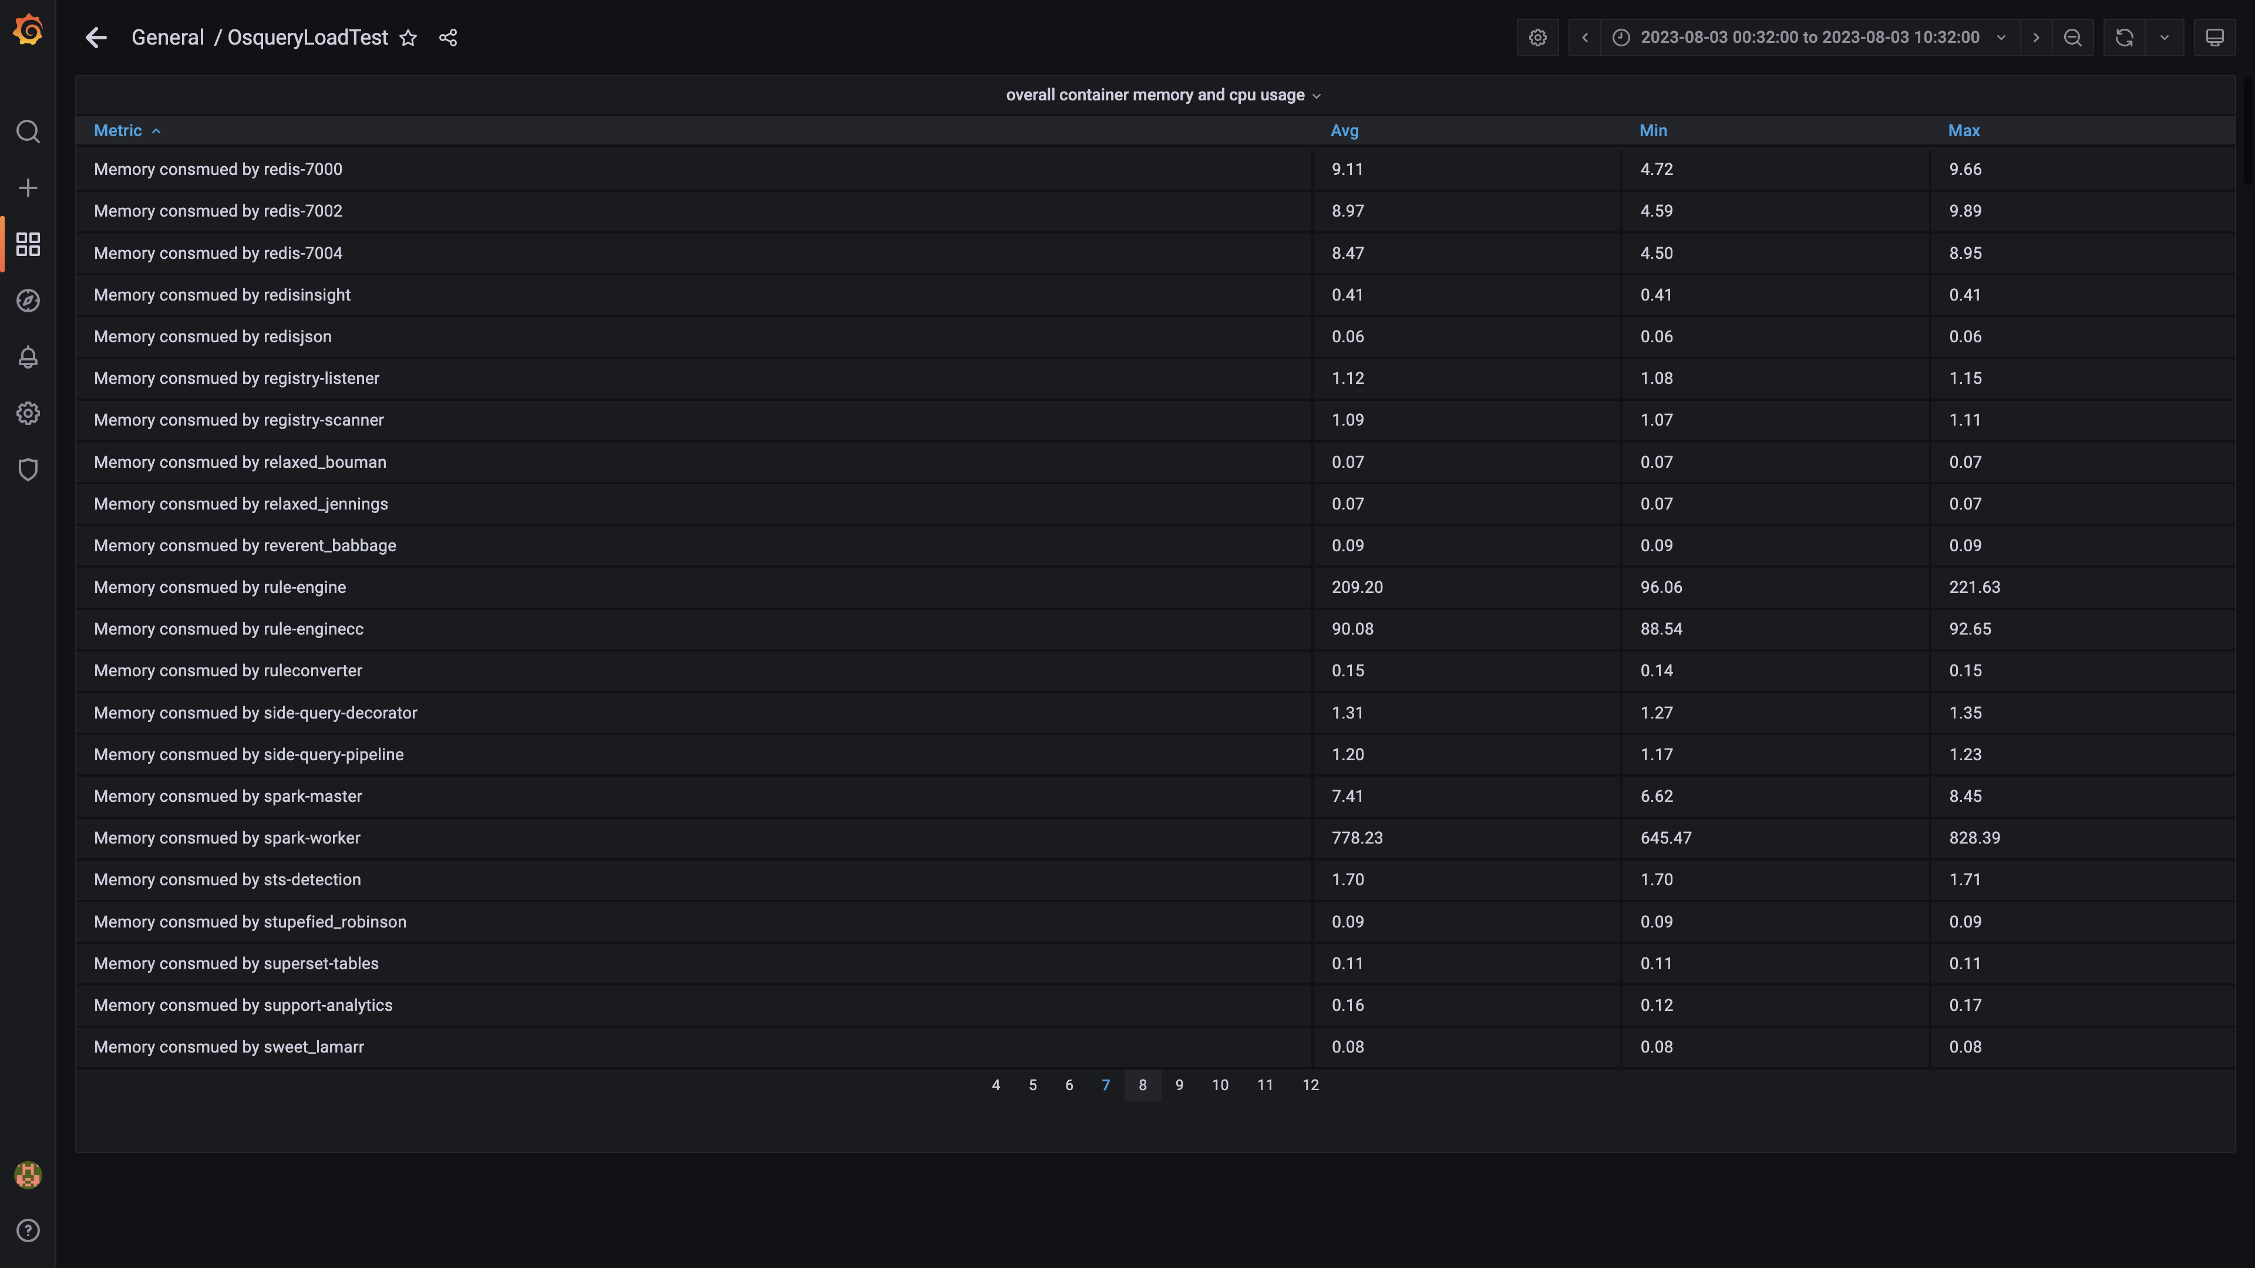

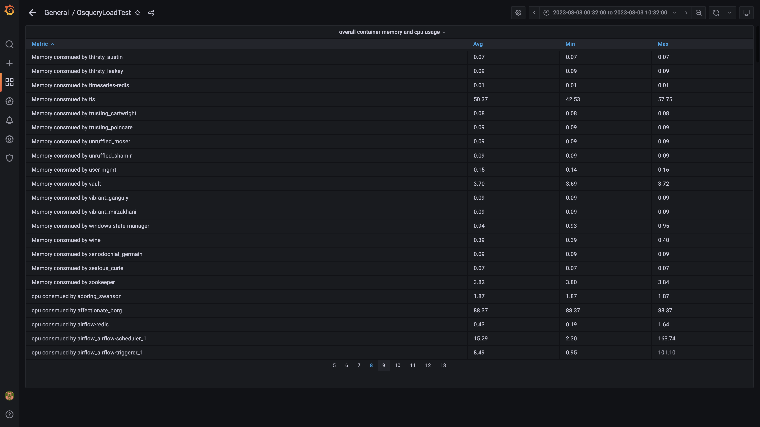

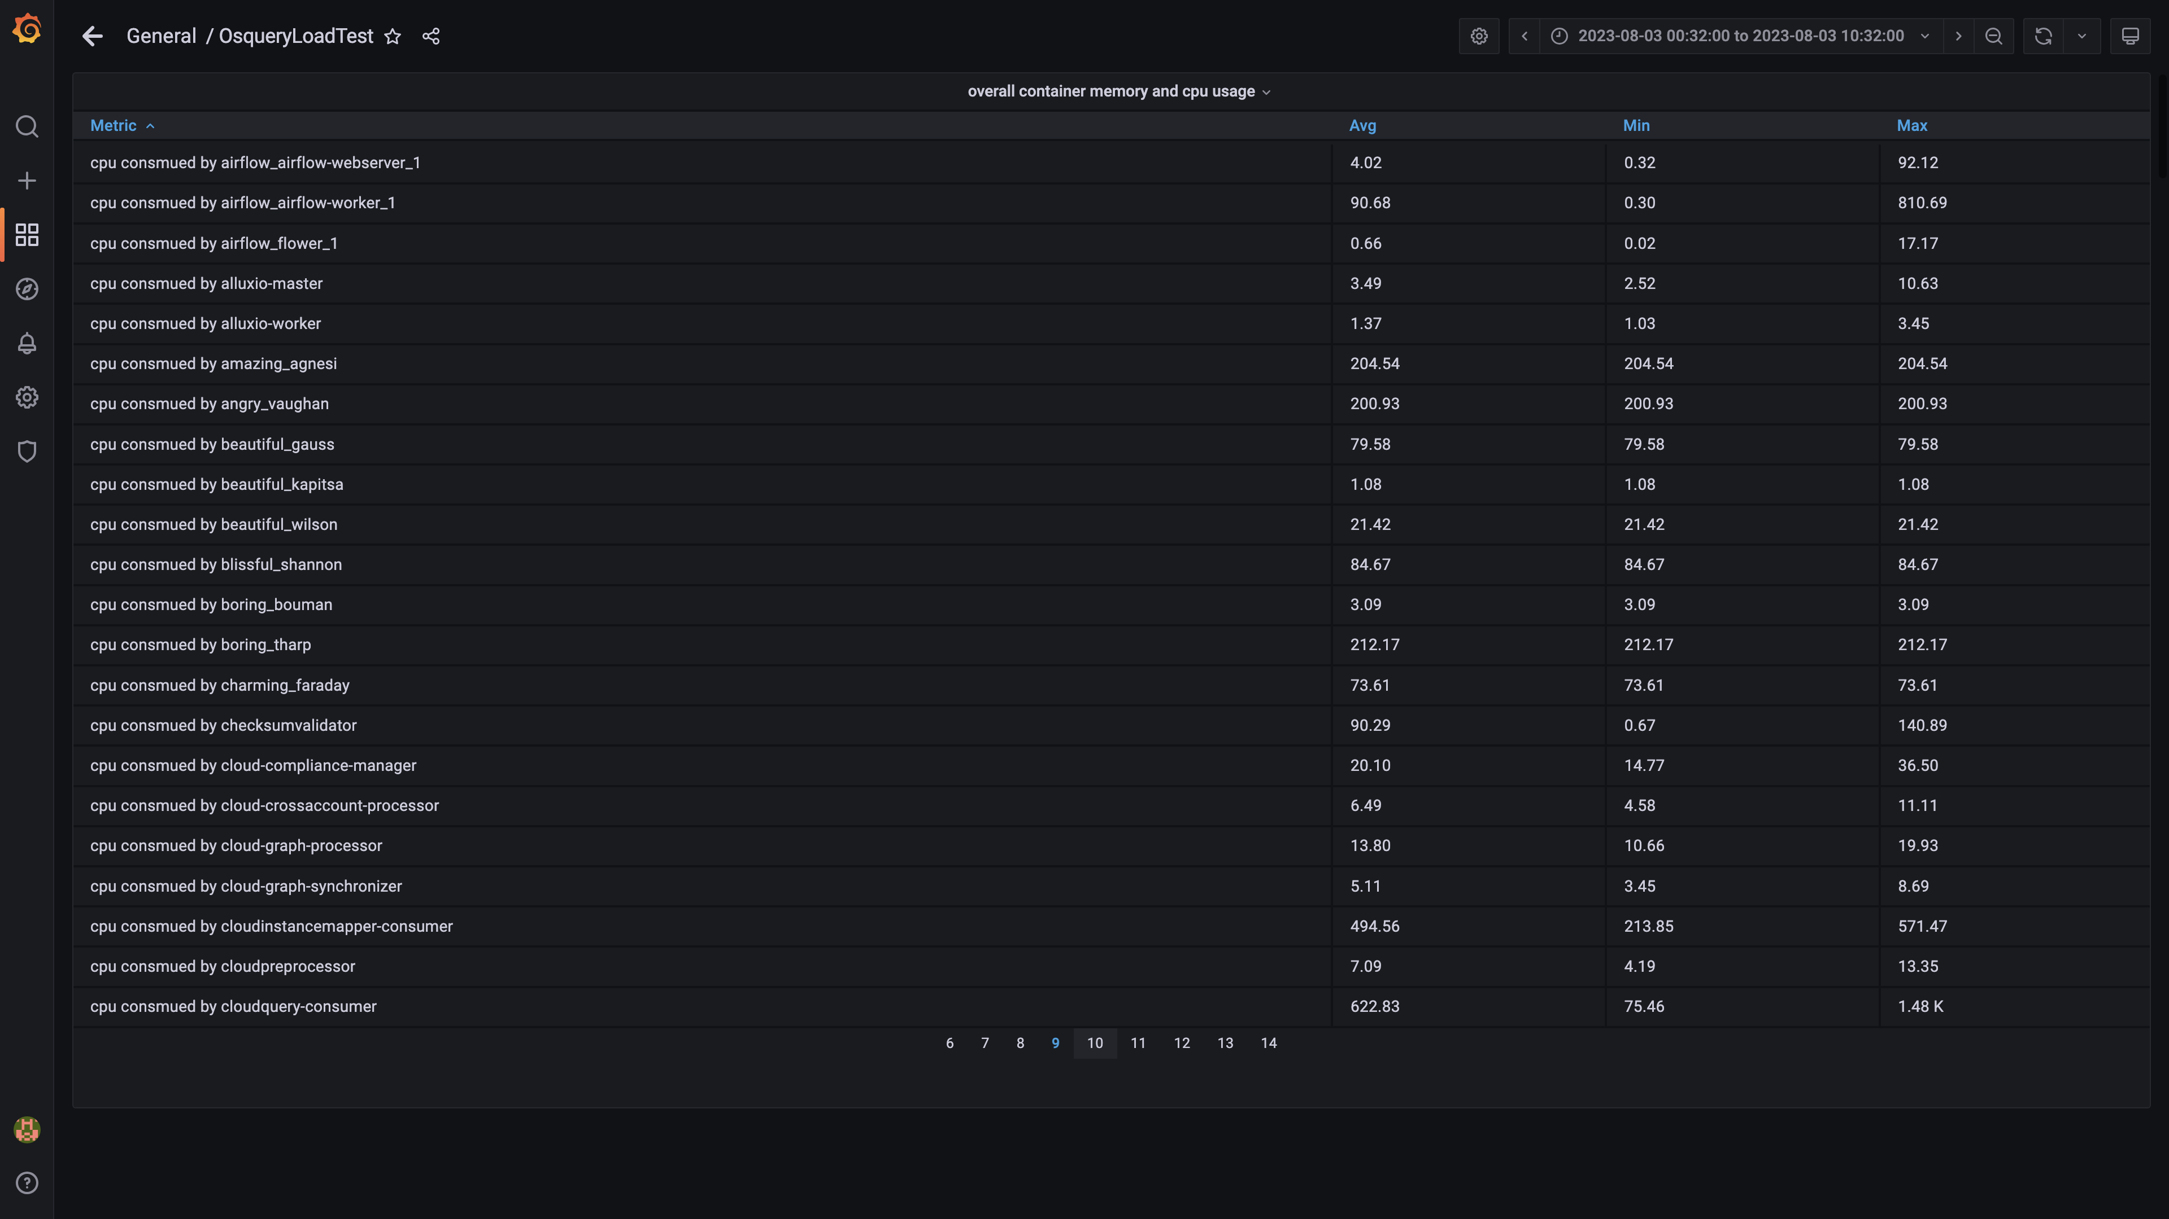

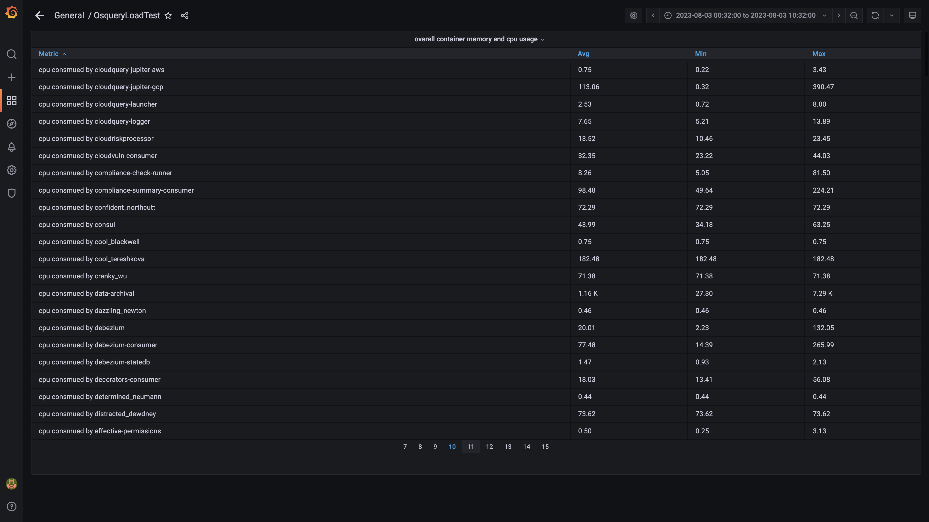

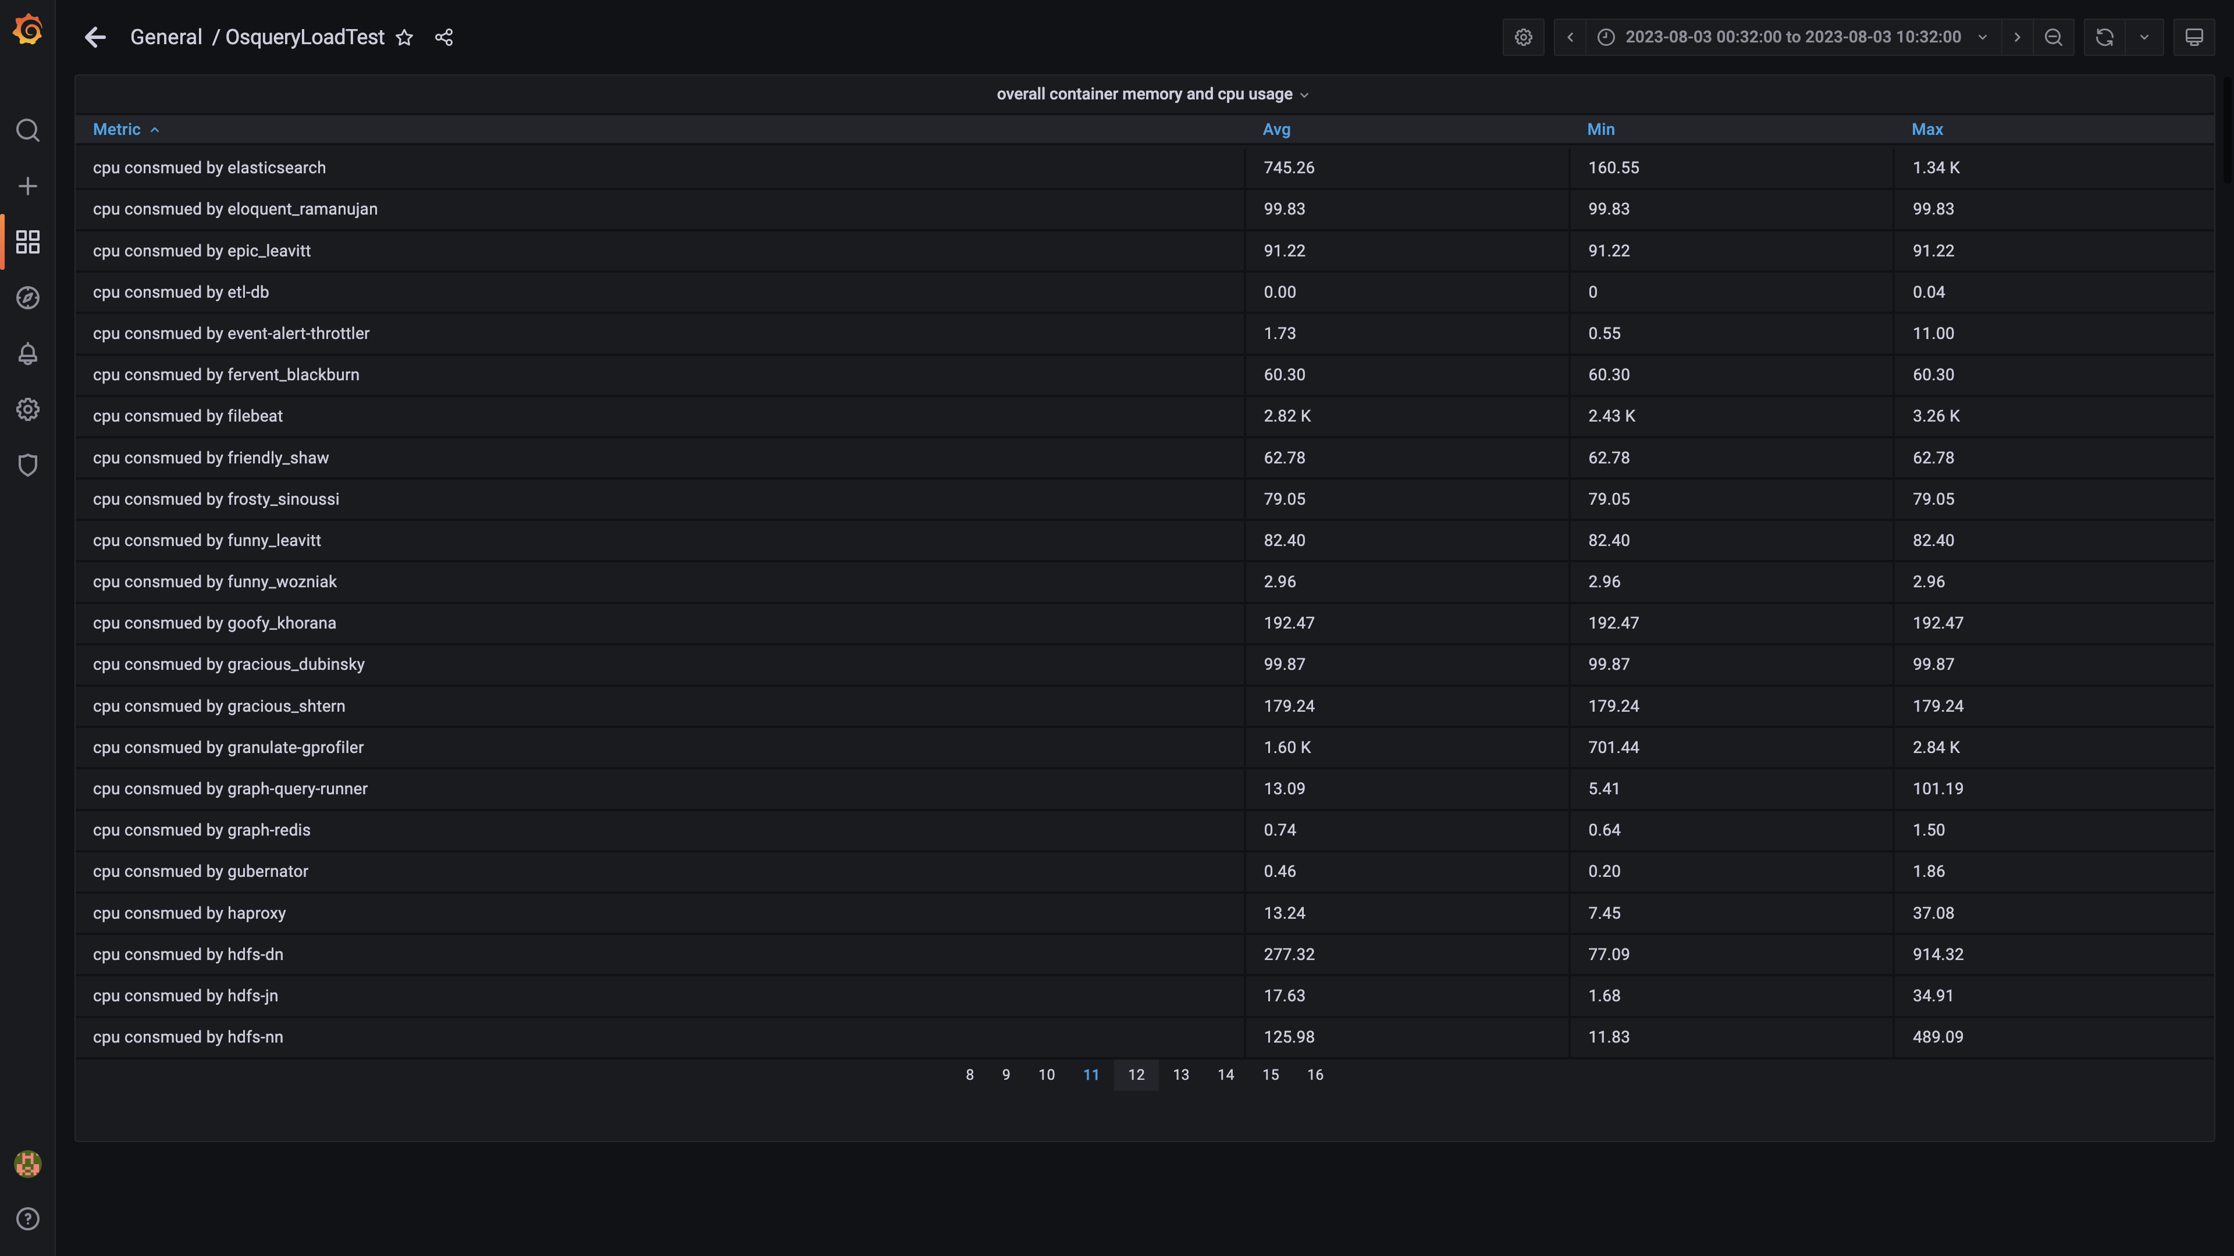

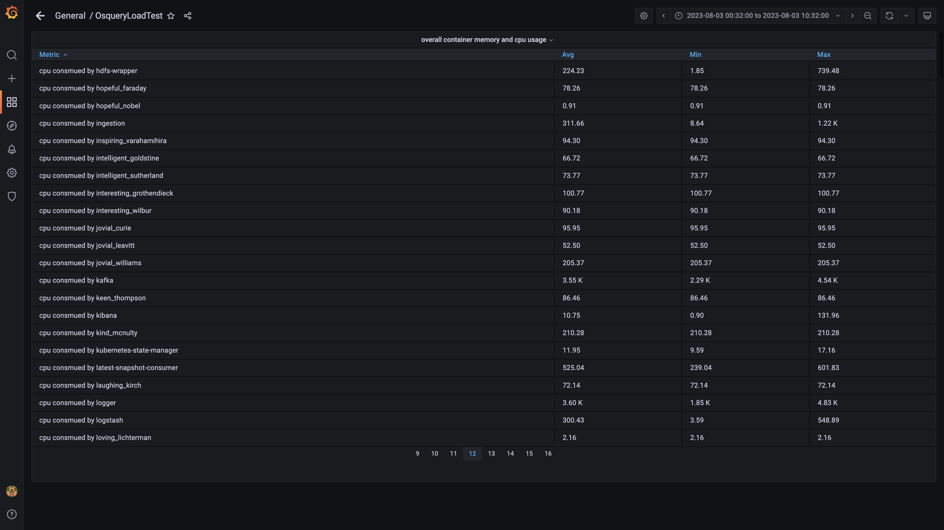

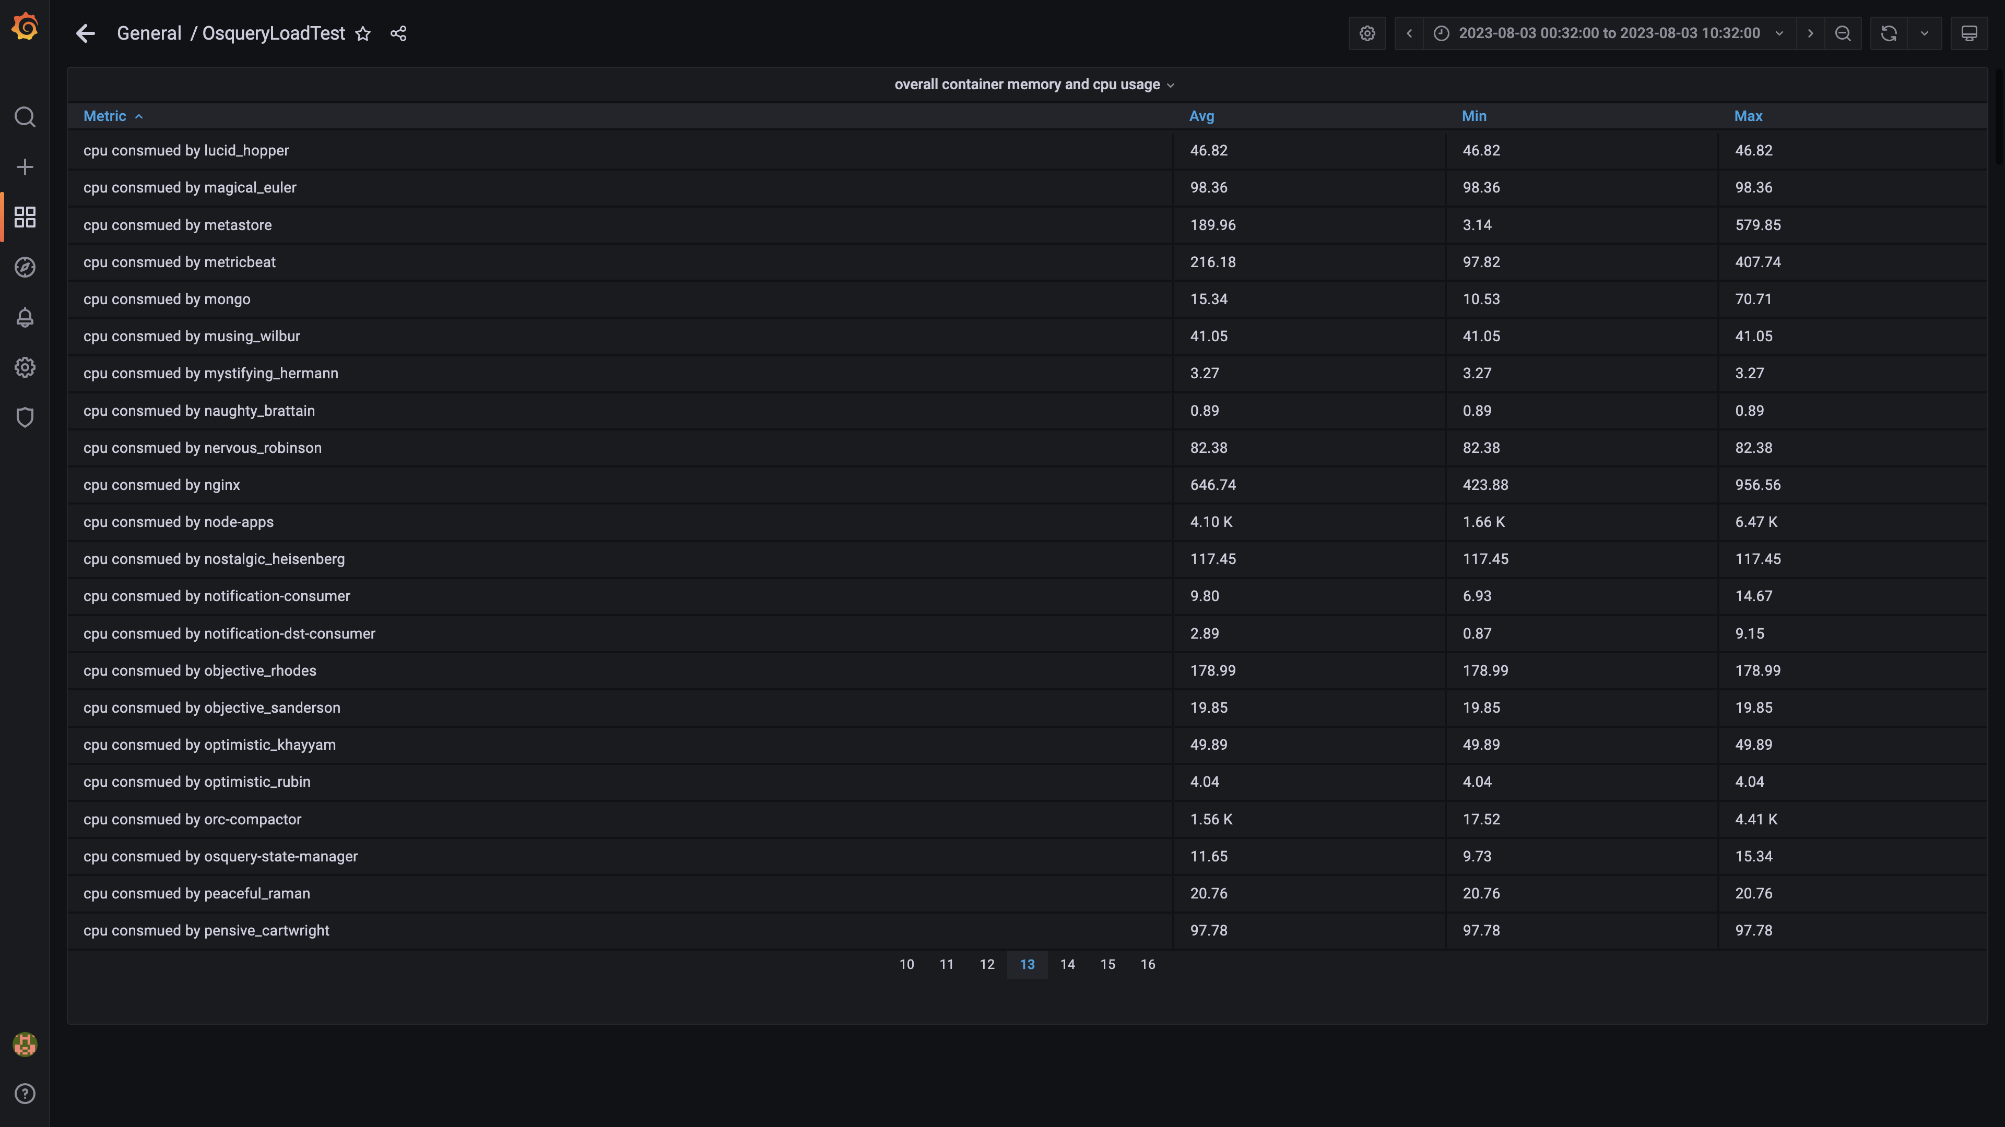

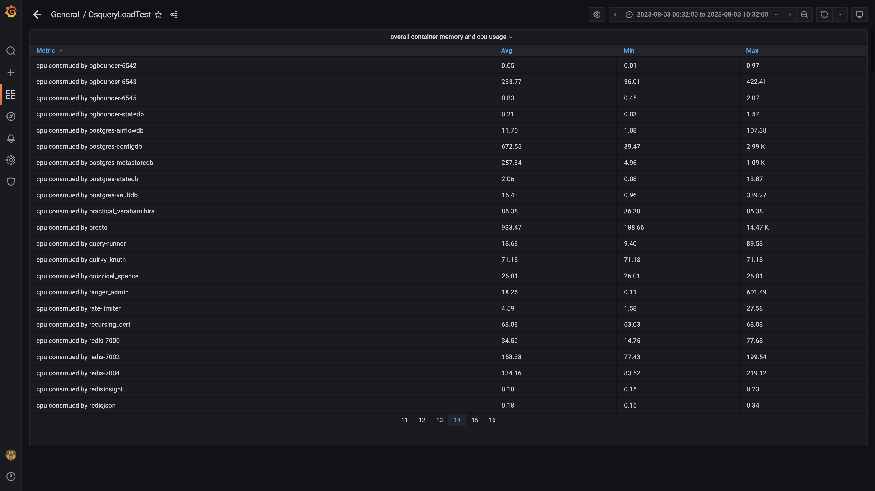

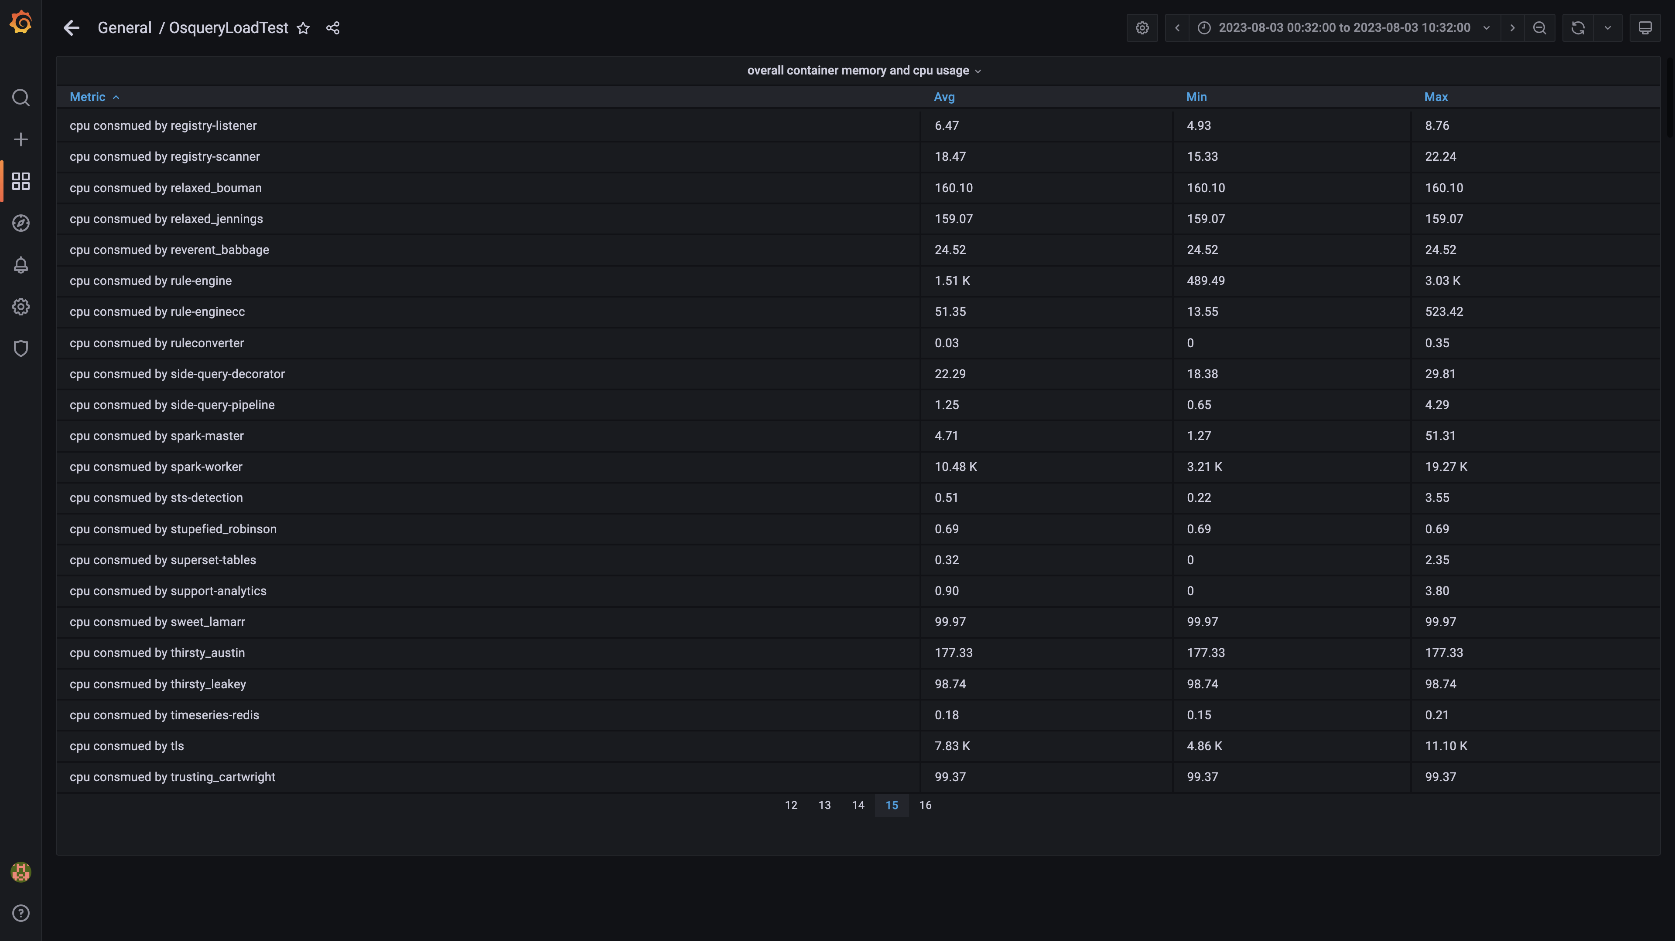

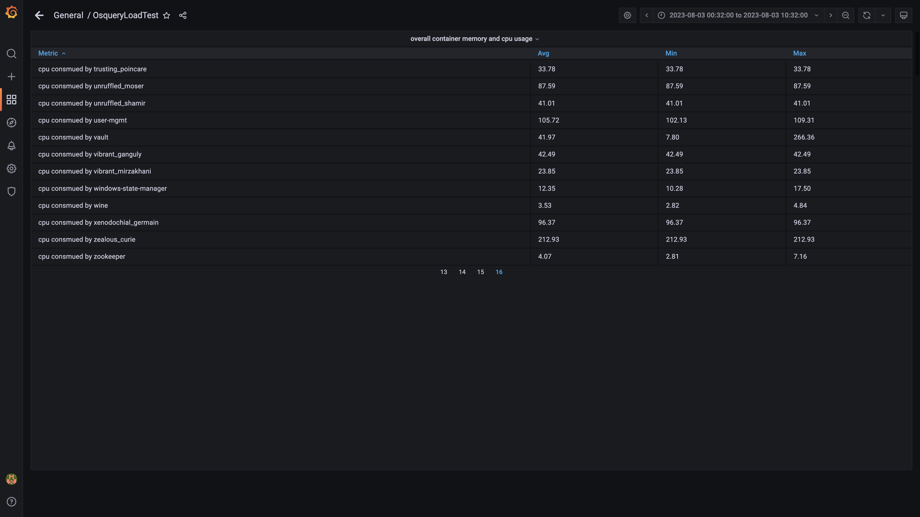

### Overall memory and cpu usages

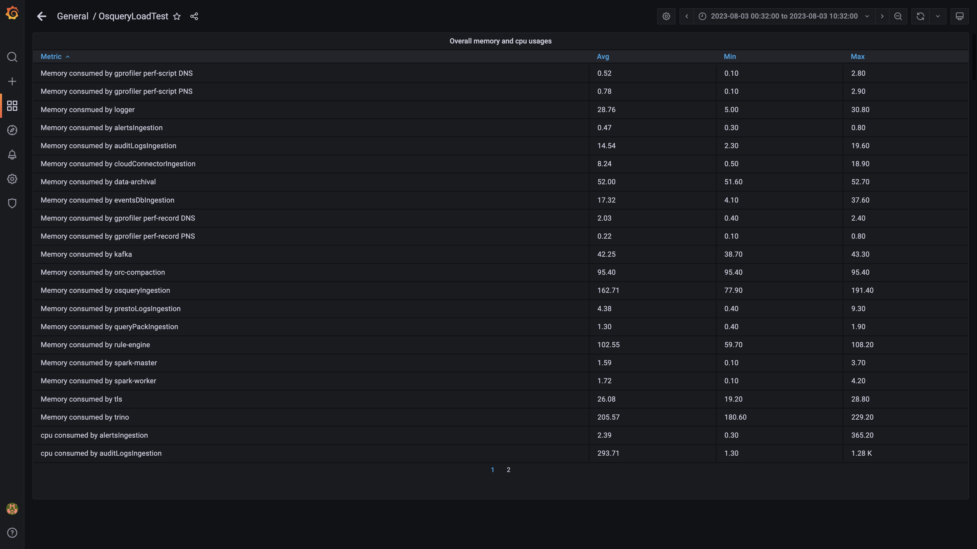

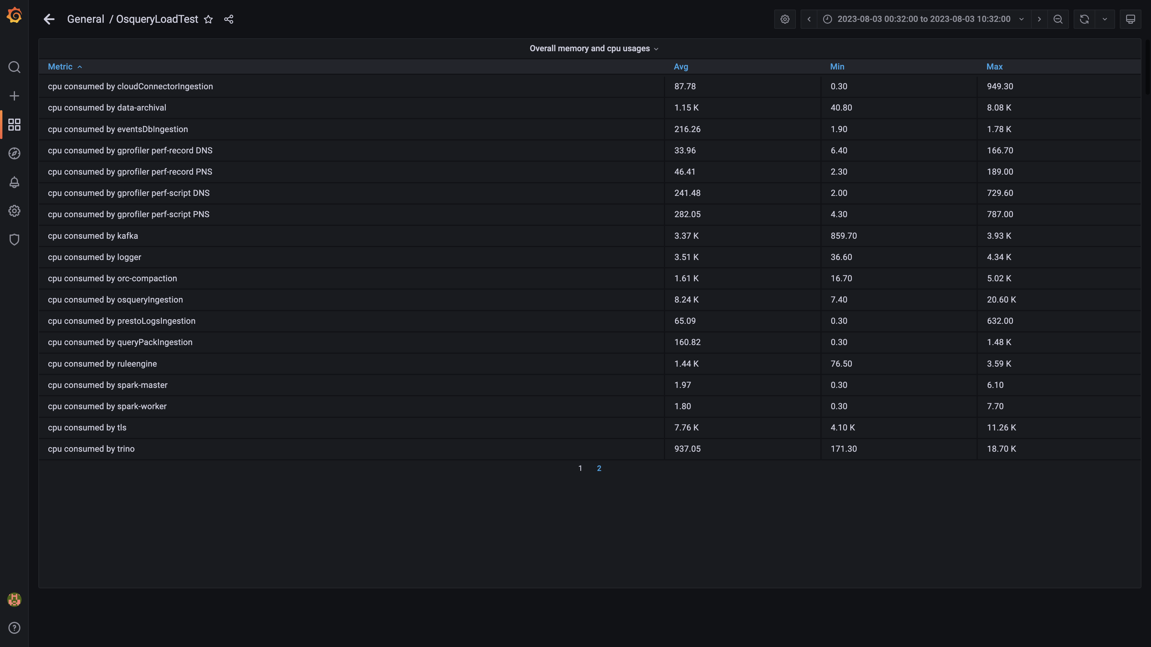

## Resource Utilization

### Comparison of average Memory utilization

|  |  |  |  |  |
| --- | --- | --- | --- | --- |
| Metric | previous | 136020 | Absolute diff(%) | Relative diff(%) |
| Memory consumed by Host s1c1dn1 | - | 72.86% | - | - |
| Memory consumed by Host s1c1dn2 | - | 65.03% | - | - |
| Memory consumed by Host s1c1dn3 | - | 65.38% | - | - |
| Memory consumed by Host s1c1dn4 | - | 74.38% | - | - |
| Memory consumed by Host s1c1dn5 | - | 74.66% | - | - |
| Memory consumed by Host s1c1dn6 | - | 75.85% | - | - |
| Memory consumed by Host s1c1pn1 | - | 52.62% | - | - |
| Memory consumed by Host s1c1pn2 | - | 51.19% | - | - |
| Memory consumed by Host s1c1pn3 | - | 52.45% | - | - |
| Memory consumed by Host s1c1pn4 | - | 49.90% | - | - |
| Memory consumed by Host s1c1pn5 | - | 49.50% | - | - |
| Memory consumed by Host s1c1pn6 | - | 47.39% | - | - |
| Memory consumed by Host s1c2dn1 | - | 54.73% | - | - |
| Memory consumed by Host s1c2dn2 | - | 54.24% | - | - |
| Memory consumed by Host s1c2dn3 | - | 57.85% | - | - |
| Memory consumed by Host s1c2dn4 | - | 67.76% | - | - |
| Memory consumed by Host s1c2dn5 | - | 68.99% | - | - |
| Memory consumed by Host s1c2dn6 | - | 66.52% | - | - |
| Memory consumed by Host s1c2pn1 | - | 45.25% | - | - |
| Memory consumed by Host s1c2pn2 | - | 45.89% | - | - |
| Memory consumed by Host s1c2pn3 | - | 45.86% | - | - |
| Memory consumed by Host s1c2pn4 | - | 46.98% | - | - |
| Memory consumed by Host s1c2pn5 | - | 45.45% | - | - |
| Memory consumed by Host s1c2pn6 | - | 38.25% | - | - |
| Memory consumed by Host s1cloudquery | - | 48.20% | - | - |
| Memory consumed by Host s1configdb1 | - | 10.39% | - | - |
| Memory consumed by Host s1configdb2 | - | 1.18% | - | - |
| Memory consumed by Host s1elasticsearch | - | 24.08% | - | - |
| Memory consumed by Host s1kibana | - | 4.19% | - | - |
| Memory consumed by Host s1logstash1 | - | 15.88% | - | - |
| Memory consumed by Host s1logstash2 | - | 15.38% | - | - |
| Memory consumed by Host s1mlnode1 | - | 7.74% | - | - |
| Memory consumed by Host s1mlnode2 | - | 4.65% | - | - |
| Memory consumed by Host s1monitor | - | 19.32% | - | - |
| Memory consumed by Host s1stsnode1 | - | 30.86% | - | - |
| Memory consumed by Host s1stsnode2 | - | 29.43% | - | - |
| Memory consumed by Host s1stsnode3 | - | 29.58% | - | - |
| Memory consumed by Rule Engine s1c1pn1 | - | 8.56% | - | - |
| Memory consumed by Rule Engine s1c1pn2 | - | 8.64% | - | - |
| Memory consumed by Rule Engine s1c1pn3 | - | 8.67% | - | - |
| Memory consumed by Rule Engine s1c1pn4 | - | 8.31% | - | - |
| Memory consumed by Rule Engine s1c1pn5 | - | 8.48% | - | - |
| Memory consumed by Rule Engine s1c1pn6 | - | 8.54% | - | - |
| Memory consumed by Rule Engine s1c2pn1 | - | 8.43% | - | - |
| Memory consumed by Rule Engine s1c2pn2 | - | 8.48% | - | - |
| Memory consumed by Rule Engine s1c2pn3 | - | 8.14% | - | - |
| Memory consumed by Rule Engine s1c2pn4 | - | 8.39% | - | - |
| Memory consumed by Rule Engine s1c2pn5 | - | 8.33% | - | - |
| Memory consumed by Rule Engine s1c2pn6 | - | 8.00% | - | - |
| Memory consumed by Osquery Ingestion s1c1dn1 | - | 11.83% | - | - |
| Memory consumed by Osquery Ingestion s1c1dn2 | - | 11.87% | - | - |
| Memory consumed by Osquery Ingestion s1c1dn3 | - | 11.71% | - | - |
| Memory consumed by Osquery Ingestion s1c1dn4 | - | 16.08% | - | - |
| Memory consumed by Osquery Ingestion s1c1dn5 | - | 15.84% | - | - |
| Memory consumed by Osquery Ingestion s1c1dn6 | - | 15.84% | - | - |
| Memory consumed by Osquery Ingestion s1c2dn1 | - | 11.76% | - | - |
| Memory consumed by Osquery Ingestion s1c2dn2 | - | 11.75% | - | - |
| Memory consumed by Osquery Ingestion s1c2dn3 | - | 12.30% | - | - |
| Memory consumed by Osquery Ingestion s1c2dn4 | - | 15.30% | - | - |
| Memory consumed by Osquery Ingestion s1c2dn5 | - | 15.32% | - | - |
| Memory consumed by Osquery Ingestion s1c2dn6 | - | 15.59% | - | - |
| Memory consumed by Kafka s1c1pn1 | - | 2.75% | - | - |
| Memory consumed by Kafka s1c1pn2 | - | 3.55% | - | - |
| Memory consumed by Kafka s1c1pn3 | - | 3.52% | - | - |
| Memory consumed by Kafka s1c1pn4 | - | 3.50% | - | - |
| Memory consumed by Kafka s1c1pn5 | - | 3.52% | - | - |
| Memory consumed by Kafka s1c1pn6 | - | 3.52% | - | - |
| Memory consumed by Kafka s1c2pn1 | - | 2.79% | - | - |
| Memory consumed by Kafka s1c2pn2 | - | 3.50% | - | - |
| Memory consumed by Kafka s1c2pn3 | - | 3.53% | - | - |
| Memory consumed by Kafka s1c2pn4 | - | 3.51% | - | - |
| Memory consumed by Kafka s1c2pn5 | - | 3.53% | - | - |
| Memory consumed by Kafka s1c2pn6 | - | 3.52% | - | - |
| Memory consumed by Trino s1c1dn1 | - | 18.96% | - | - |
| Memory consumed by Trino s1c1dn2 | - | 16.25% | - | - |
| Memory consumed by Trino s1c1dn3 | - | 16.37% | - | - |
| Memory consumed by Trino s1c1dn4 | - | 17.17% | - | - |
| Memory consumed by Trino s1c1dn5 | - | 17.40% | - | - |
| Memory consumed by Trino s1c1dn6 | - | 17.79% | - | - |
| Memory consumed by Trino s1c1pn1 | - | 0.10% | - | - |
| Memory consumed by Trino s1c2dn1 | - | 16.39% | - | - |
| Memory consumed by Trino s1c2dn2 | - | 16.34% | - | - |
| Memory consumed by Trino s1c2dn3 | - | 16.50% | - | - |
| Memory consumed by Trino s1c2dn4 | - | 17.26% | - | - |
| Memory consumed by Trino s1c2dn5 | - | 18.20% | - | - |
| Memory consumed by Trino s1c2dn6 | - | 16.92% | - | - |
| Memory consumed by Tls s1c1pn1 | - | 0.27% | - | - |
| Memory consumed by Tls s1c1pn2 | - | 0.27% | - | - |
| Memory consumed by Tls s1c1pn3 | - | 0.27% | - | - |
| Memory consumed by Tls s1c1pn4 | - | 0.27% | - | - |
| Memory consumed by Tls s1c1pn5 | - | 0.27% | - | - |
| Memory consumed by Tls s1c1pn6 | - | 0.27% | - | - |
| Memory consumed by Tls s1c2pn1 | - | 0.28% | - | - |
| Memory consumed by Tls s1c2pn2 | - | 0.27% | - | - |
| Memory consumed by Tls s1c2pn3 | - | 0.27% | - | - |
| Memory consumed by Tls s1c2pn4 | - | 0.27% | - | - |
| Memory consumed by Tls s1c2pn5 | - | 0.27% | - | - |
| Memory consumed by Tls s1c2pn6 | - | 0.27% | - | - |
| Memory consumed by EventsDbIngestion s1c1dn1 | - | 0.70% | - | - |
| Memory consumed by EventsDbIngestion s1c1dn2 | - | 1.04% | - | - |
| Memory consumed by EventsDbIngestion s1c1dn3 | - | 1.11% | - | - |
| Memory consumed by EventsDbIngestion s1c1dn4 | - | 1.42% | - | - |
| Memory consumed by EventsDbIngestion s1c1dn5 | - | 1.46% | - | - |
| Memory consumed by EventsDbIngestion s1c1dn6 | - | 1.41% | - | - |
| Memory consumed by EventsDbIngestion s1c2dn1 | - | 1.09% | - | - |
| Memory consumed by EventsDbIngestion s1c2dn2 | - | 1.12% | - | - |
| Memory consumed by EventsDbIngestion s1c2dn3 | - | 0.76% | - | - |
| Memory consumed by EventsDbIngestion s1c2dn4 | - | 1.46% | - | - |
| Memory consumed by EventsDbIngestion s1c2dn5 | - | 1.46% | - | - |
| Memory consumed by EventsDbIngestion s1c2dn6 | - | 1.38% | - | - |
| Memory consumed by Logger s1c1pn1 | - | 2.41% | - | - |
| Memory consumed by Logger s1c1pn2 | - | 2.40% | - | - |
| Memory consumed by Logger s1c1pn3 | - | 2.40% | - | - |
| Memory consumed by Logger s1c1pn4 | - | 2.41% | - | - |
| Memory consumed by Logger s1c1pn5 | - | 2.40% | - | - |
| Memory consumed by Logger s1c1pn6 | - | 2.40% | - | - |
| Memory consumed by Logger s1c2pn1 | - | 2.40% | - | - |
| Memory consumed by Logger s1c2pn2 | - | 2.40% | - | - |
| Memory consumed by Logger s1c2pn3 | - | 2.40% | - | - |
| Memory consumed by Logger s1c2pn4 | - | 2.40% | - | - |
| Memory consumed by Logger s1c2pn5 | - | 2.40% | - | - |
| Memory consumed by Logger s1c2pn6 | - | 2.40% | - | - |

## Resource Utilization

### Comparison of average CPU utilization

|  |  |  |  |  |
| --- | --- | --- | --- | --- |
| Metric | previous | 136020 | Absolute diff(%) | Relative diff(%) |
| CPU consumed by Host s1c1dn1 | - | 56.80% | - | - |
| CPU consumed by Host s1c1dn2 | - | 51.61% | - | - |
| CPU consumed by Host s1c1dn3 | - | 51.60% | - | - |
| CPU consumed by Host s1c1dn4 | - | 49.57% | - | - |
| CPU consumed by Host s1c1dn5 | - | 50.71% | - | - |
| CPU consumed by Host s1c1dn6 | - | 52.25% | - | - |
| CPU consumed by Host s1c1pn1 | - | 78.91% | - | - |
| CPU consumed by Host s1c1pn2 | - | 76.09% | - | - |
| CPU consumed by Host s1c1pn3 | - | 75.22% | - | - |
| CPU consumed by Host s1c1pn4 | - | 75.49% | - | - |
| CPU consumed by Host s1c1pn5 | - | 82.30% | - | - |
| CPU consumed by Host s1c1pn6 | - | 79.21% | - | - |
| CPU consumed by Host s1c2dn1 | - | 39.59% | - | - |
| CPU consumed by Host s1c2dn2 | - | 39.88% | - | - |
| CPU consumed by Host s1c2dn3 | - | 40.54% | - | - |
| CPU consumed by Host s1c2dn4 | - | 39.09% | - | - |
| CPU consumed by Host s1c2dn5 | - | 39.64% | - | - |
| CPU consumed by Host s1c2dn6 | - | 39.28% | - | - |
| CPU consumed by Host s1c2pn1 | - | 70.90% | - | - |
| CPU consumed by Host s1c2pn2 | - | 65.05% | - | - |
| CPU consumed by Host s1c2pn3 | - | 66.90% | - | - |
| CPU consumed by Host s1c2pn4 | - | 70.97% | - | - |
| CPU consumed by Host s1c2pn5 | - | 73.61% | - | - |
| CPU consumed by Host s1c2pn6 | - | 65.63% | - | - |
| CPU consumed by Host s1cloudquery | - | 76.09% | - | - |
| CPU consumed by Host s1configdb1 | - | 32.63% | - | - |
| CPU consumed by Host s1configdb2 | - | 3.44% | - | - |
| CPU consumed by Host s1elasticsearch | - | 57.72% | - | - |
| CPU consumed by Host s1kibana | - | 7.36% | - | - |
| CPU consumed by Host s1logstash1 | - | 21.04% | - | - |
| CPU consumed by Host s1logstash2 | - | 19.90% | - | - |
| CPU consumed by Host s1mlnode1 | - | 11.35% | - | - |
| CPU consumed by Host s1mlnode2 | - | 6.62% | - | - |
| CPU consumed by Host s1monitor | - | 3.47% | - | - |
| CPU consumed by Host s1stsnode1 | - | 3.25% | - | - |
| CPU consumed by Host s1stsnode2 | - | 3.77% | - | - |
| CPU consumed by Host s1stsnode3 | - | 2.85% | - | - |
| CPU consumed by Rule Engine s1c1pn1 | - | 132.90% | - | - |
| CPU consumed by Rule Engine s1c1pn2 | - | 125.76% | - | - |
| CPU consumed by Rule Engine s1c1pn3 | - | 132.46% | - | - |
| CPU consumed by Rule Engine s1c1pn4 | - | 122.97% | - | - |
| CPU consumed by Rule Engine s1c1pn5 | - | 133.29% | - | - |
| CPU consumed by Rule Engine s1c1pn6 | - | 123.95% | - | - |
| CPU consumed by Rule Engine s1c2pn1 | - | 106.73% | - | - |
| CPU consumed by Rule Engine s1c2pn2 | - | 104.85% | - | - |
| CPU consumed by Rule Engine s1c2pn3 | - | 106.84% | - | - |
| CPU consumed by Rule Engine s1c2pn4 | - | 115.11% | - | - |
| CPU consumed by Rule Engine s1c2pn5 | - | 106.08% | - | - |
| CPU consumed by Rule Engine s1c2pn6 | - | 105.18% | - | - |
| CPU consumed by Osquery Ingestion s1c1dn1 | - | 156.17% | - | - |
| CPU consumed by Osquery Ingestion s1c1dn2 | - | 187.16% | - | - |
| CPU consumed by Osquery Ingestion s1c1dn3 | - | 191.96% | - | - |
| CPU consumed by Osquery Ingestion s1c1dn4 | - | 191.59% | - | - |
| CPU consumed by Osquery Ingestion s1c1dn5 | - | 198.09% | - | - |
| CPU consumed by Osquery Ingestion s1c1dn6 | - | 203.97% | - | - |
| CPU consumed by Osquery Ingestion s1c2dn1 | - | 158.68% | - | - |
| CPU consumed by Osquery Ingestion s1c2dn2 | - | 153.97% | - | - |
| CPU consumed by Osquery Ingestion s1c2dn3 | - | 116.28% | - | - |
| CPU consumed by Osquery Ingestion s1c2dn4 | - | 155.69% | - | - |
| CPU consumed by Osquery Ingestion s1c2dn5 | - | 165.99% | - | - |
| CPU consumed by Osquery Ingestion s1c2dn6 | - | 169.01% | - | - |
| CPU consumed by Kafka s1c1pn1 | - | 152.77% | - | - |
| CPU consumed by Kafka s1c1pn2 | - | 212.75% | - | - |
| CPU consumed by Kafka s1c1pn3 | - | 213.64% | - | - |
| CPU consumed by Kafka s1c1pn4 | - | 337.32% | - | - |
| CPU consumed by Kafka s1c1pn5 | - | 360.52% | - | - |
| CPU consumed by Kafka s1c1pn6 | - | 423.77% | - | - |
| CPU consumed by Kafka s1c2pn1 | - | 142.82% | - | - |
| CPU consumed by Kafka s1c2pn2 | - | 144.26% | - | - |
| CPU consumed by Kafka s1c2pn3 | - | 188.15% | - | - |
| CPU consumed by Kafka s1c2pn4 | - | 243.79% | - | - |
| CPU consumed by Kafka s1c2pn5 | - | 352.94% | - | - |
| CPU consumed by Kafka s1c2pn6 | - | 466.39% | - | - |
| CPU consumed by Trino s1c1dn1 | - | 65.98% | - | - |
| CPU consumed by Trino s1c1dn2 | - | 72.60% | - | - |
| CPU consumed by Trino s1c1dn3 | - | 76.74% | - | - |
| CPU consumed by Trino s1c1dn4 | - | 79.28% | - | - |
| CPU consumed by Trino s1c1dn5 | - | 78.40% | - | - |
| CPU consumed by Trino s1c1dn6 | - | 79.53% | - | - |
| CPU consumed by Trino s1c1pn1 | - | 16.00% | - | - |
| CPU consumed by Trino s1c2dn1 | - | 79.33% | - | - |
| CPU consumed by Trino s1c2dn2 | - | 86.01% | - | - |
| CPU consumed by Trino s1c2dn3 | - | 74.30% | - | - |
| CPU consumed by Trino s1c2dn4 | - | 77.21% | - | - |
| CPU consumed by Trino s1c2dn5 | - | 80.90% | - | - |
| CPU consumed by Trino s1c2dn6 | - | 85.83% | - | - |
| CPU consumed by Tls s1c1pn1 | - | 80.01% | - | - |
| CPU consumed by Tls s1c1pn2 | - | 81.29% | - | - |
| CPU consumed by Tls s1c1pn3 | - | 81.46% | - | - |
| CPU consumed by Tls s1c1pn4 | - | 83.18% | - | - |
| CPU consumed by Tls s1c1pn5 | - | 83.52% | - | - |
| CPU consumed by Tls s1c1pn6 | - | 84.37% | - | - |
| CPU consumed by Tls s1c2pn1 | - | 78.36% | - | - |
| CPU consumed by Tls s1c2pn2 | - | 77.23% | - | - |
| CPU consumed by Tls s1c2pn3 | - | 78.27% | - | - |
| CPU consumed by Tls s1c2pn4 | - | 80.90% | - | - |
| CPU consumed by Tls s1c2pn5 | - | 79.14% | - | - |
| CPU consumed by Tls s1c2pn6 | - | 81.61% | - | - |
| CPU consumed by EventsDbIngestion s1c1dn1 | - | 12.10% | - | - |
| CPU consumed by EventsDbIngestion s1c1dn2 | - | 10.96% | - | - |
| CPU consumed by EventsDbIngestion s1c1dn3 | - | 9.32% | - | - |
| CPU consumed by EventsDbIngestion s1c1dn4 | - | 7.71% | - | - |
| CPU consumed by EventsDbIngestion s1c1dn5 | - | 10.28% | - | - |
| CPU consumed by EventsDbIngestion s1c1dn6 | - | 12.99% | - | - |
| CPU consumed by EventsDbIngestion s1c2dn1 | - | 9.07% | - | - |
| CPU consumed by EventsDbIngestion s1c2dn2 | - | 9.45% | - | - |
| CPU consumed by EventsDbIngestion s1c2dn3 | - | 11.94% | - | - |
| CPU consumed by EventsDbIngestion s1c2dn4 | - | 6.96% | - | - |
| CPU consumed by EventsDbIngestion s1c2dn5 | - | 7.99% | - | - |
| CPU consumed by EventsDbIngestion s1c2dn6 | - | 11.02% | - | - |
| CPU consumed by Logger s1c1pn1 | - | 314.50% | - | - |
| CPU consumed by Logger s1c1pn2 | - | 325.64% | - | - |
| CPU consumed by Logger s1c1pn3 | - | 325.79% | - | - |
| CPU consumed by Logger s1c1pn4 | - | 312.61% | - | - |
| CPU consumed by Logger s1c1pn5 | - | 330.52% | - | - |
| CPU consumed by Logger s1c1pn6 | - | 320.59% | - | - |
| CPU consumed by Logger s1c2pn1 | - | 261.92% | - | - |
| CPU consumed by Logger s1c2pn2 | - | 253.75% | - | - |
| CPU consumed by Logger s1c2pn3 | - | 255.92% | - | - |
| CPU consumed by Logger s1c2pn4 | - | 258.07% | - | - |
| CPU consumed by Logger s1c2pn5 | - | 261.38% | - | - |
| CPU consumed by Logger s1c2pn6 | - | 295.05% | - | - |

## Overall Usages

### Comparision of Overall Memory Usage

|  |  |  |  |
| --- | --- | --- | --- |
| Metric | previous | 136020 | Delta |
| Average Memory used by pnodes (GB) | 0.00 GB | 1072.97 GB | - |
| Average Memory used by dnodes (GB) | 0.00 GB | 1733.86 GB | - |
| Average Memory used by pgnodes (GB) | 0.00 GB | 21.75 GB | - |

## Overall Usages

### Comparision of Overall CPU Usage

|  |  |  |  |
| --- | --- | --- | --- |
| Metric | previous | 136020 | Delta |
| Average CPU used by pnodes (cores) | 0.00 cores | 281.70 cores | - |
| Average CPU used by dnodes (cores) | 0.00 cores | 176.18 cores | - |
| Average CPU used by pgnodes (cores) | 0.00 cores | 11.54 cores | - |